Day 1

Q1. Why we need to learn a programming language?

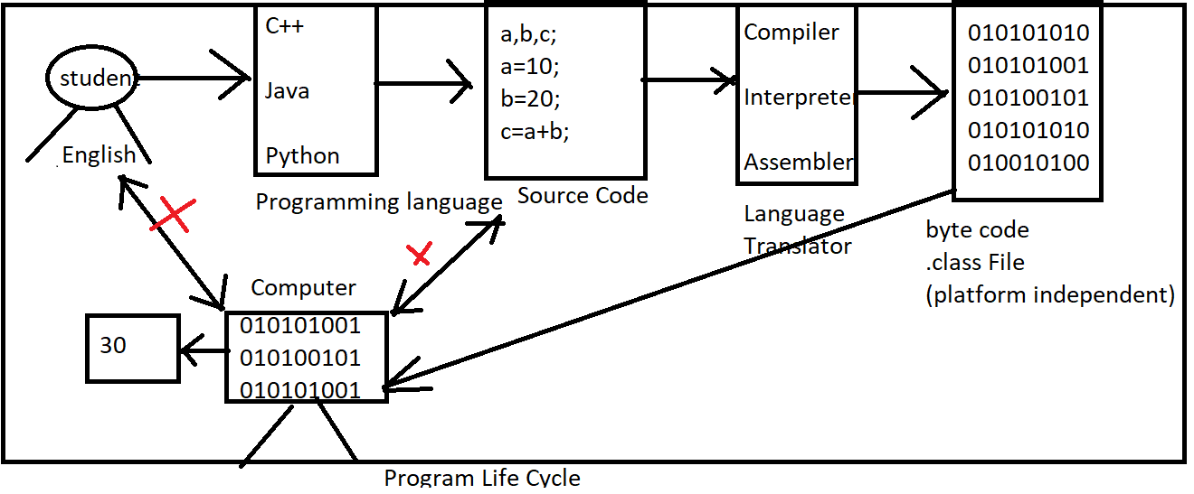

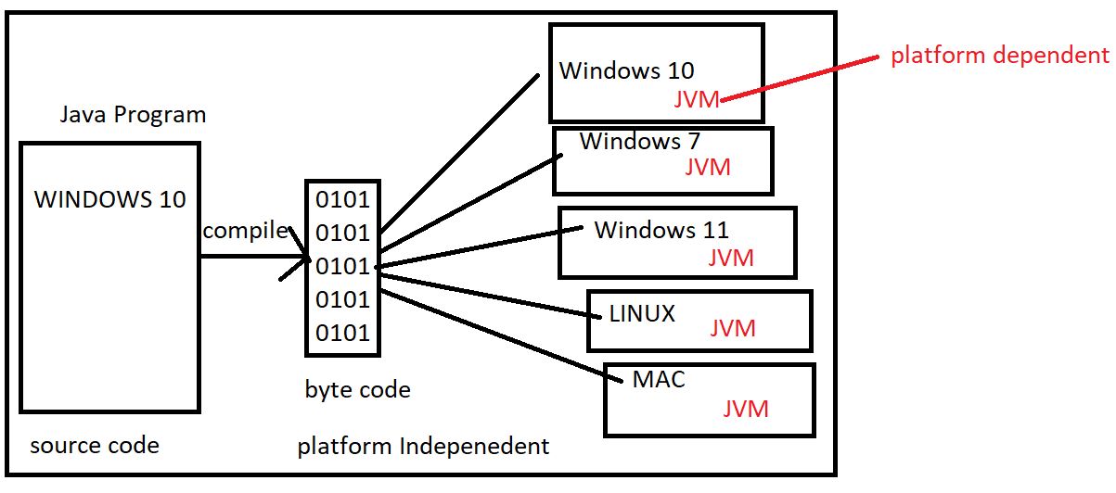

Q2. How to learn Programming language?

Ans: Learning of Programming language is very similar with learning of English Language

Ans:

1. Character Set: Character Set is a set of characters that a language can be recognize.

UpperCase : A to Z(65 To 90)

Lower case: a to z(97 to 122)

1. Tokens: Smallest Individual unit in a program.
2. Keywords: keywords are reserved words that have a special meaning to the java compiler

void,int, char, float,double,boolean, byte, short, return, if, if else, else if , switch,break,continue, while, do while, for, private, public, protected, final, static

Rules of Keywords

1. Keywords always written in lower case
2. Use space after keyword

public static void main()

1. Identifier name should not be keyword.

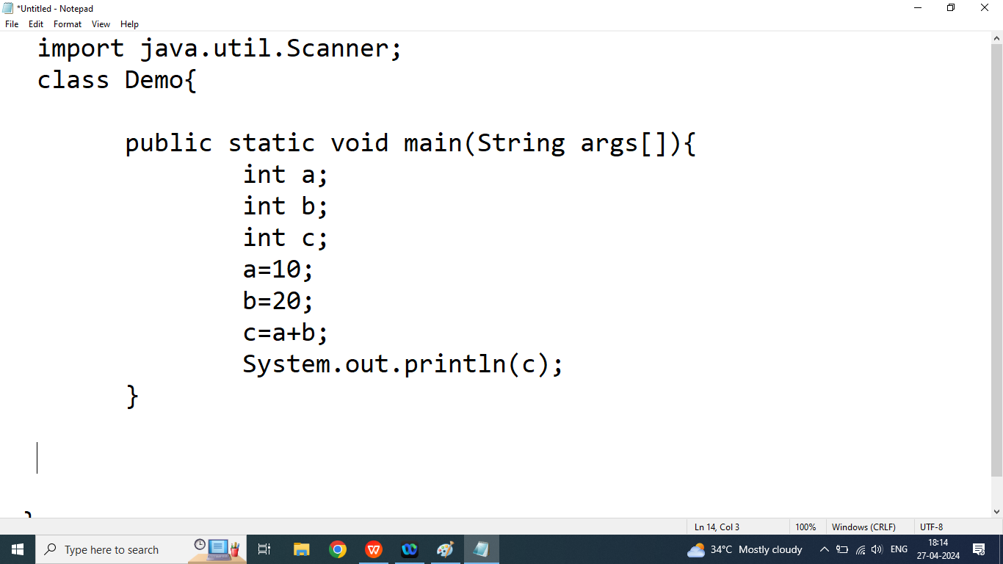

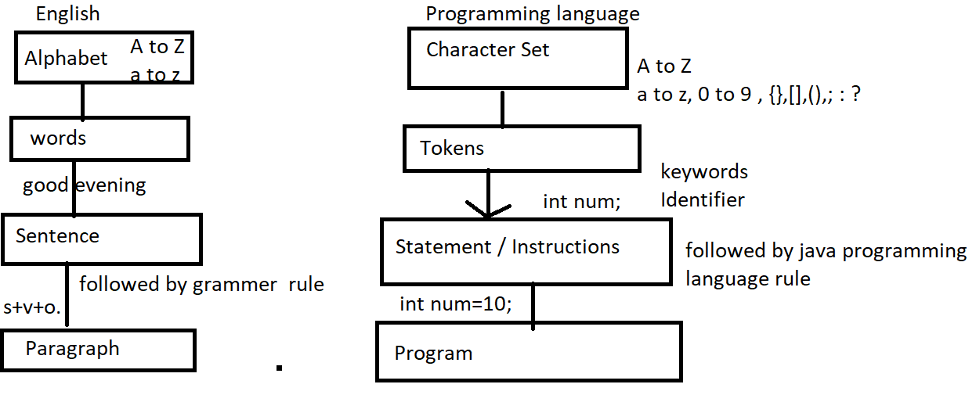

Q3. Explain Identifier in java programming?

Ans: Identifier is a name given by the programmer, Identifier name may be name of variable, name of Class, name of object name of methods name of array.

Example:

int num;

In above expression num is an identifier

Rules of Identifier

1. Identifier name may be combination of alphabet and digits but first character must be an alphabet.

Example:

int num123;//valid

int NUM123;//valid

int 123num;//invalid

int num@123;//invalid

1. In java Programming _ and $ symbol also count as an alphabet. So we can use these symbol anywhere with identifier name.

Example:

int num 123;//invalid

int num_123;//valid

int num$123;//valid

int _123;//valid

int $123;//valid

int $$;//valid

1. Identifier name should not be keyword

Example:

int WHILE;// valid

int while;//invalid

Day 2

Q1. How to download Jdk1.8 from the net?

<https://www.oracle.com/in/java/technologies/javase/javase8-archive-downloads.html>

Q2. How to set path?

Ans:

Step1: will goto C Drive

Step2: Program Files

Step3: Click on java

Step4: Click on jdk1.8

Step5: Click on bin

Step6: copy the path from address bar (C:\Program Files\Java\jdk1.8.0_60\bin)

Step7: Right click on My Computer/ This PC

Step8: Click on Properties

Step9: Click on Advanced System Setting

Step10: Click on Enviorement Variable

Step11: Search path in System variables click on edit, click on new

Step12: How to verify our path is Set or not

Will command prompt

Javac

Q3. Java Program Structure?

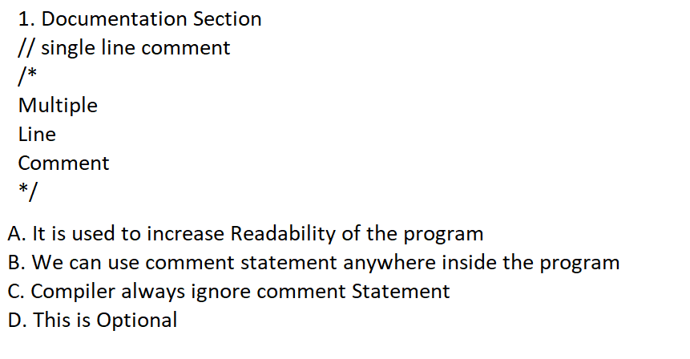

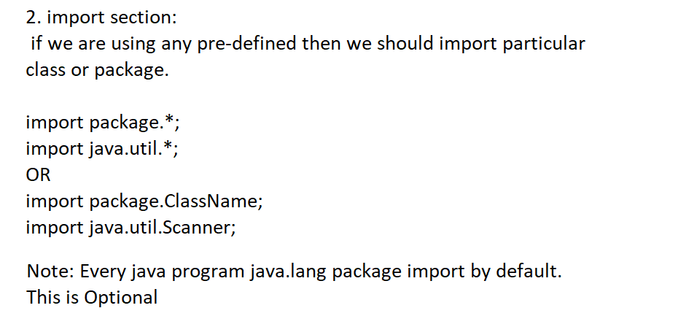

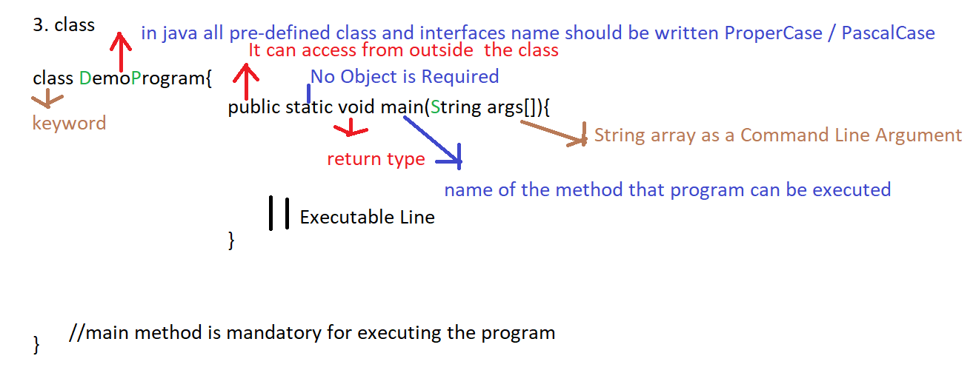

Day 3

Q1.Explain output method in java programming?

Ans: if you want to display anything on the console window then we should go for output method in java programming

We use following output method in java

1. System.out.println(): print and change the cursor on new line
2. System.out.print(): print data on the console but it not change cursor on new line
3. System.out.printf(): print data on the console but it not change cursor on new line

The output method broken into 3 parts

1. System: Pre-defined class present in java.lang package
2. out: Pre-defined public static variables of PrintStream class inside the System class
3. println(): method defined inside the PrintStream() class

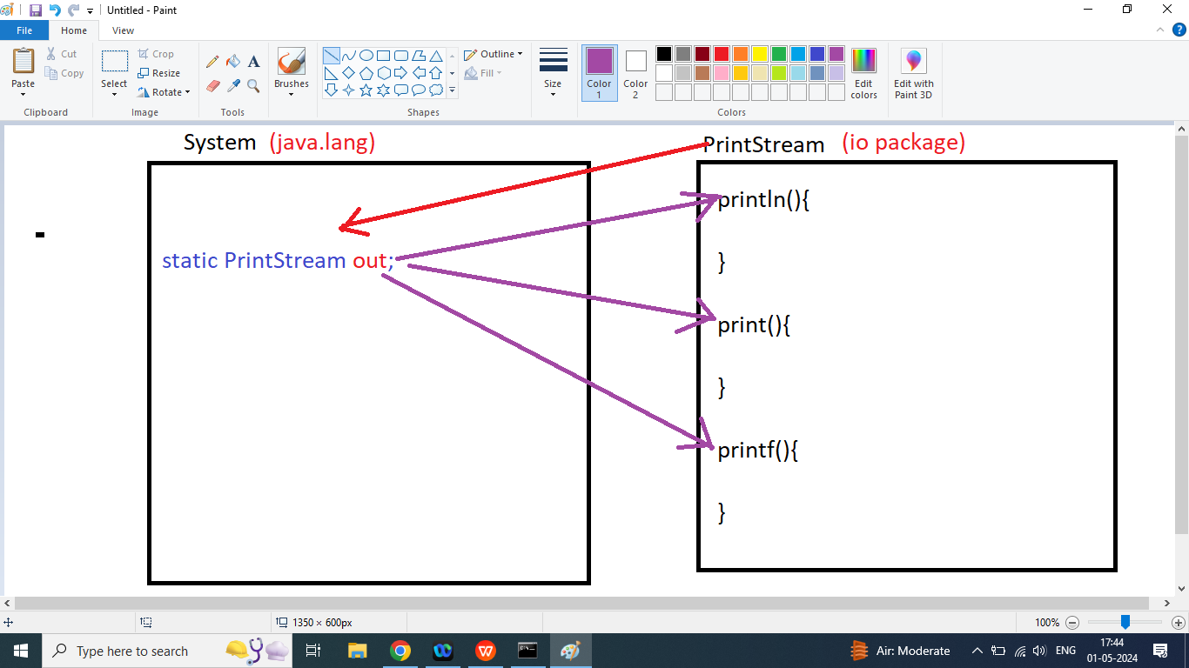

System.out.println(“Hello World”);

OR

System.out.print(“Hello World”);

OR

System.out.printf(“Hello World”);

Q2. Write a java program to print Hello World on the Screen

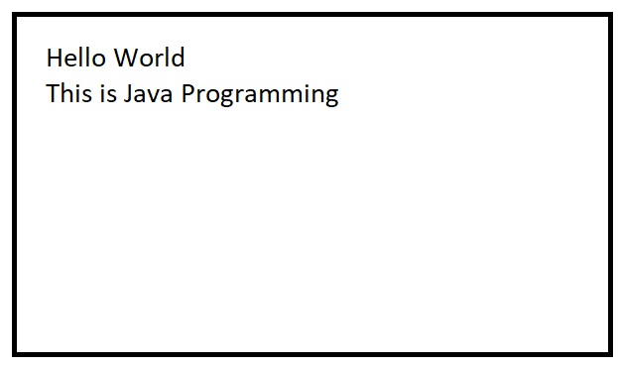

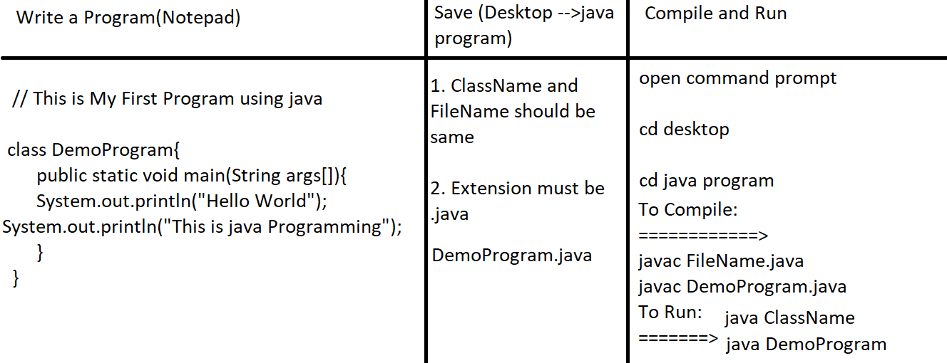

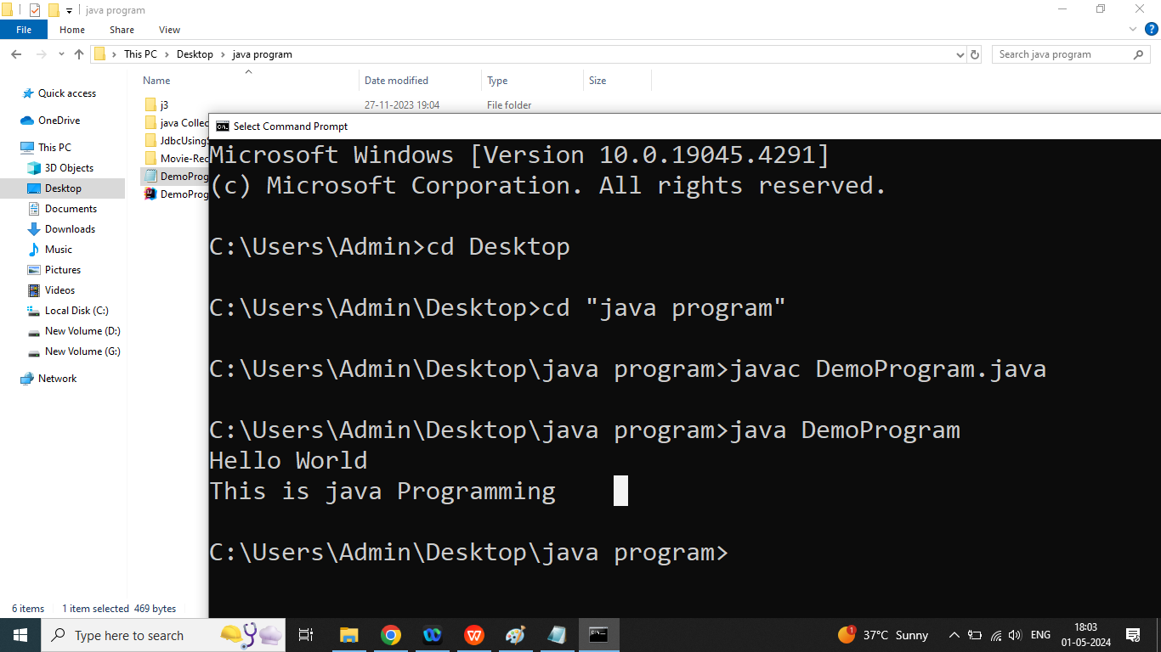

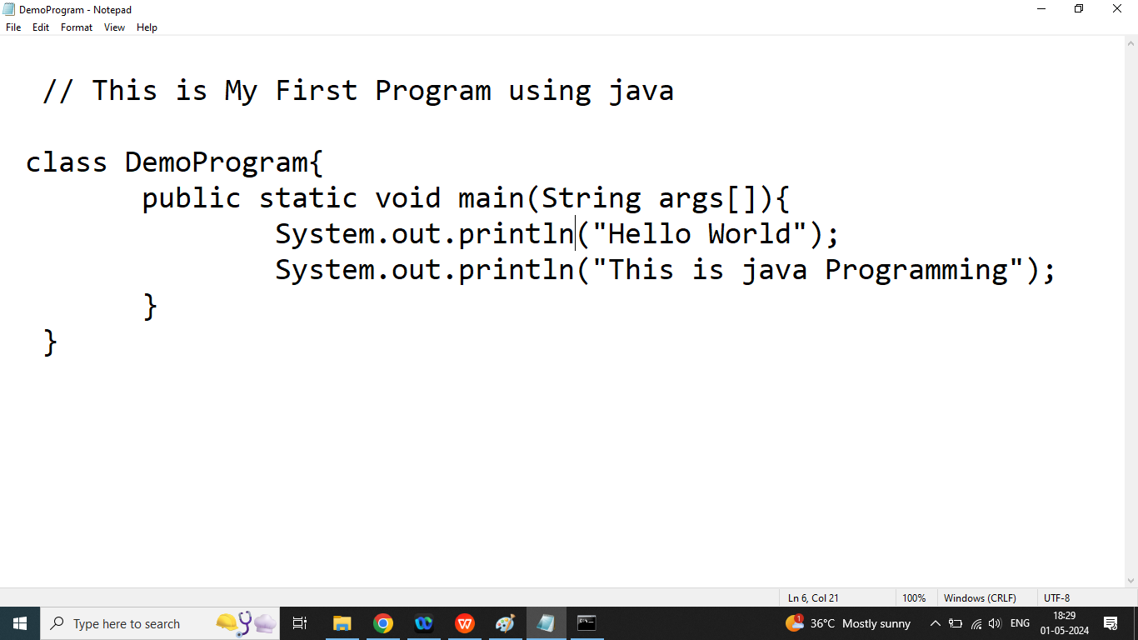

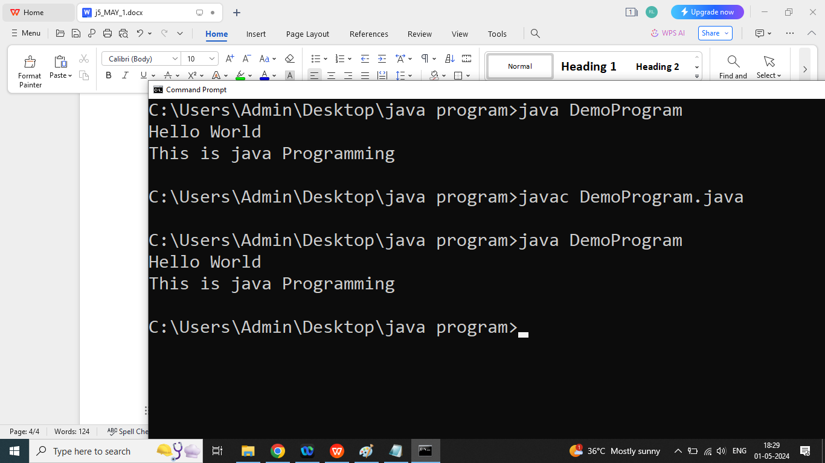

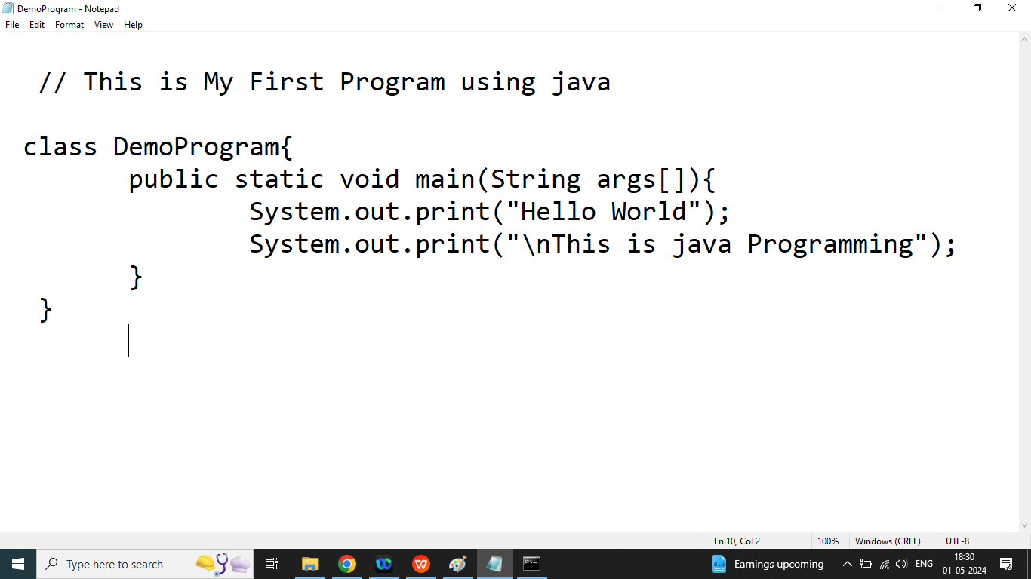

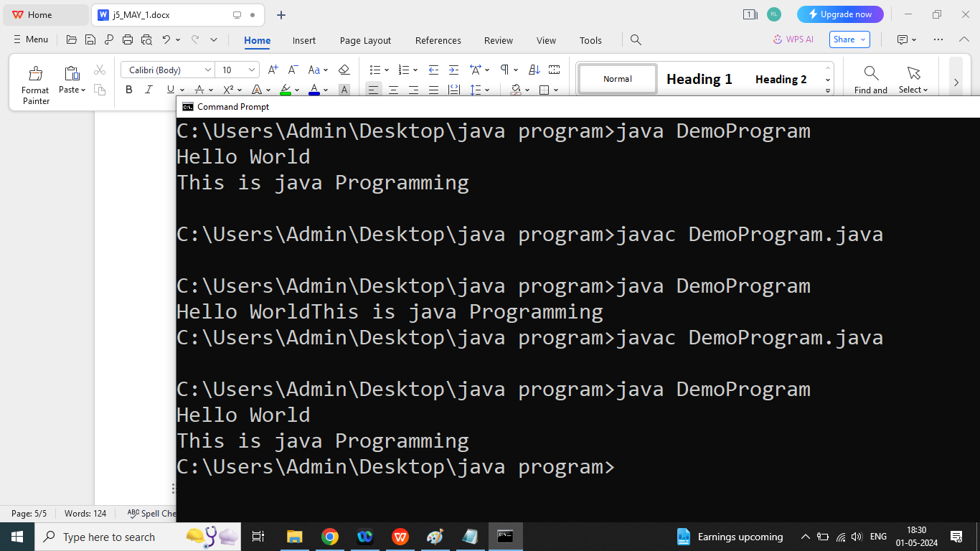

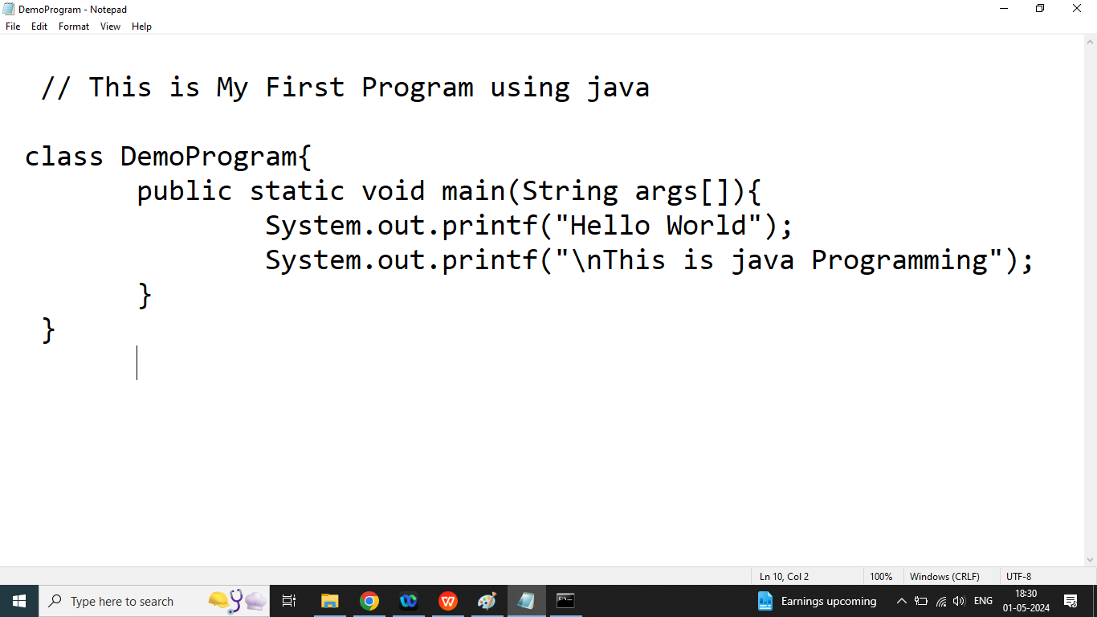

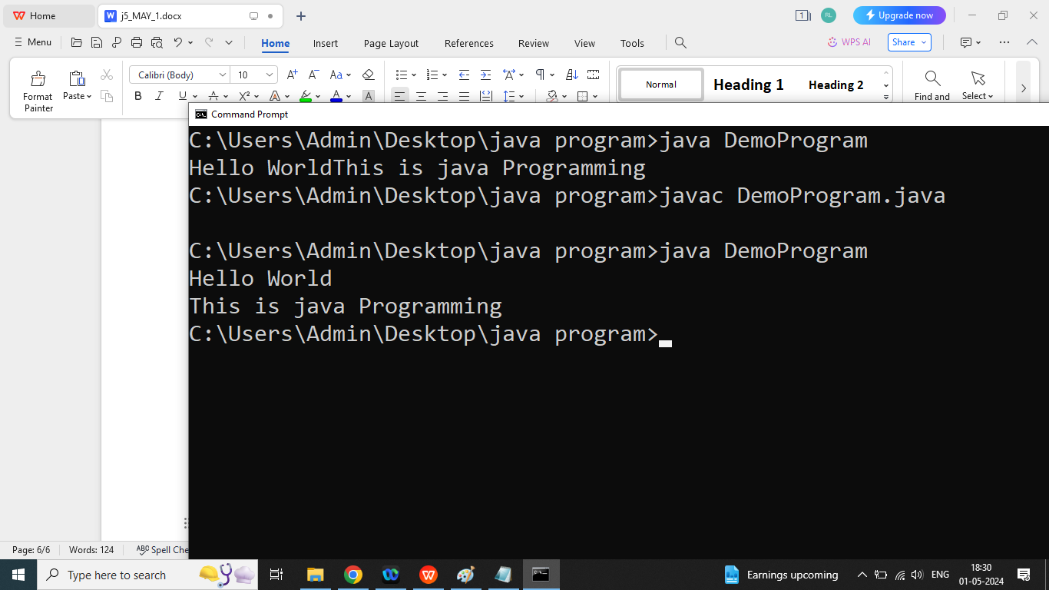

Day 4

Q1. Write a java program to print Student Information

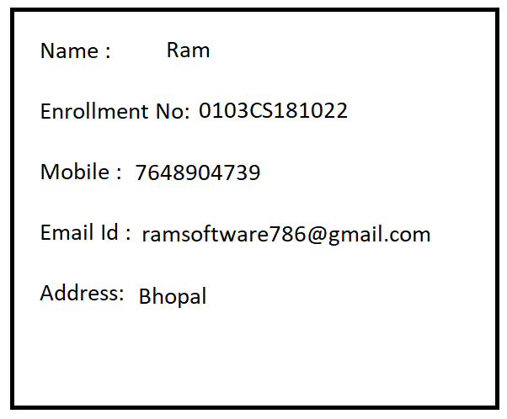

Q2. Explain Data type in java programming?

Ans: Data type can specify what type data can be store and how many bytes memory could be allocated.

Types of Data types

1. Primitive Data type: such as int,char,float,double,Boolean,long,sort,byte
2. Non Primitive: Such as String,Array

Types of Data type

1. Pre-defined Data type: int,char,float,double,boolean
2. User-Defined Data type: using class
3. int : if we want to store a whole number then we should go for int data type.

Example: age,rollno,sno, hno,pincode

Size : 4 byte

Format specifier : %d

1. float: if we want to store a real number upto 6 decimal places then we should go for float data type

Example: percentage, average

Size : 4 byte

Format specifier : %f

Literals: f or F

1. double: if we want to store a real number upto 15 decimal places then we should go for double data type

Example: percentage, average

Size : 8 byte

Format specifier : %f

Literals: d or D

1. char: if we want to store a alphabet then we should go for character data type

Example: grade, gender, section

Size : 2 byte

Format Specifier: %c

Literals: ‘ ’

1. boolean: It is used to store true and false value

Example: to store result of condition

Non-Primitive Data type:

1. String: it is a Pre-defined immutable class present in java.lang package
2. It is used to store multiple character or alphanumeric value

Format Specifier: %s

Literals: “ ”

Q3. Explain Variables in java programming?

Ans:

1. Variable is a temporary memory location it is used to store a value.
2. Value of variable may be changed during execution of the program
3. Variable must be declare before using it
4. Variable must be initialized before using it.

How to declare variable in java programming: Declaration of the variable is nothing but this is to inform the compiler

Step1:

Syntax:

Data type variable_name;

int n1;

int n2;

int n3;

Step2:

How to initialize variable in java

LHS=RHS;

LHS must be a variable

RHS may be constant, variable, expression

n1=10;

n2=20;

Step3: Operations

n3=n1+n2;

Step4: print value of Result variable

System.out.println(“Message ”+variable);

System.out.println(variable);

OR

System.out.print(“Message ”+variable);

System.out.print(variable);

OR

System.out.printf(“Message Format Specifier”,variable);

System.out.printf(“Format Specifier”,variable);

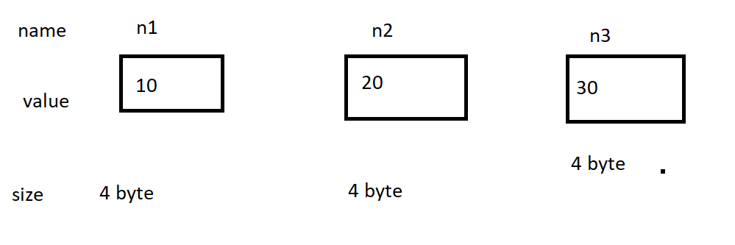

Q4. Write a java program to print sum of two numbers.

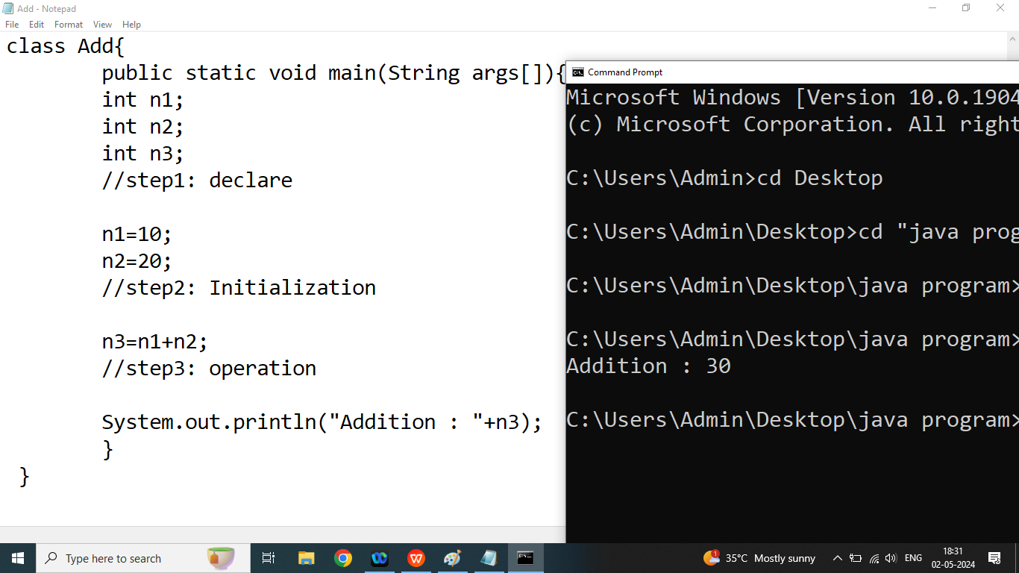

Day 5

Q1. Write a java program to calculate area and parameter Rectangle?

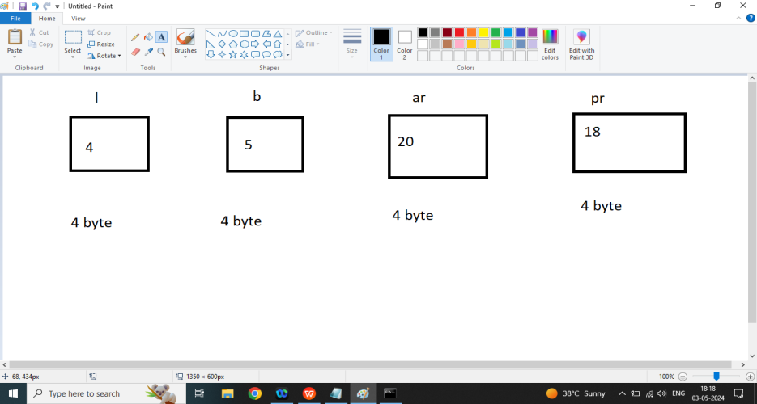

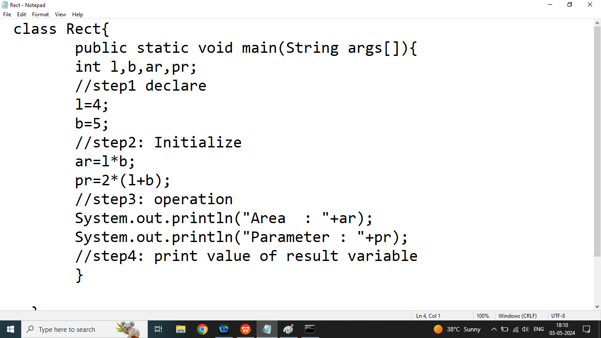

Q2. Write a java program to print square and cube of given number

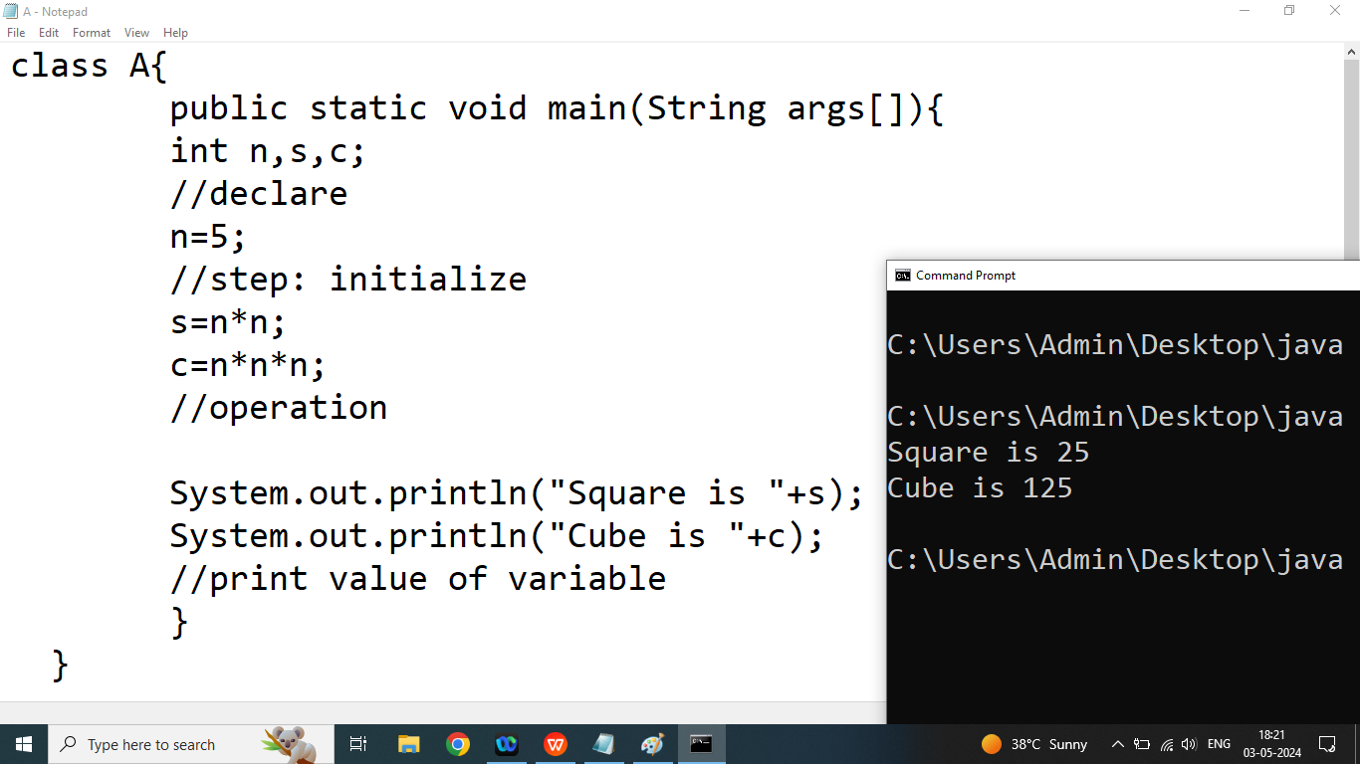

Q3. Write a java program to calculate area and circumference circle

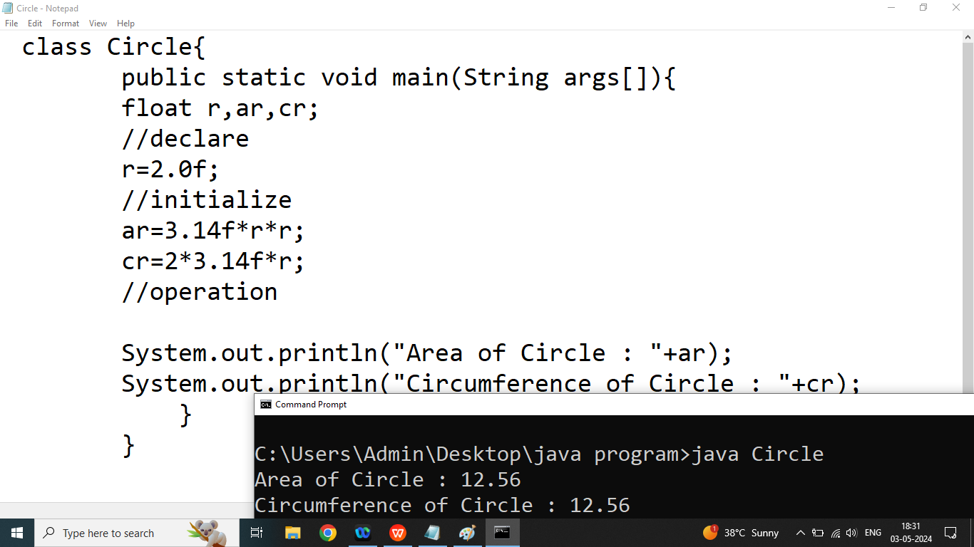

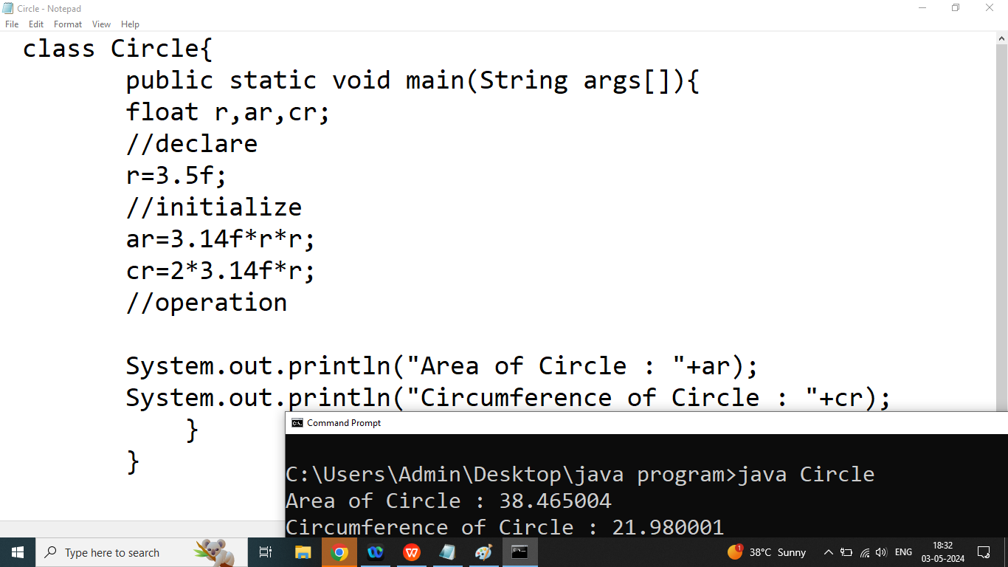

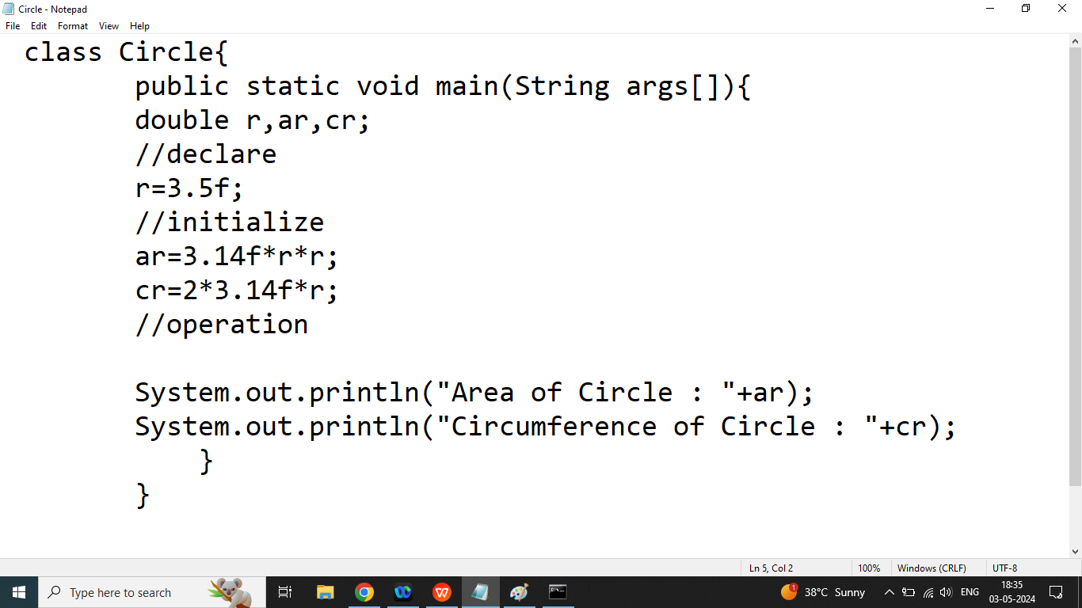

Q5. Write a java program to print to student information

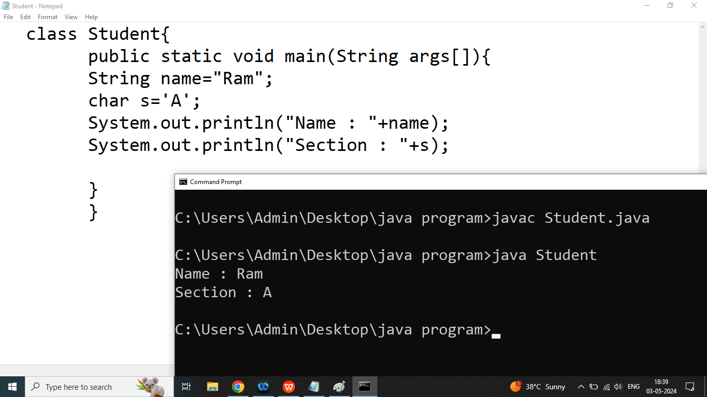

Day 6

Q1. How to take input from the user in java programming?

Ans: if we want to take quick input from the user then we should go for Scanner class

Scanner class comes from java.util.package

If we are using Scanner class in our program then we should follow 3 steps

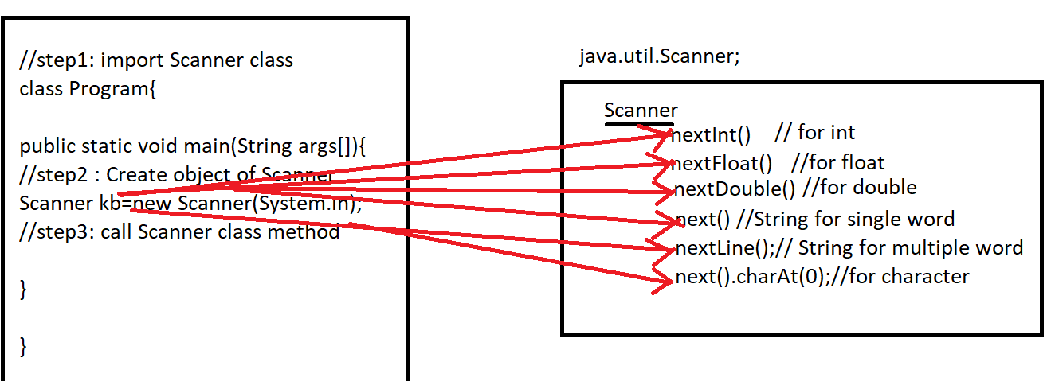

Step1: import Scanner class in the program(before class)

import java.util.*;

OR

import java.util.Scanner;

Step2: Create an object of Scanner class(inside main)

Syntax:

ClassName objectName=new ClassName(Parameter).

Scanner input=new Scanner(System.in);

Step3: Call Scanner class method via object

int a=input.nextInt();//10

float b=input.nextFloat();//2.5

double c=input.nextDouble(); //45.6

String d=input.next(); welcome to bhopal

String e=input.nextLine();//welcome to bhopal

char f=input.next().charAt(0);//abc

Note: In java all per-defined methods written in camelCase.

In java all methods name should be start with verb

Q2. Write a java program to print sum of Two Numbers.

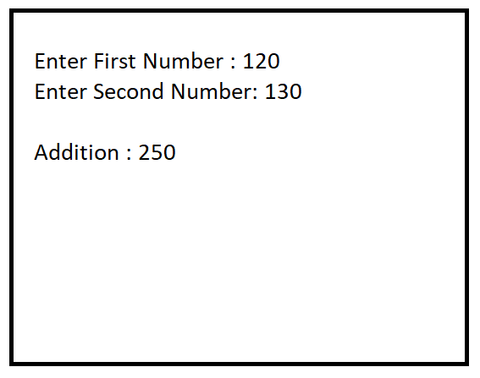

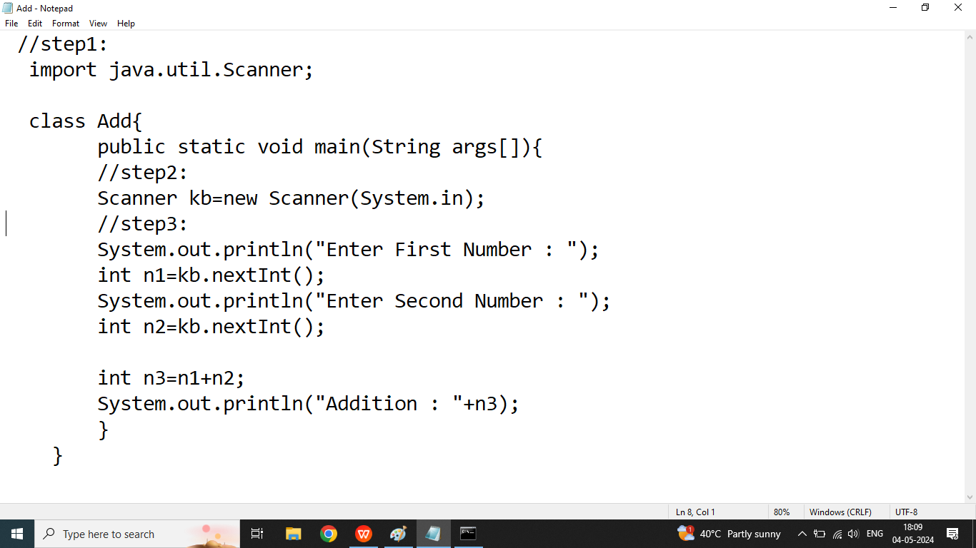

Q2. Write a java program to calculate area and parameter of Rectangle

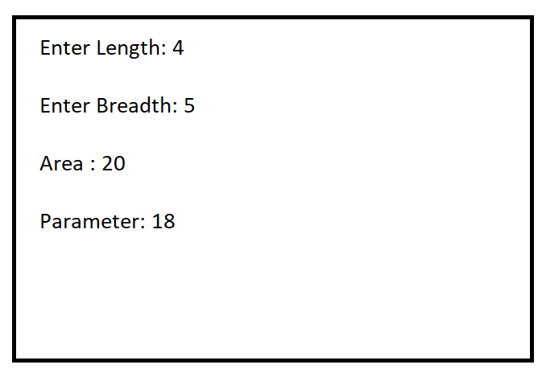

Q3. Write a java program to calculate Square and Cube of the Given Number

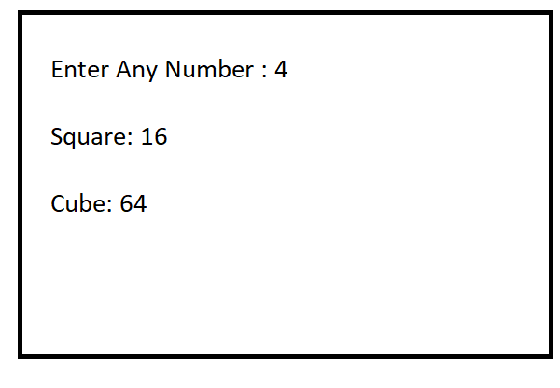

Q3. Write a java program to calculate area and circumference of Circle

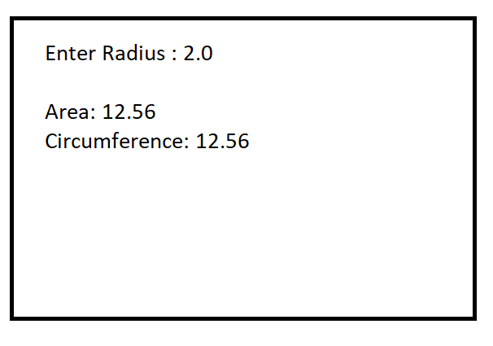

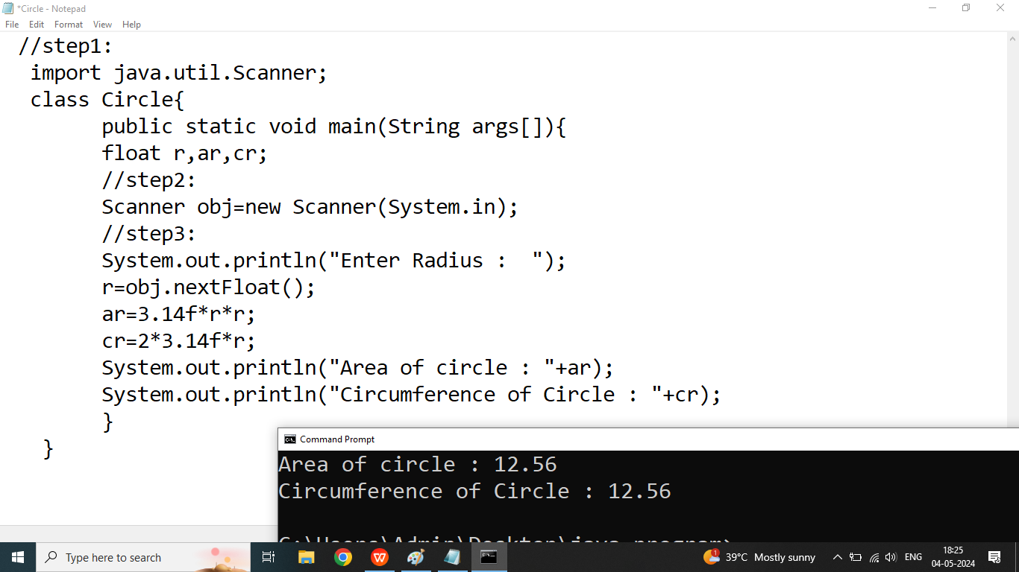

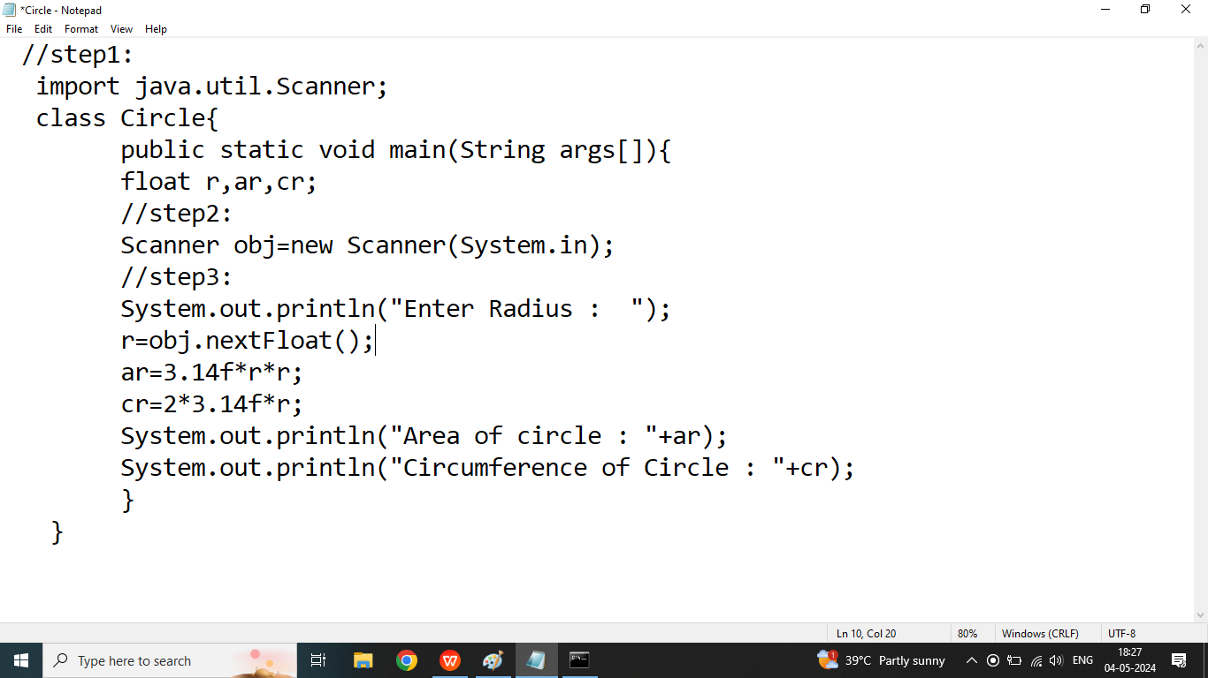

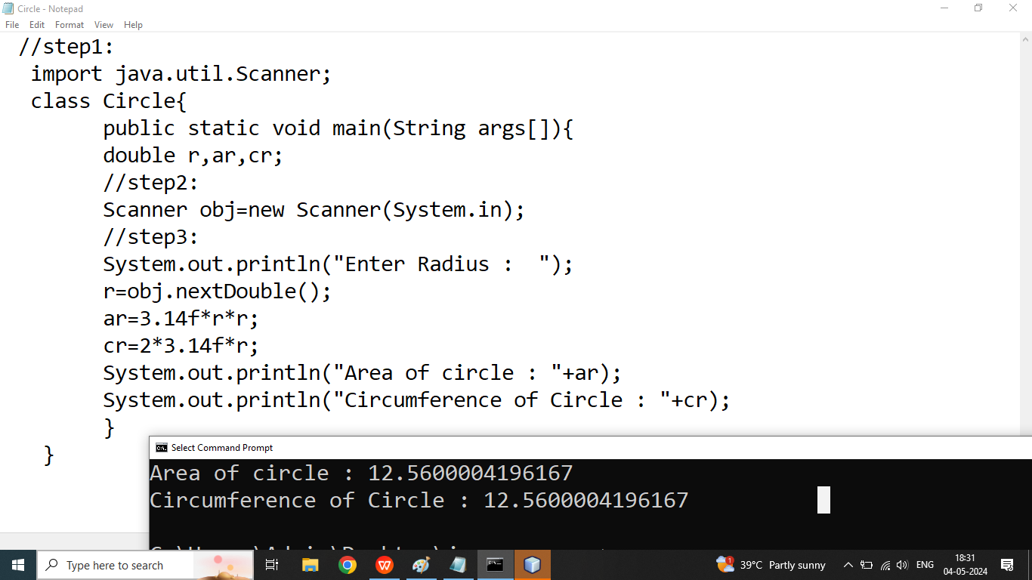

Day 7

Q1. Write a java program to take input Student information from the User and print it on the screen.

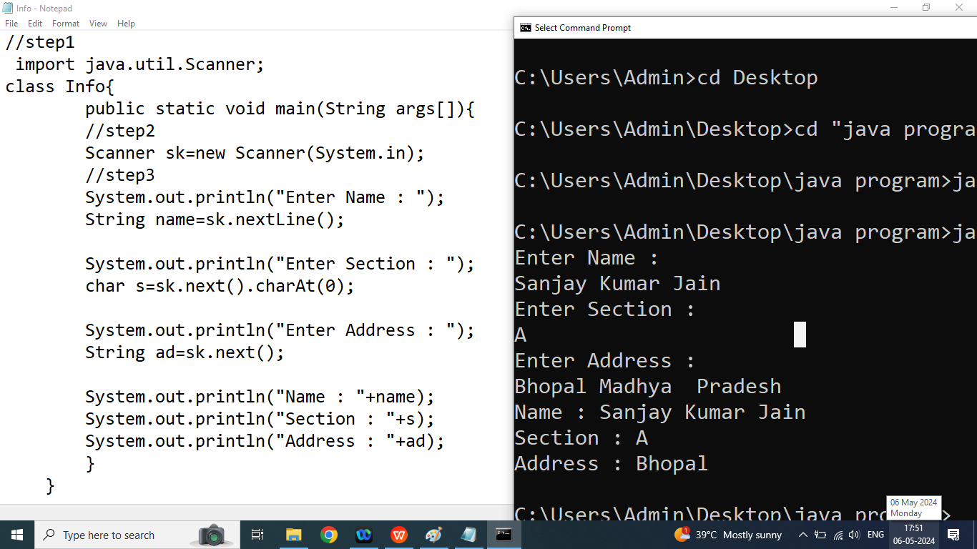

Q2. Write a java program to take Employee Infromation from the user and print it.

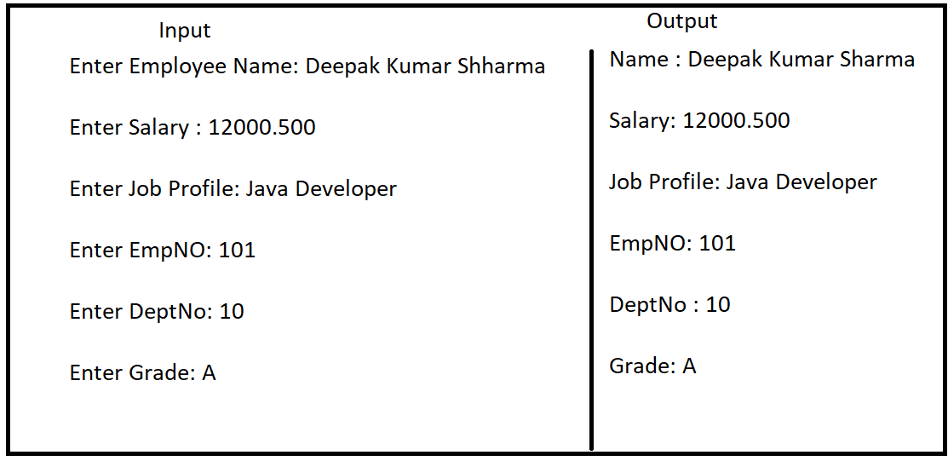

//step1:

import java.util.Scanner;

class Emp{

public static void main(String args[]){

//step2:

Scanner obj=new Scanner(System.in);

System.out.println("Enter Name of the Employee : ");

String name=obj.nextLine();

System.out.println("Enter Salary : ");

float sal=obj.nextFloat();

obj.nextLine();

System.out.println("Enter Job Profile : ");

String profile=obj.nextLine();

System.out.println("Enter EMPNO : ");

int empno=obj.nextInt();

System.out.println("Enter DEPTNO : ");

int deptno=obj.nextInt();

System.out.println("Enter Grade : ");

char g=obj.next().charAt(0);

System.out.println("Name : "+name);

System.out.println("Salary : "+sal);

System.out.println("Job Profile : "+profile);

System.out.println("EmpNo : "+empno);

System.out.println("DeptNo : "+deptno);

System.out.println("Grade : "+g);

}

}

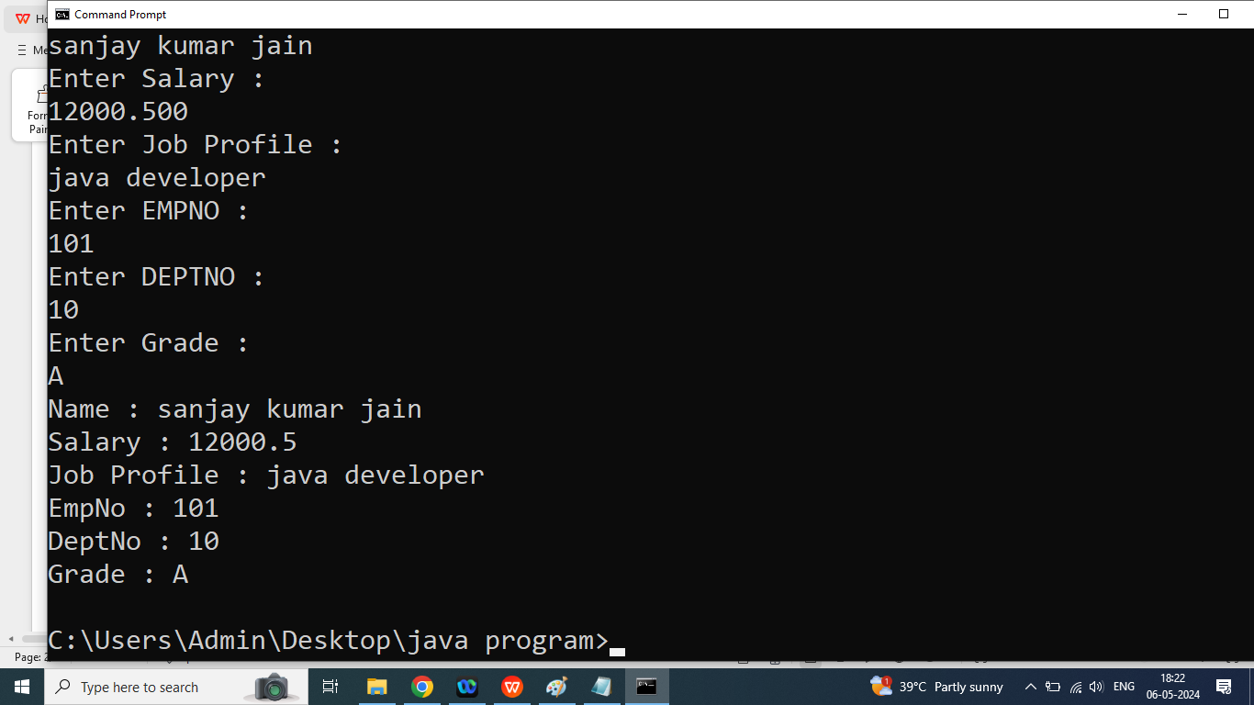

Q3. Write a java program to swap two numbers using third variable?

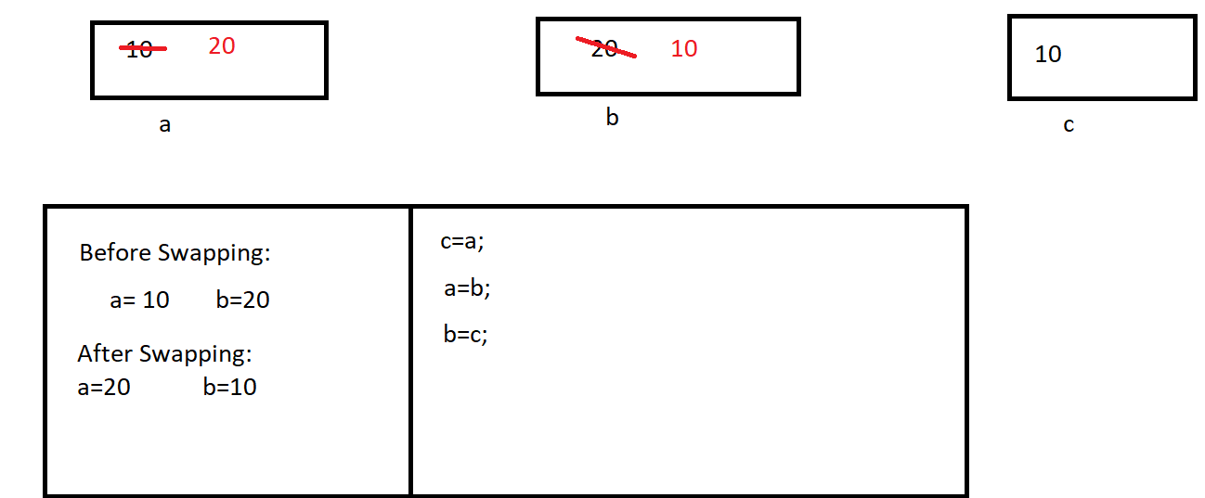

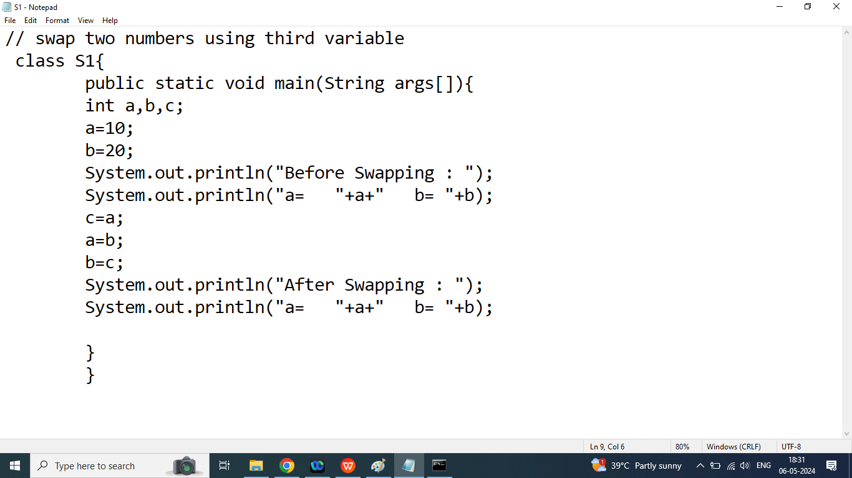

Day 8

Q1. Write a java program to swap two numbers without using variable.

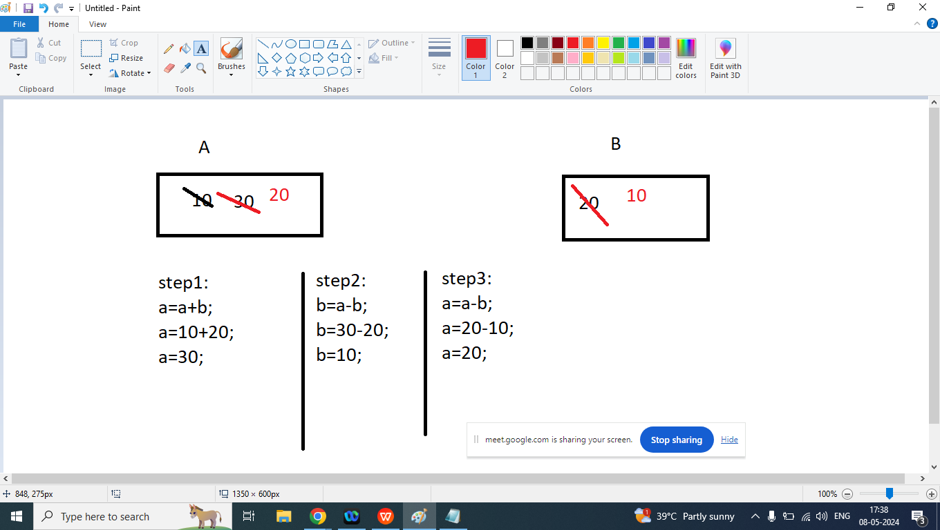

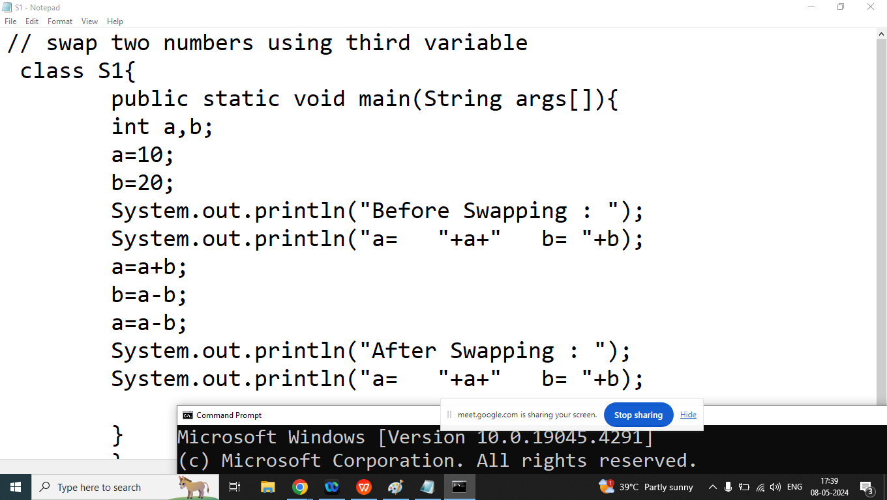

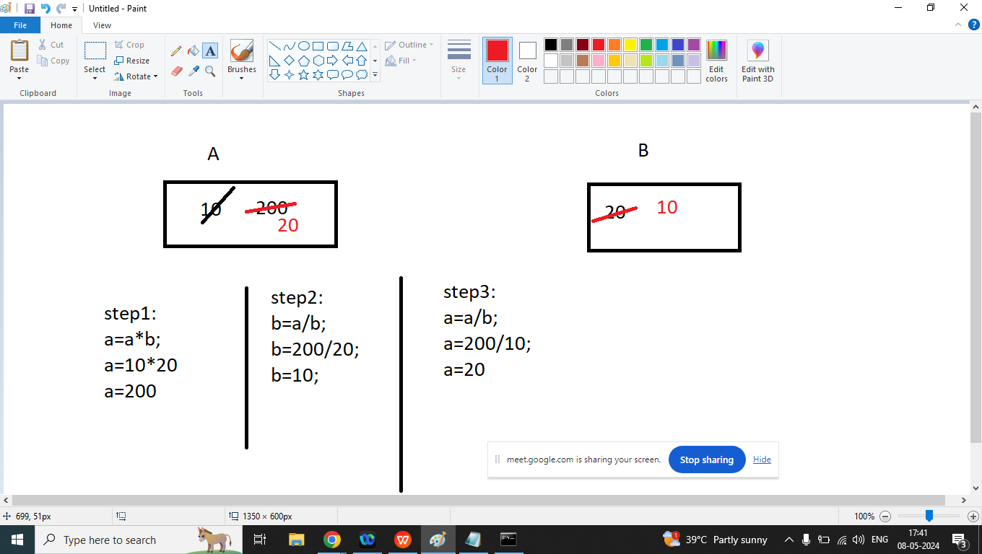

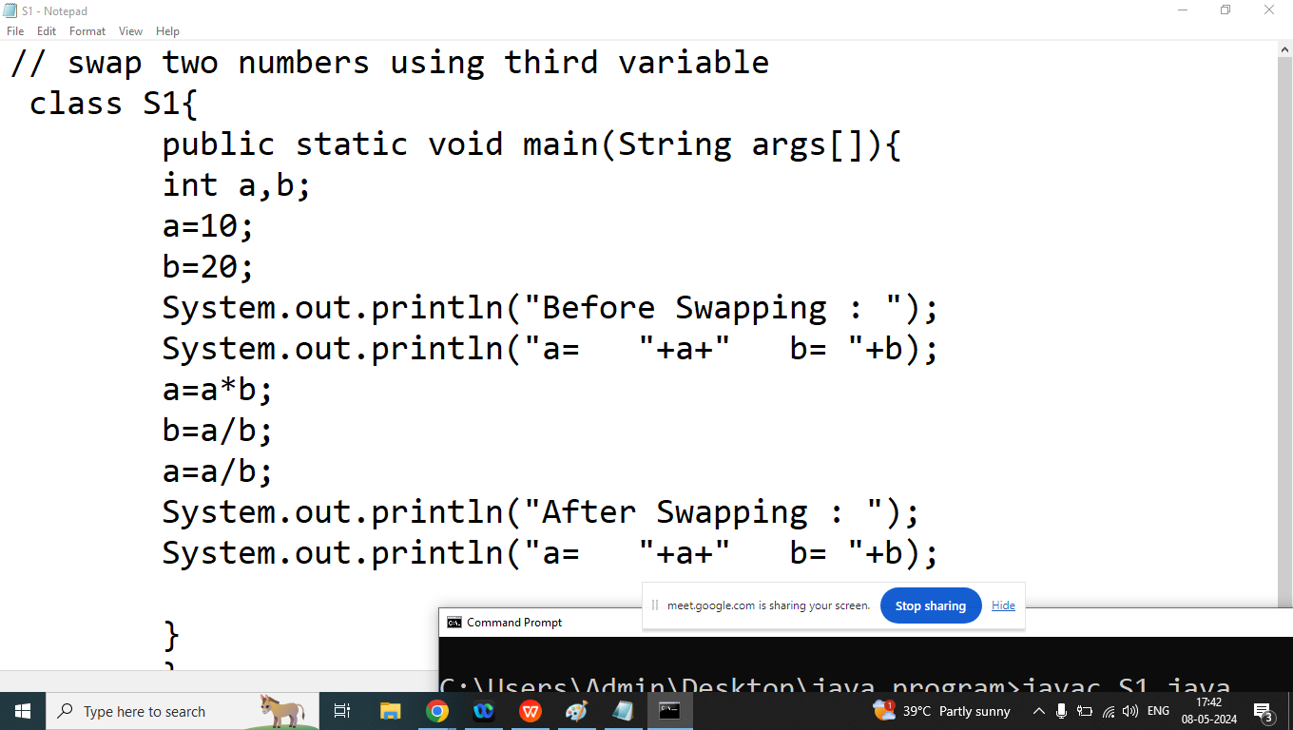

Q1. Explain Operators in java programming?

Ans: Operators are symbols that tells to the compiler to perform some specific task

Example:

C=10+20;

In above expression =,+ are operators and C,10,20 are operators

Types of Operators on the basis of Number of Operand

1. Unary Operator: It takes only one operand at a time and perform some specific operations

Example: i++,!,~,

1. Binary operators: It takes two operand at a time and perform some operations

Example: >,<,==, +,-,*,/,%

1. Ternary Operator: It Takes three operand at a time and perform some specifc operation

Example: exp1 ? exp2: exp3;

Types of Operators on the basis of functionalities

1. Arithmetic operators[+,-,*,/,%,++,--]
2. Relational Operators[>,<,>=,<=,==,!=]
3. Logical Operators [&&,||,!]
4. Bitwise Operators[&,|,~,<<,>>,^]
5. Conditional Operators/ Ternary Operators[? : ]
6. Assignment Operators[=,+=,-=,*=,/=]

Operator Precedence

Operator Associativity

Q3.Explain Modulo operator in java programming?

Ans: if we want to find reminder of any number then we should go for module operator

Modulo(%)

First Operand % Second Operand

Example:

10%3====>1

35%4====>3

4%10====>4

Note: in case of modulo operator if first operand is less than second operand then reminder will be first operand

Division (/)

First Operand / Second Operand

Example:

10/3=====>3

35/4=====>8

4/10=====>0

Q4. Write a java program to print last digit of the given number

Enter Any Number : 123

Last digit of the number: 3

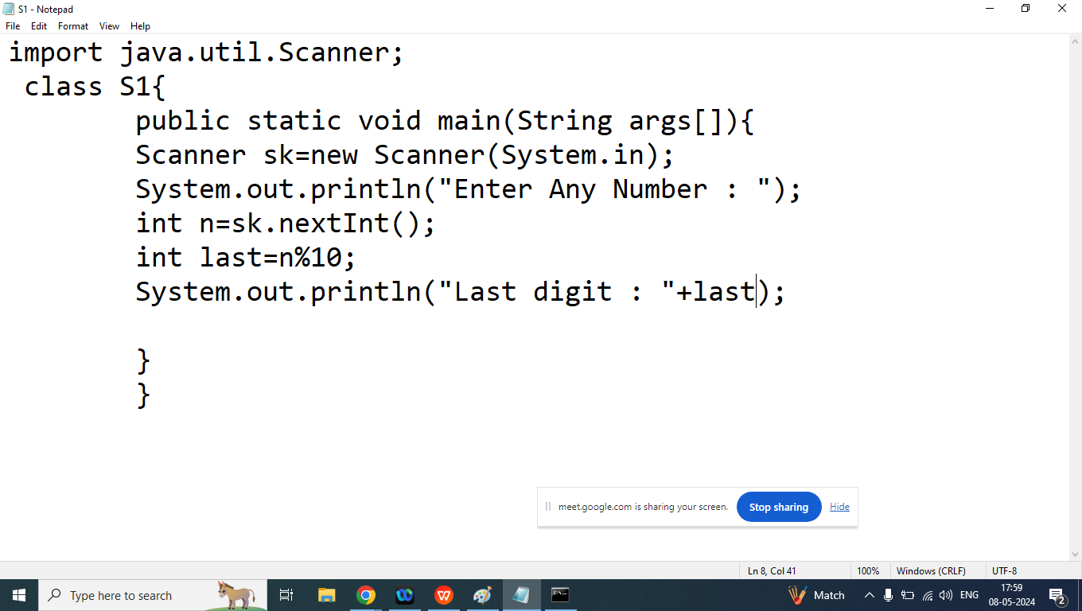

Homework:

Q1. Write a java program to print second last digit of the given number.

Enter Any Number : 1234

Second Last Digit of the given number : 3

Q2. Write a java program to convert given amount into smallest possible bank notes.

Enter Amount : 1388

Notes of 100: 13

Notes of 50 : 1

Notes of 20: 1

Notes of 10: 1

Notes of 5: 1

Notes of 2: 1

Notes of 1: 1

Day 9

Q1. Write a java program to convert given amount into smallest possible bank notes

Enter Amount: 1388

Notes of 100: 13

Notes of 50: 1

Notes of 20: 1

Notes of 10: 1

Notes of 5: 1

Notes of 2: 1

Notes of 1: 1

import java.util.Scanner;

class Bank{

public static void main(String args[]){

int a,rm,n;

Scanner sk=new Scanner(System.in);

System.out.println("Enter Any Number ");

a=sk.nextInt();//1388

n=a/100;

System.out.println("Notes of 100 : "+n);

rm=a-n*100;

n=rm/50;

System.out.println("Notes of 50 : "+n);

rm=rm-n*50;

n=rm/20;

System.out.println("Notes of 20 : "+n);

rm=rm-n*20;

n=rm/10;

System.out.println("Notes of 10 : "+n);

rm=rm-n*10;

n=rm/5;

System.out.println("Notes of 5 : "+n);

rm=rm-n*5;

n=rm/2;

System.out.println("Notes of 2 : "+n);

rm=rm-n*2;

n=rm/1;

System.out.println("Notes of 1 : "+n);

}

}

Q2. Explain Increment(++) and decrement(--) operator in java programming?

Ans:

In case of Increment operator value of its operands increase by 1

Example:

int a;

a=45;

++a;

OR

a++

In case of decrement operator value of its operands decrease by 1

Example:

int a;

a=45;

--a;

OR

a--;

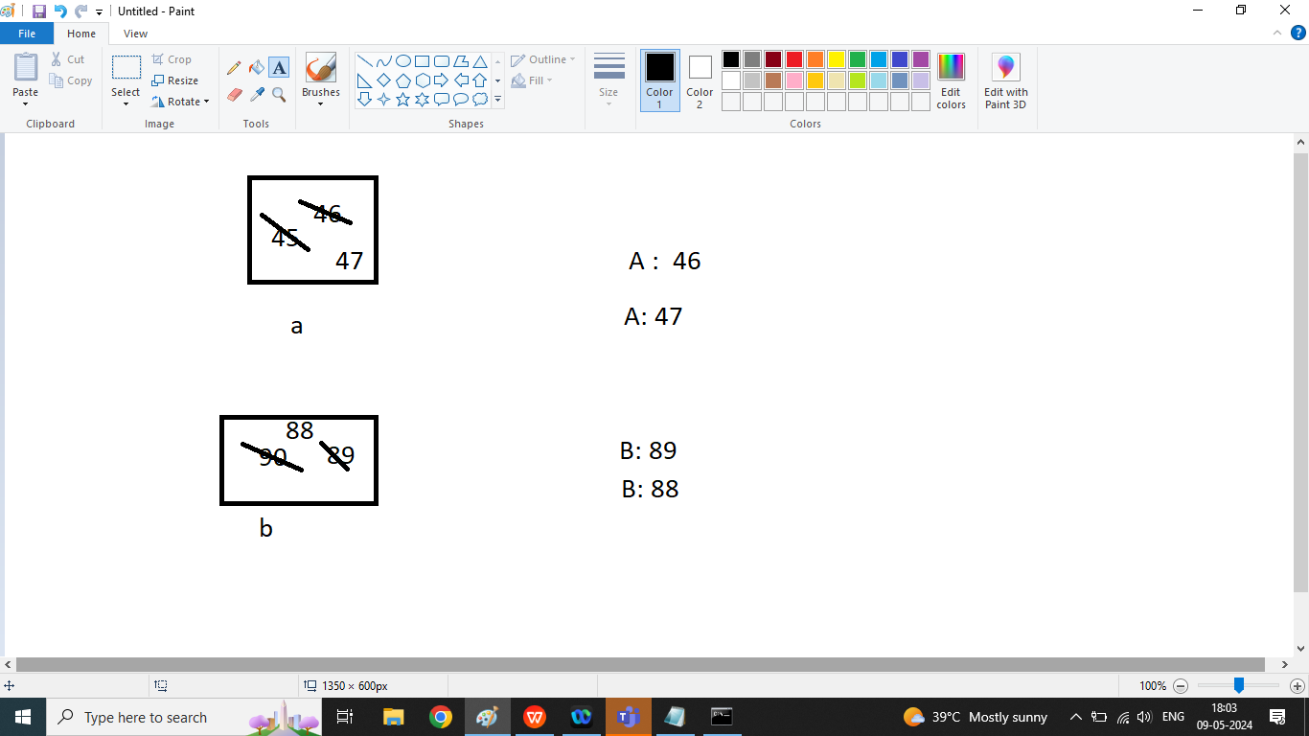

class A1{

public static void main(String args[]){

int a,b;

a=45;

b=90;

++a;

System.out.println("A : "+a);

a++;

System.out.println("A : "+a);

b--;

System.out.println("B : "+b);

--b;

System.out.println("B : "+b);

}

}

Q2. Explain Pre-Increment and Pre-Decrement in java programming?

Ans:

Pre-Increment : In case of Pre Increment first increase the value of its operands by 1 then we can used this value in the expression (incremented value)

Example:

int a,b;

a=10;

b=++a;//a=11

Pre-Decrement : In case of Pre Decrement first decrease the value of its operands by 1 then we can used this value in the expression (decremented value)

Example:

int a,b;

a=10;

b=--a;

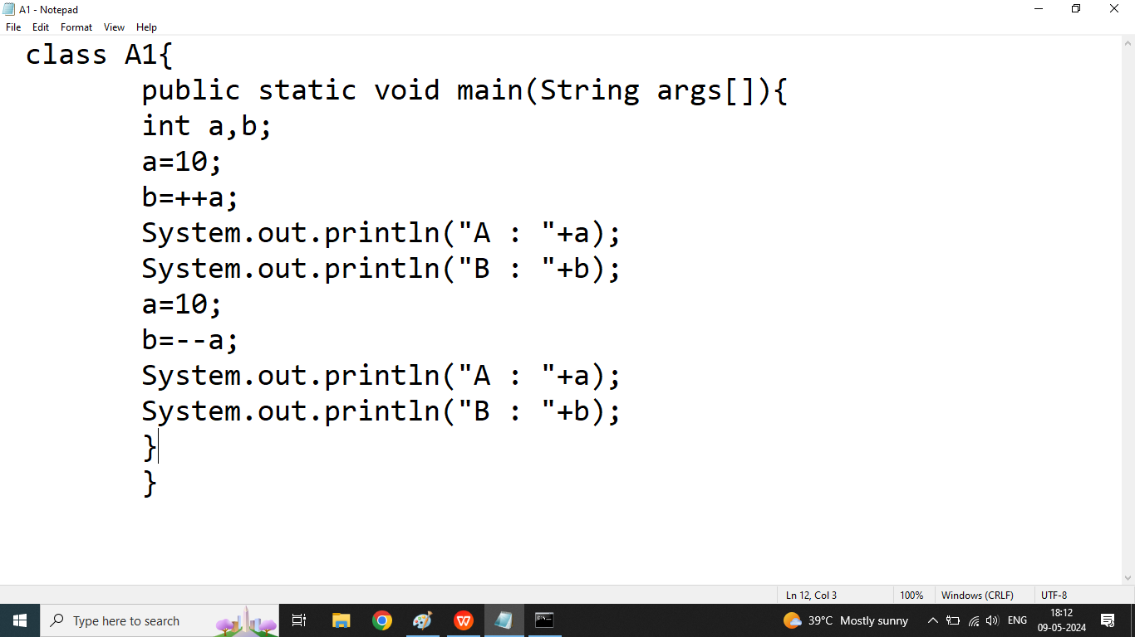

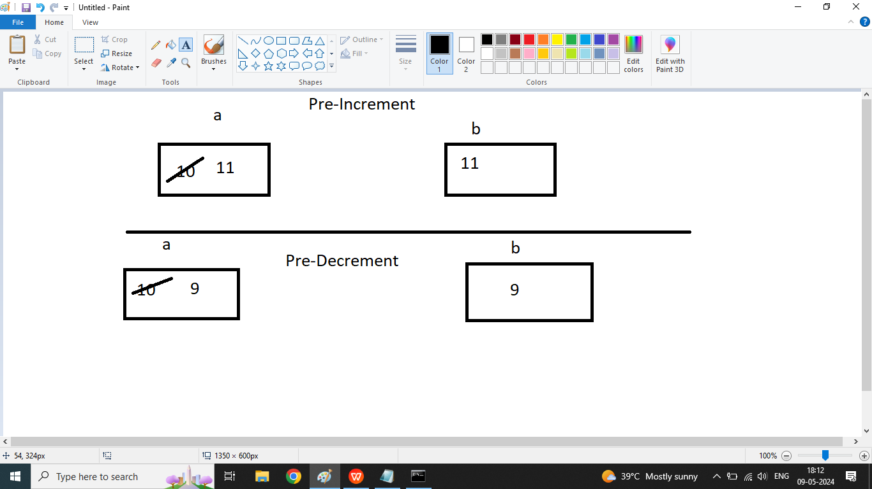

Q4. Explain post Increment or post decrement operator in java programming?

Ans :

Post Increment : In case of Post Increment First we use original value of its operand in the expression, after complete execution of the expression then value of operand will increase by 1 and we cannot use incremented value in the expression

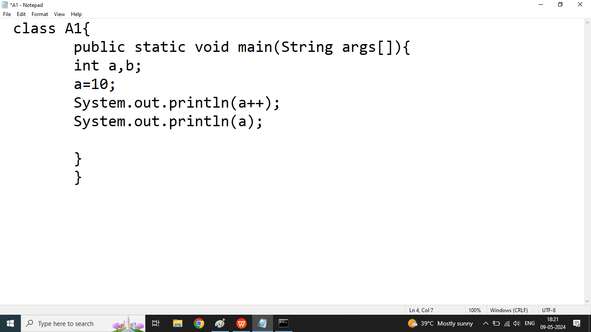

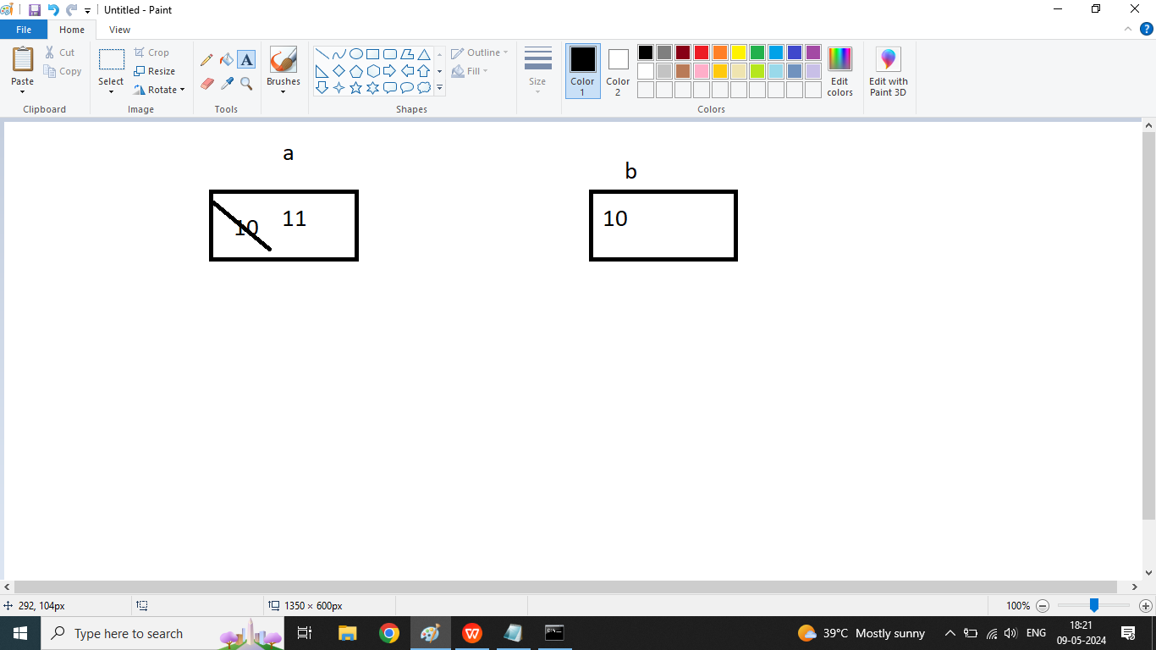

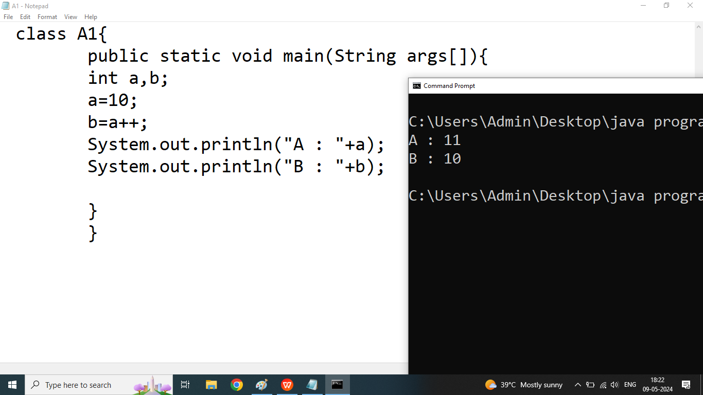

Post Decrement : In case of Post Decrement First we use original value of its operand in the expression, after complete execution of the expression then value of operand will decrease by 1 and we cannot use decremented value in the expression

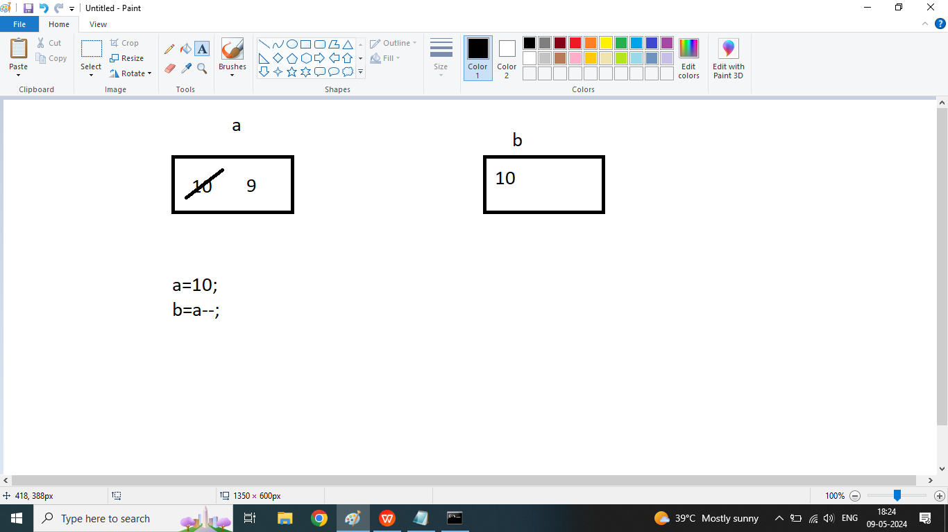

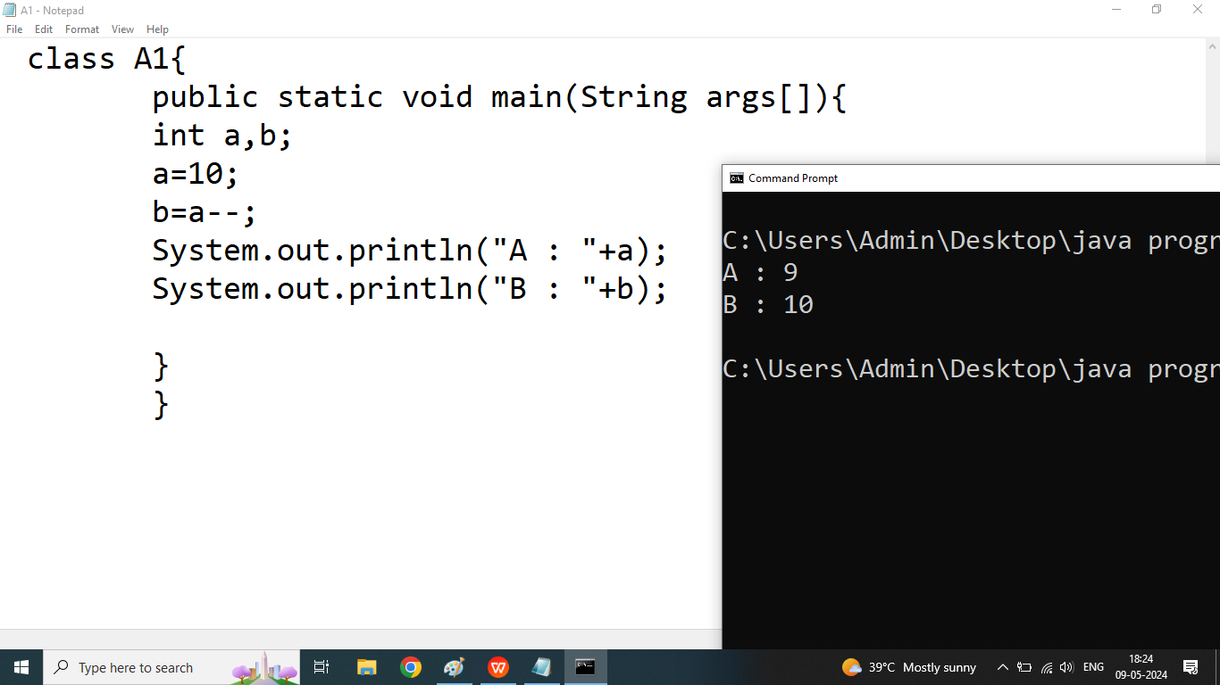

Q5. What will be the output of following program?

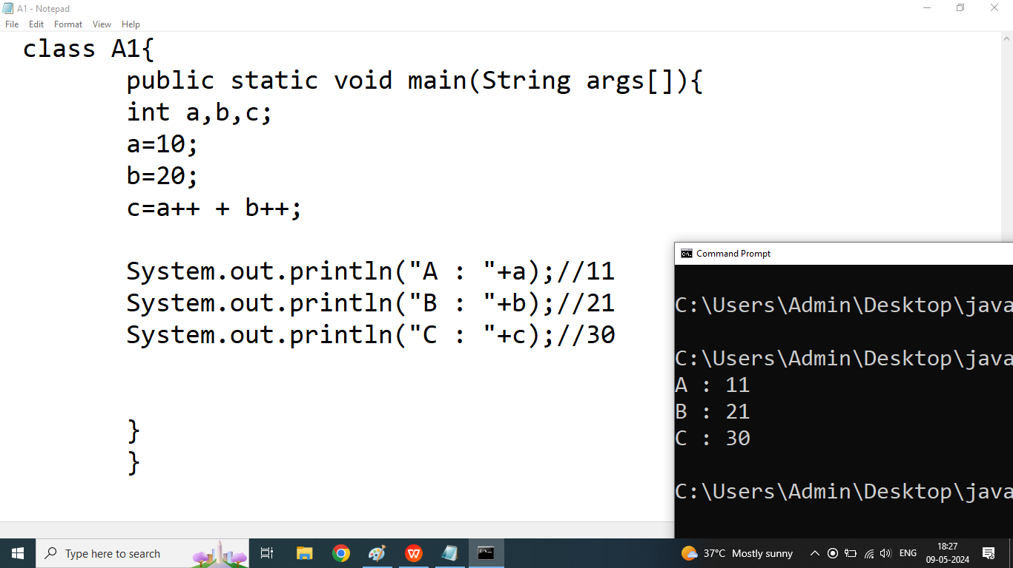

Q6. What will be the output of following program?

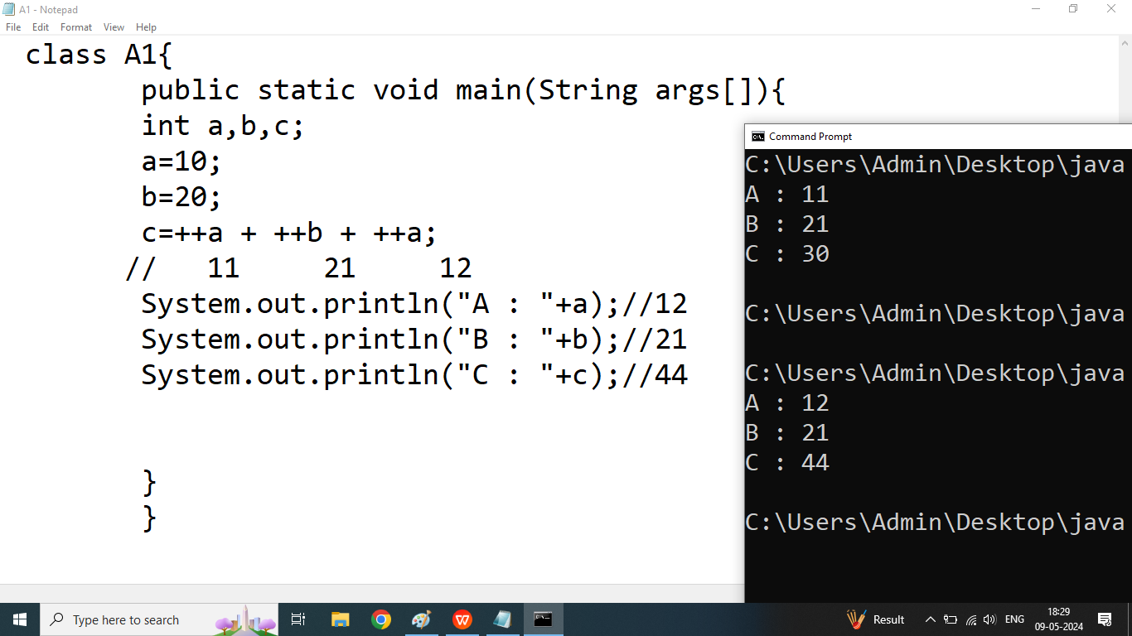

Q2. Explain Relational Operator or Conditional Operator in java programming?

Ans: if we want to compare something or define some condition then we should go for Relational operators

We discuss following conditional Operators

1. >
2. <
3. >=
4. <=
5. ==
6. !=

Note: Result of All Relational operators are true or false.

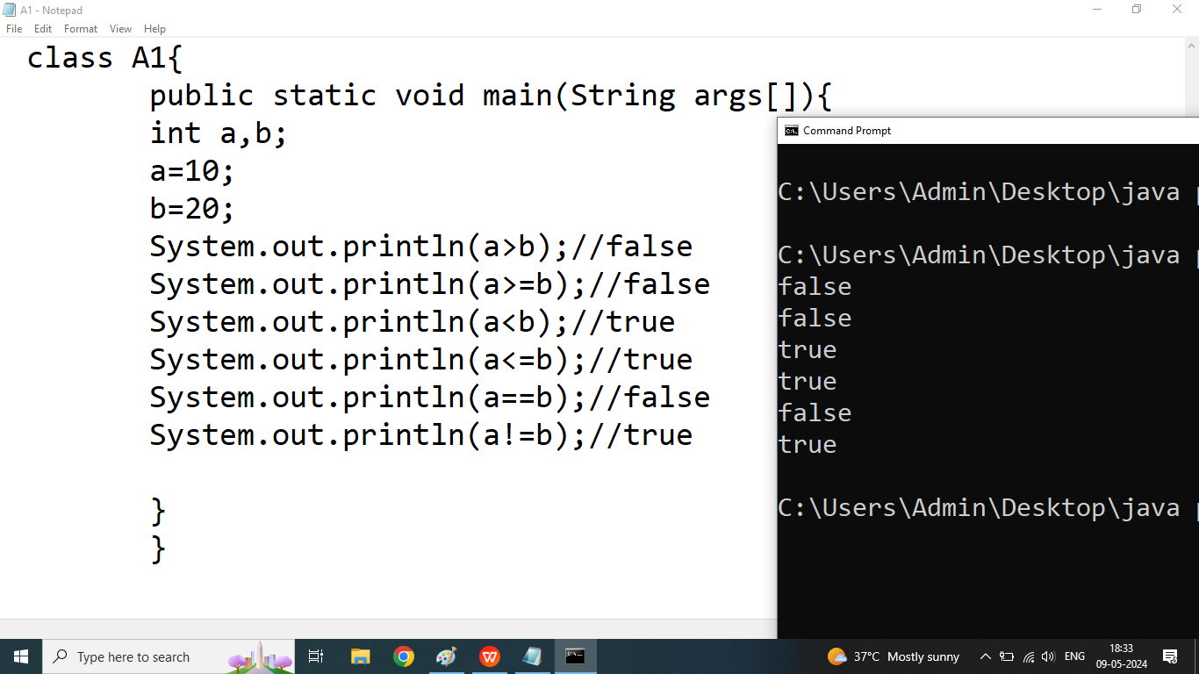

Day 10

Q1. Write a java program to check given number is positive or negative using if.

Enter Any Number : 5

This is Positive Number

Enter Any Number: -3

This is Negative Number

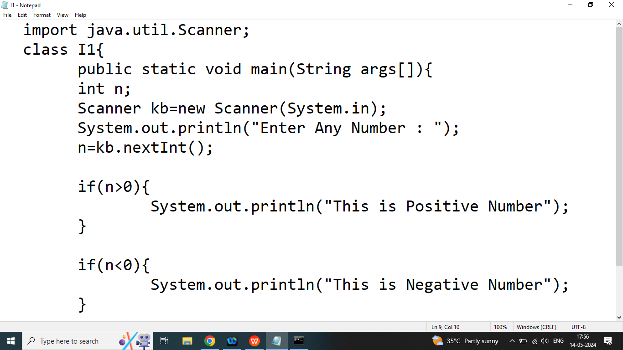

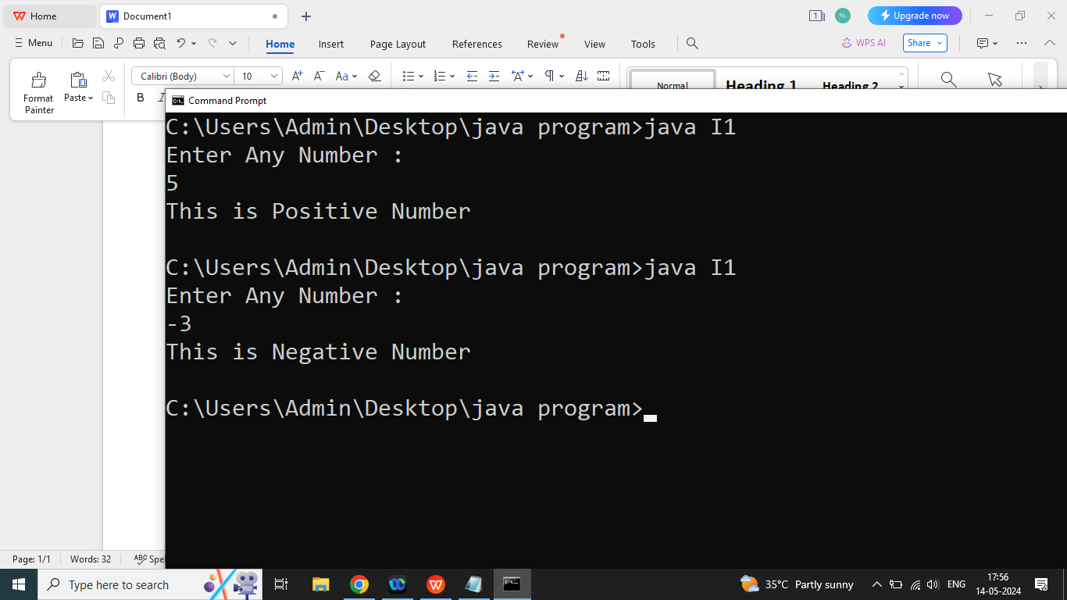

Q2. Explain if else statement in java programming?

Ans: if we have exactly two possibility then we should go for if else statement.The if else statement is used to execute both the true part and false part. If given condition evaluated true statement of if will executed, if given condition evaluated false then statement of else will executed. else always depends on if.

|  |
| --- |
| Syntax:  if(condition){  //if statement  }  else{  //else statement  } |

Q2. Write a java program to check given number is even or odd using if else?

Enter Any Number : 46

Even Number

Enter Any Number: 47

Odd Number

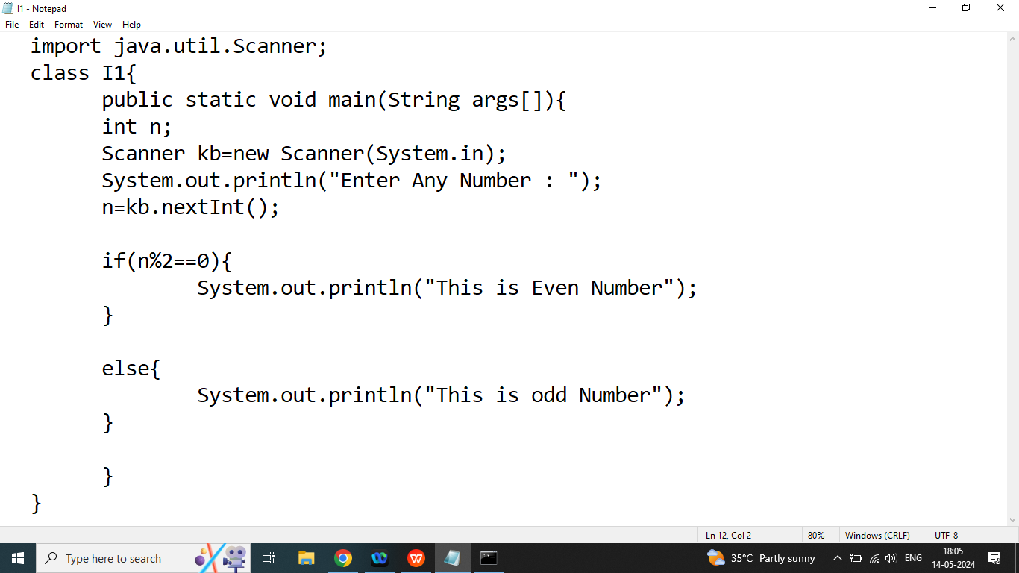

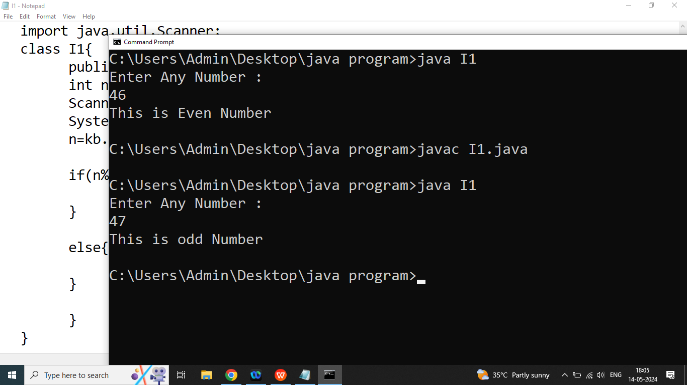

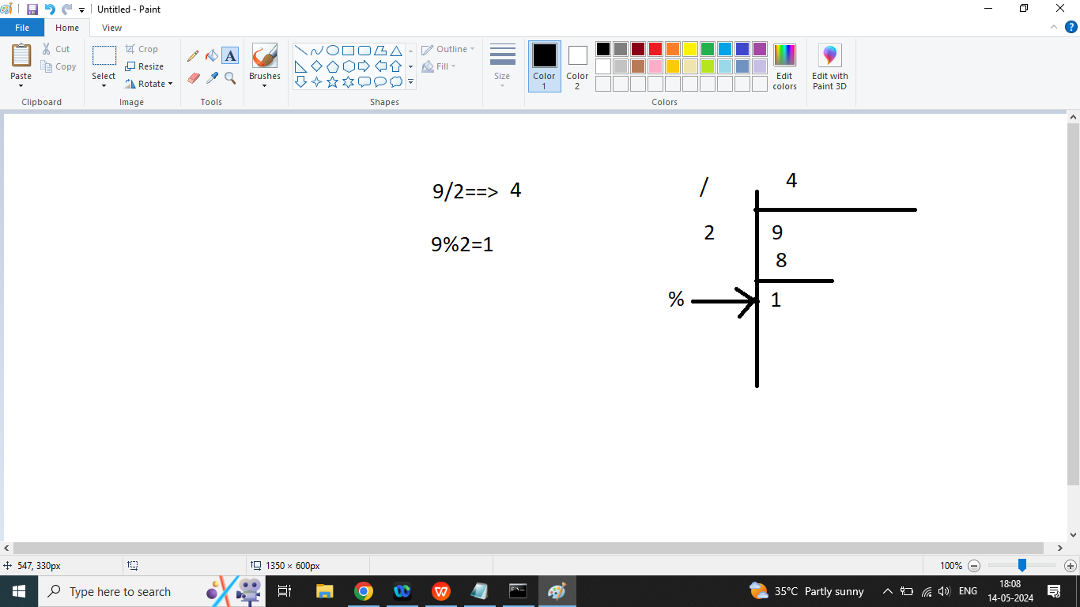

Q3. Explain else if statement in java programming?

Ans: if we have more than two possibilities and we want to execute only one at a time then we should go for else if statement else if statement depends on if

|  |
| --- |
| Syntax:  if(condition1){  //statement 1  }  else if(condition2){  // statement 2  }  else if(condition 3){  //statement 3  }  else{  //statement 4  } |

Q2. Write a java program to check given character is UpperCase, LowerCase, digits or special character

Enter Any Character: b

It is lowercase character

Enter Any Character: B

It is Upper Case Character

Enter Any character : 7

It is Digits

Enter Any character : %

It is special character

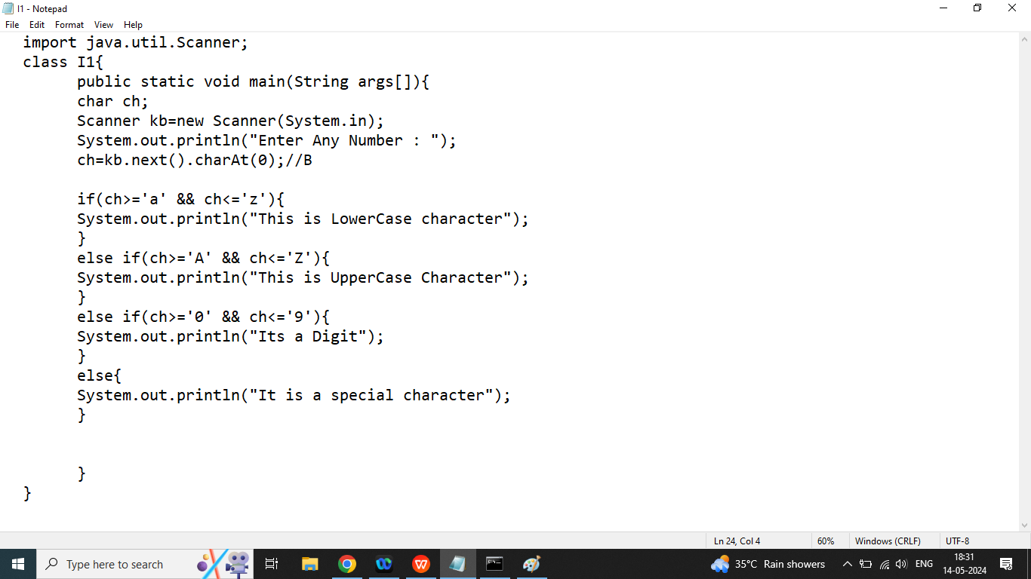

Day 11

Q1. Write a java program to check given character is vowel or not?

Enter Any Character : K

It is not a vowel

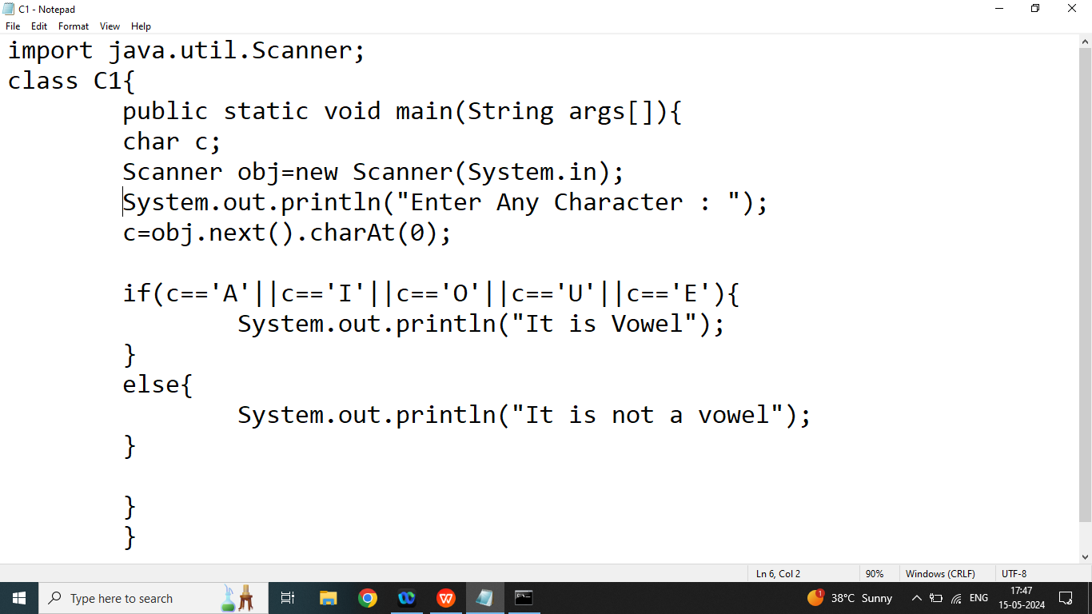

Q2. Explain Nested in in java programming?

Ans:

If we are using if inside another if or else if is also known as nested if.

Syntax:

|  |
| --- |
| if(condition1){//97>65  if(condition1_1){  //statement1_1  }  }  else if(condition2){  if(condition2_2){  //statement2_2  }  } |

Q3. Write a java program to check given character is Upper Case or Lowercase using nested if.

OR

Write a java program to check given character is Upper case or lower case without using logical operator?

import java.util.Scanner;

//step1:

class C1{

public static void main(String args[]){

char c;

Scanner obj=new Scanner(System.in);

//step2

System.out.println("Enter Any Character : ");

//step3

c=obj.next().charAt(0);

if(c>='a'){//condition1// 97>65

if(c<='z'){//condition1_1

System.out.println("lower Case");

}

}else if(c>='A'){//condition2

if(c<='Z'){//condition2_2

System.out.println("Upper Case");

}

}

}

}

Q3. Explain Switch Statement in java programming?

Ans:

Switch is also used to select one option out of multiple conditions.

Syntax:

|  |
| --- |
| switch(constant/variable/Expression/function call){  case constant/expression:  //statement  break;  case constant/expression:  //statement  break;  case constant/expression:  //statement  break;  case constant/expression:  //statement  break;  default:  //statement  } |

Note : In switch we cannot define duplicate case

Q2. Write a java program to check given character is vowel or not without using logical and relational operators

OR

Write a java program to check given character is vowel or not using switch.

import java.util.Scanner;

//step1:

class C1{

public static void main(String args[]){

char c;

Scanner obj=new Scanner(System.in);

//step2

System.out.println("Enter Any Character : ");

//step3

c=obj.next().charAt(0);

switch(c){

case 'a' :

case 'A':

System.out.println("It is vowel");

break;

case 'e' :

case 'E':

System.out.println("It is vowel");

break;

case 'i' :

case 'I':

System.out.println("It is vowel");

break;

case 'o' :

case 'O' :

System.out.println("It is vowel");

break;

case 'u' :

case 'U':

System.out.println("It is vowel");

break;

default:

System.out.println("it is not a vowel");

}

}

}

Homework

Q1. Write a java program to create basic calculator using switch or else if?

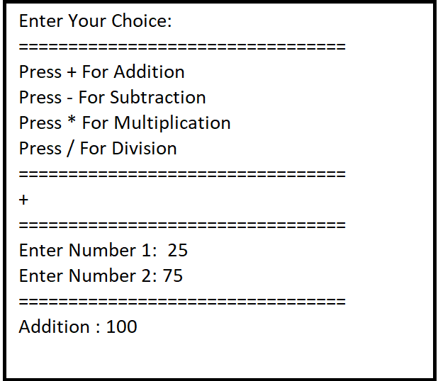

Day 12

Q1.Basic Calculator Using Java?

import java.util.Scanner;

class Calc{

public static void main(String args[]){

Scanner sk=new Scanner(System.in);

System.out.println("Enter Your Choice : ");

System.out.println("=========================");

System.out.println("Press + For Addition : ");

System.out.println("Press - For Subtraction : ");

System.out.println("Press * For Multiplication : ");

System.out.println("Press / For Division : ");

System.out.println("=========================");

char ch=sk.next().charAt(0);

System.out.println("=========================");

System.out.println("Enter Number 1 : ");

int n1=sk.nextInt();

System.out.println("Enter Number 2 : ");

int n2=sk.nextInt();

System.out.println("=========================");

switch(ch){

case '+':

System.out.println("Addition : "+(n1+n2));

break;

case '-':

System.out.println("Subtraction : "+(n1-n2));

break;

case '*':

System.out.println("Multiplication : "+(n1*n2));

break;

case '/':

System.out.println("Division : "+(n1/n2));

break;

default:

System.out.println("Invalid Operation");

}

}

}

Q2. Explain Looping statement in java programming?

Ans: if we want repeat something then we should go for loop in java programming

Loop Related Terms

Start(Initialization): only once

Example: I want to print number from 1 to 5

1

2

3

4

5

int x;

x=1;//Initialization

End(Test Condition):every time before loop statement executing

Example: I want to print number from 1 to 5

1

2

3

4

5

int x;

x=1;//Initialization

x<=5;// <,<= Increment

Increment /decrement

x++;

1. Start(Initialization): only once

Example: I want to print number from 1 to 5

5

4

3

2

1

int x;

x=5;//Initialization

End(Test Condition):every time before loop statement executing

Example: I want to print number from 1 to 5

5

4

3

2

1

int x;

x=5;//Initialization

x>=1;// >,>= Decrement

Increment /decrement

x--

* Initialization
* Test Condition
* Increment /decrement

Q2. Explain Types of Loop in java programming?

Ans: There are two types loop available in java

1. Entry Controlled Loop

Example: while,for

1. Exit Controlled

Example: do while

Purpose of

1. While: if we don’t know exact number of Iteration then we should go for while loop.
2. for: if we have a exact number of Iteration then we should go for , for loop
3. do while: If I want to execute loop at least once if given condition is false, then we should go for do while loop.

Q3. Explain while, do while, for loop in java programming?

Ans:

1. While Loop:

Syntax:

|  |
| --- |
| **Initialization**  while(**Test Condition**){  //statement  **Increment / decrement**  } |

1. Do while Loop:

Syntax:

|  |
| --- |
| **Initialization**  do{  //statement  **Increment / decrement**  }while(**Test Condition**); |

1. For Loop:

|  |
| --- |
| for(Initialization(1); Test Condition(2); Increment / Decrement(4)){  //statement(3)  } |

Q2. Write a java program to print number from 1 to 5 using while loop, do while loop, for Loop?

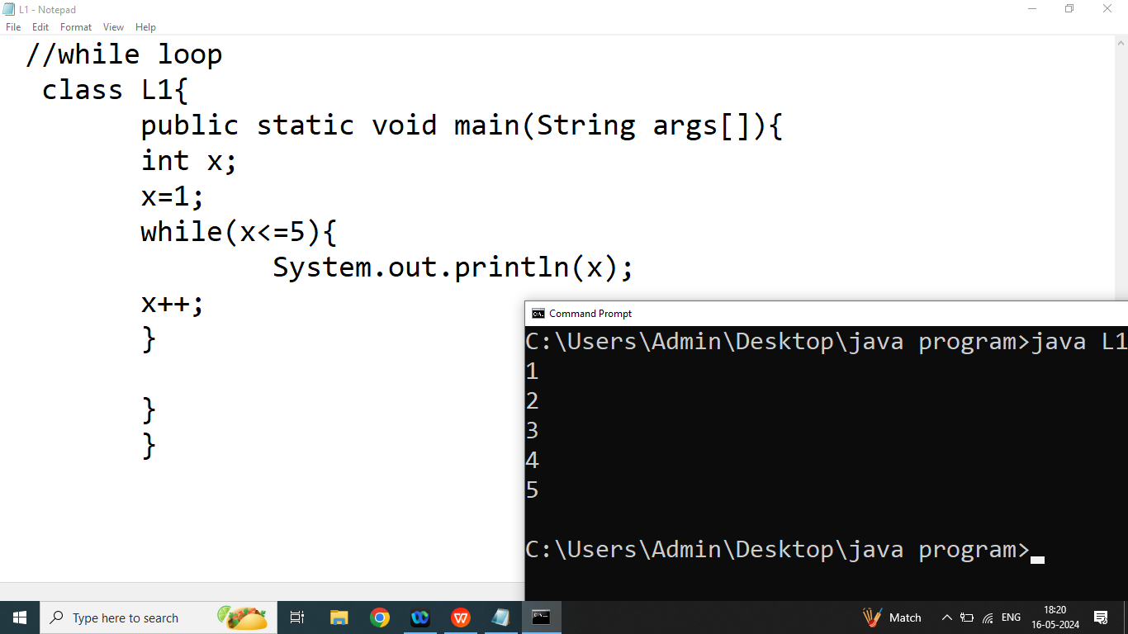

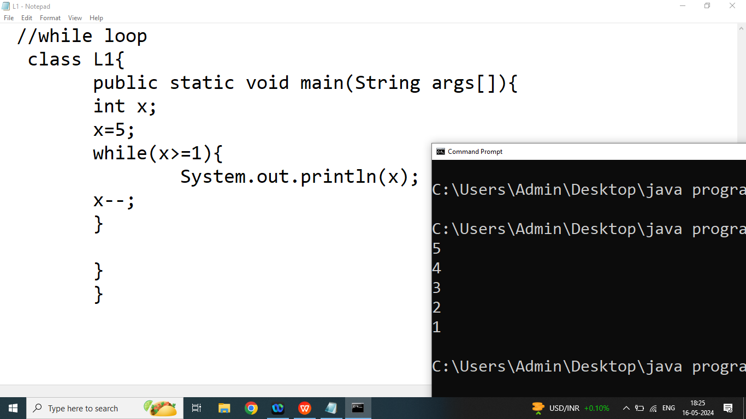

Day 13

Q1. Write a java program to print even number from10 to 20.

10 12 14 16 18 20

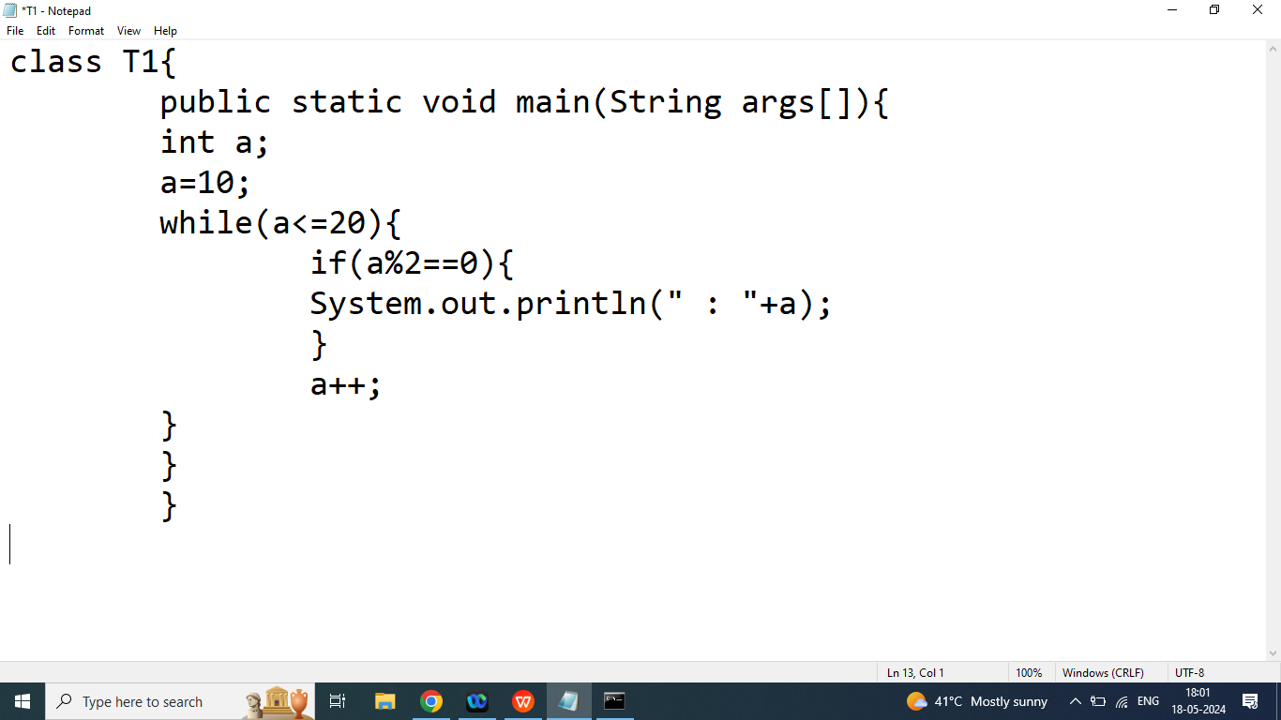

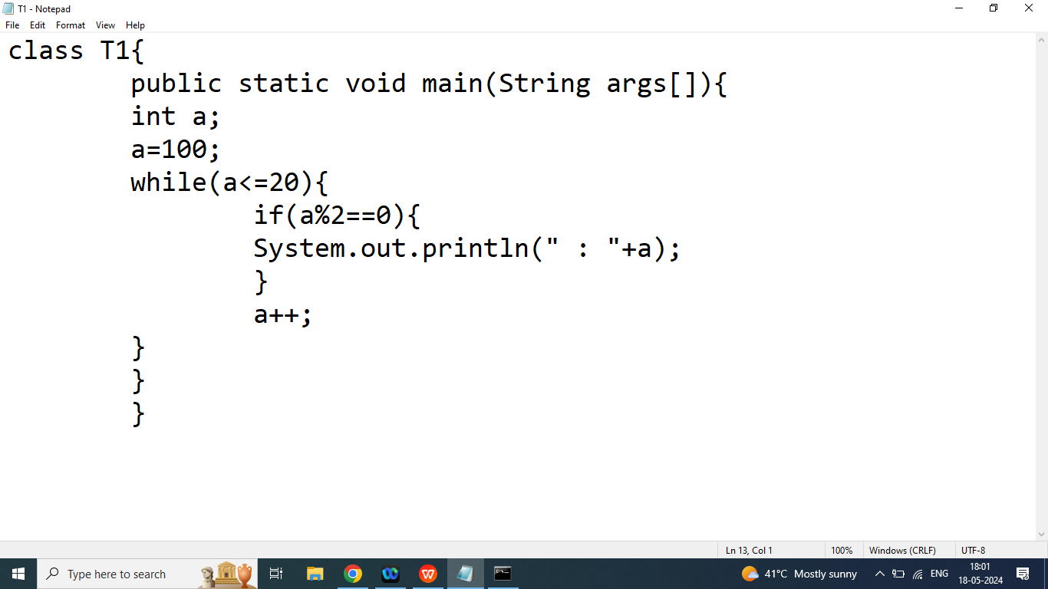

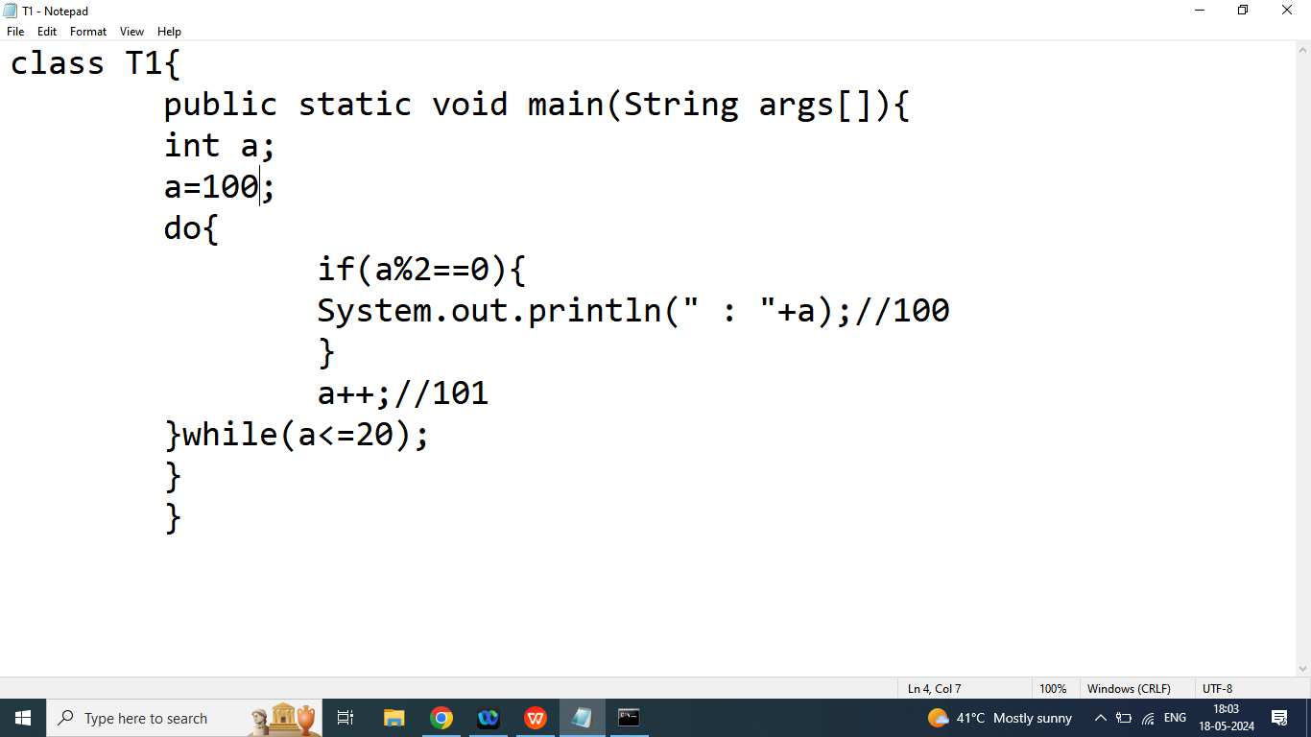

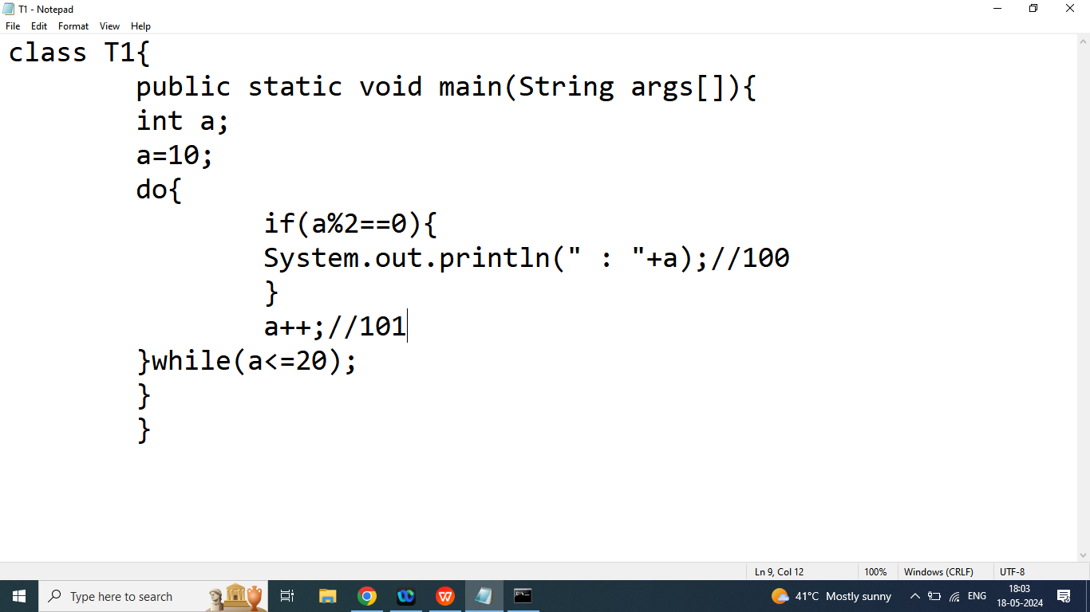

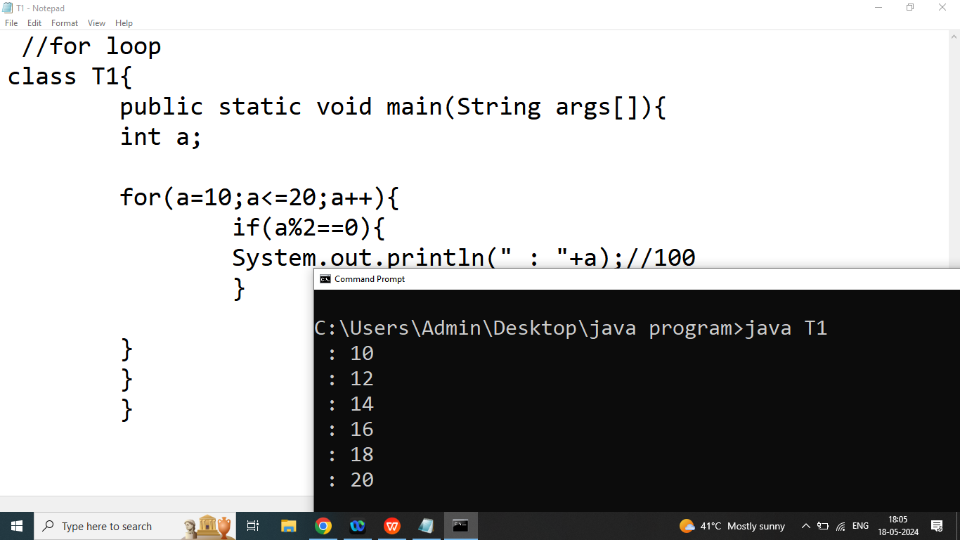

Q2. Write a java program to print table of given Number

Enter Any Number : 2

2 4 6 8 10 12 14 16 18 20

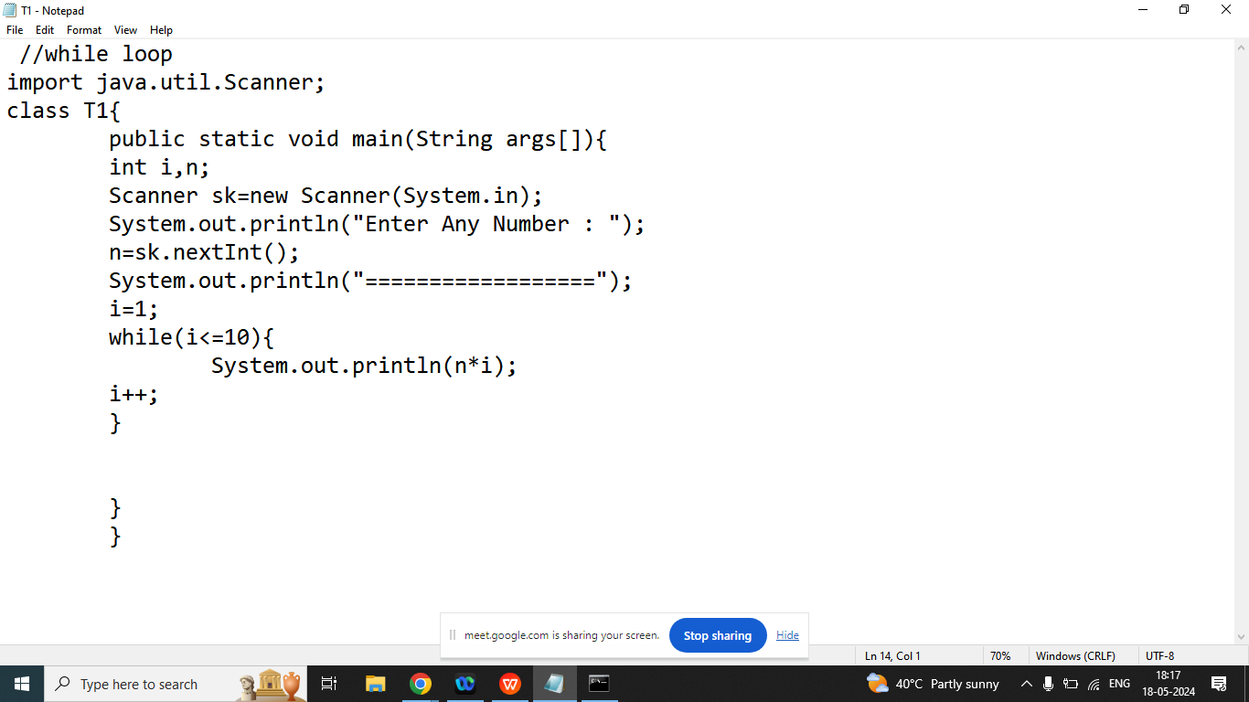

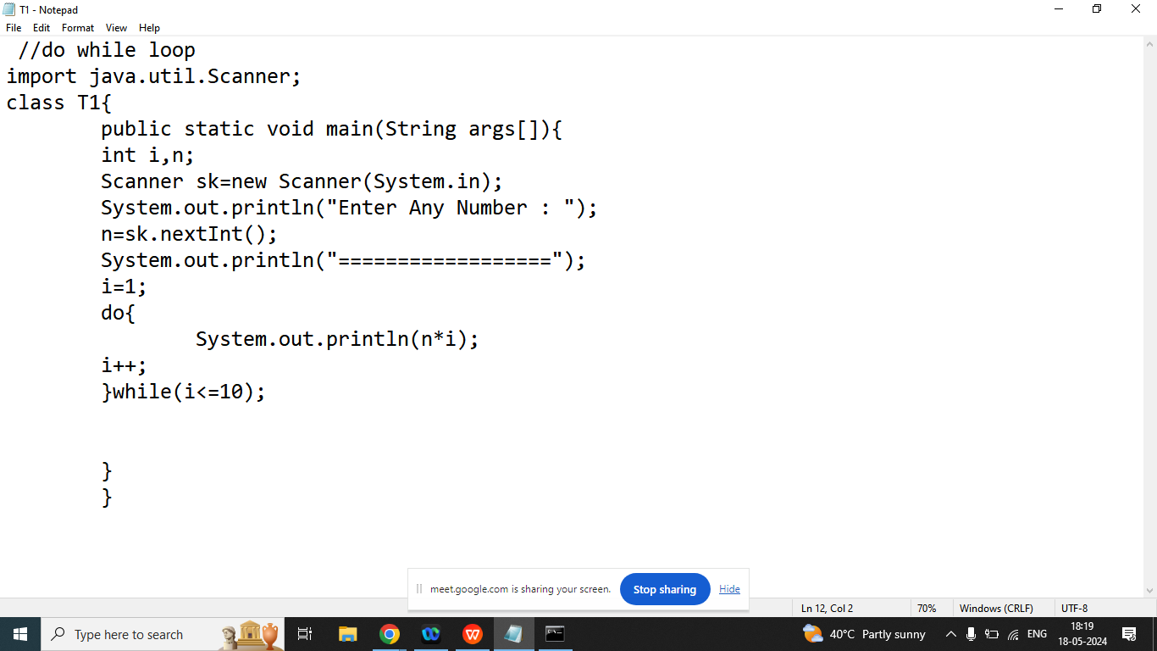

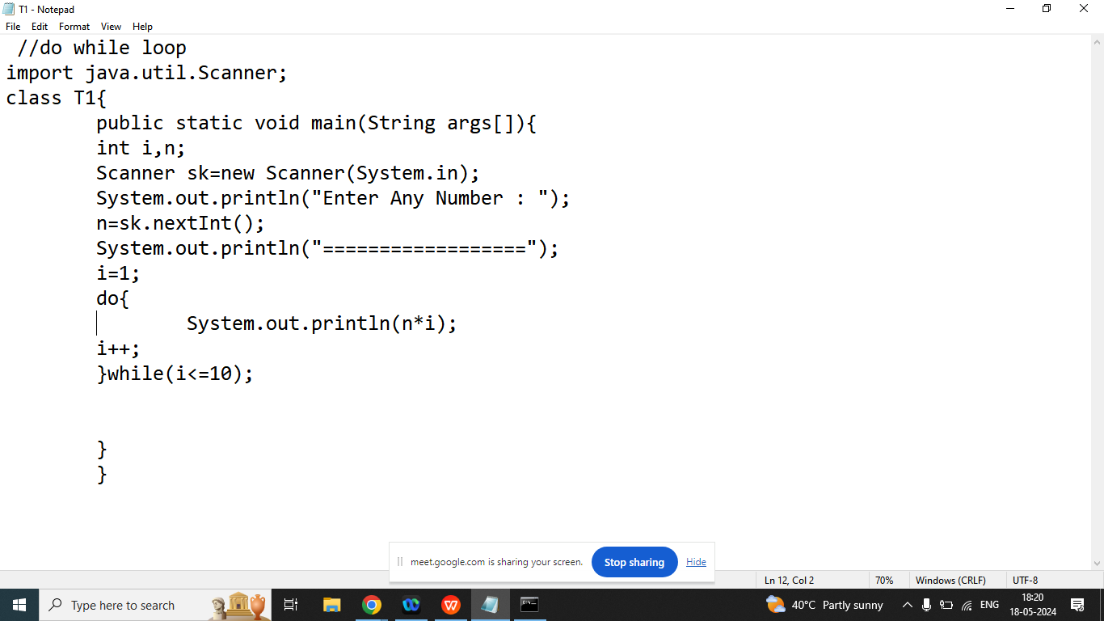

Q3. Write a java program to print Number from 50 to 100 which is divisible by 5 using while, do while, for loop?

50 55 60 65 70 75 80 85 90 95 100

Day 14

Date

import java.util.Calendar;

class Solution {

public String dayOfTheWeek(int day, int month, int year) {

String s = "";

int t[] = {0, 3, 2, 5, 0, 3, 5, 1, 4, 6, 2, 4};

if (month < 3) year -= 1;

int i = (year + year/4 - year/100 + year/400 + t[month-1] + day) % 7;

//i= (2019+504-20+5+1+31)%7

switch (i) {

case 1: s = "Monday"; break;

case 2: s = "Tuesday"; break;

case 3: s = "Wednesday"; break;

case 4: s = "Thursday"; break;

case 5: s = "Friday"; break;

case 6: s = "Saturday"; break;

case 0: case 7: s = "Sunday"; break;

default: ;

}

return s;

}

}

================

AlternateDigit Sum

class Solution {

public int alternateDigitSum(int n) {

int k = 1, sum = 0;

while(n>0){//0

int r=n%10*k;

sum=sum+r;//sum=-1+5=4

n=n/10;//0

k=k*-1;//k=-1

}

return -k * sum;

}

}

Day 15

Q1.Explain break statement in java programming?

Ans: if we want to exit from the loop or switch then we should go for break

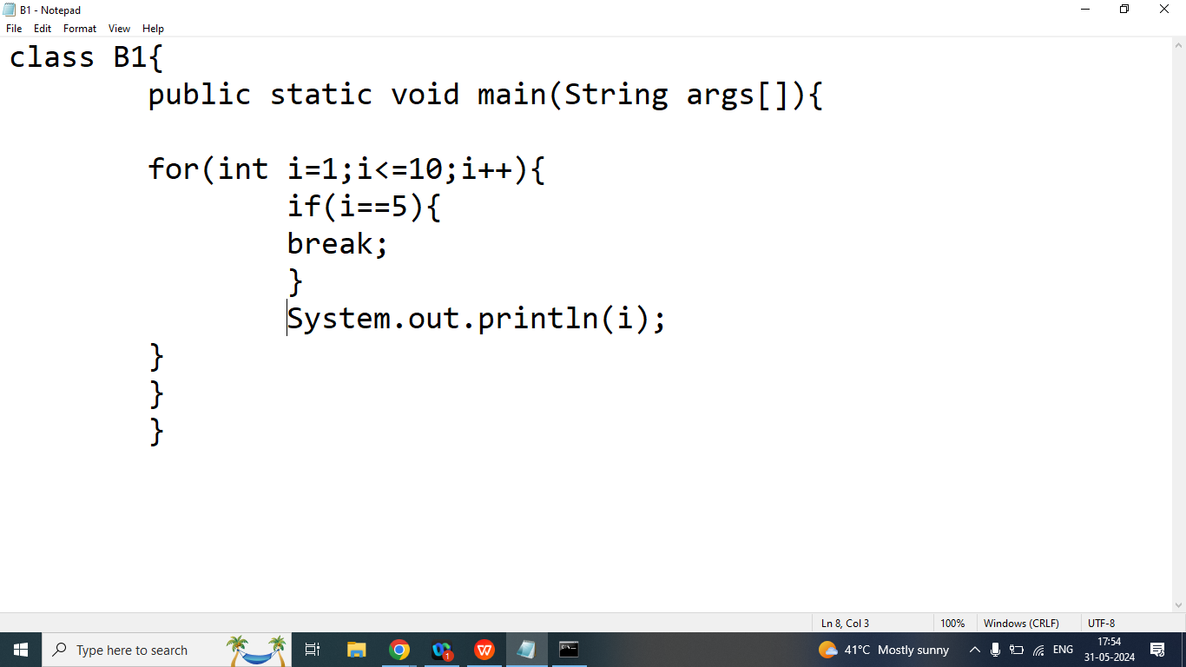

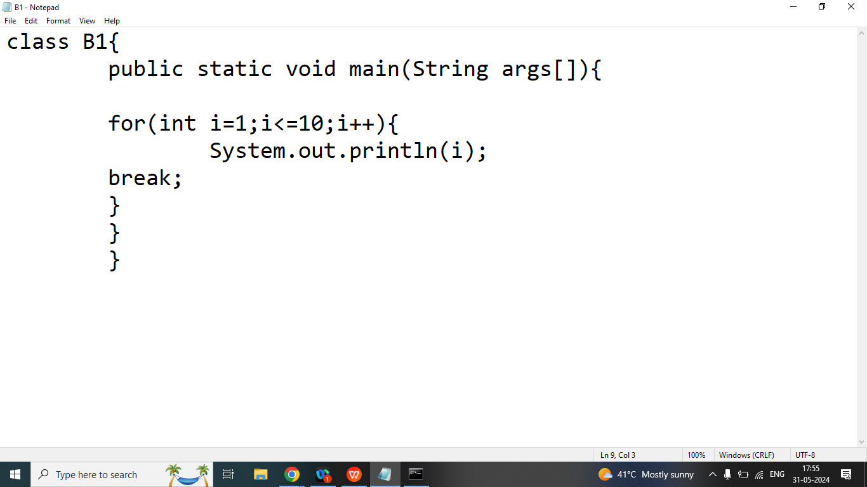

Q2. Explain continue statement in java programming?

Ans: if we want to exit from the current iteration then we should go for continue statement.

continue statement only work with loop.

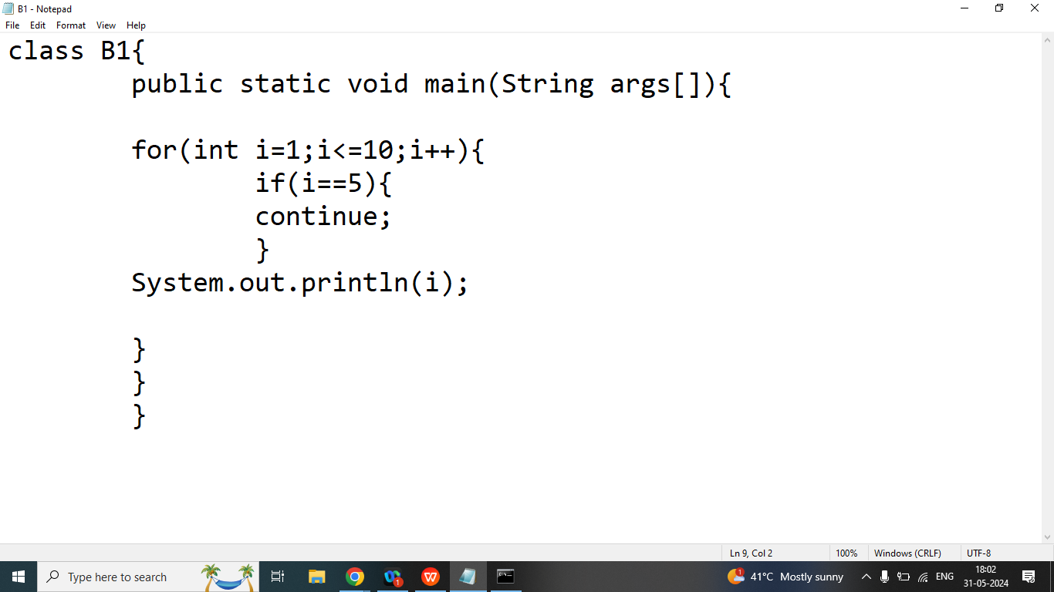

class A1{

public static boolean isPrime(int n){

int count=0;

for(int i=1;i<=n;i++){

if(n%i==0){

count++;

}

}

if(count==2){

return true;

}

else{

return false;

}

}

public static void main(String args[]){

int n=10;

int countp=0;

for(int i=1;i<=n;i++){

if(isPrime(i)){

countp++;//

}

}

System.out.println(countp);

}

}

Day 16

Q1.Explain String class in java programming?

Ans:

String is a Pre-defined class present in java.lang package

String is Immutable class

If our content are fixed and we won’t perform any modification then we should go for String class.

|  |
| --- |
| String class provides different ways to create string, 13 way to create construct string some of the way are  **example**  Char[] name={‘A’,’B’,’c’};  String myString=new String(name);  To making string using existing string  String email=[shani@gmail.com](mailto:shani@gmail.com);  String MyNewString=new String(email); |
| The way equalivent to be second way  String personalEmail=new String(“nybane@gmal.com”);  Java provides to different storage area to work with String  String pool and second is heap memory  When we createing string using double quotes then that string will store in String pool  When we create string using new operator then that string will store in heap memory |
| String are immutable. Means once created it can not be changed.  The sequence of character that is representing the string can not be changed |
| String should never be checked for equality using the equl to operator |
| As String as a class it contain multiple method to work with string  1)length();  2)this method will return number of character present in the string. |

**String class**

1. **String()**
2. **String(String str)**
3. **String(char array)**
4. **String(byte arr[],int start,int number of character)**

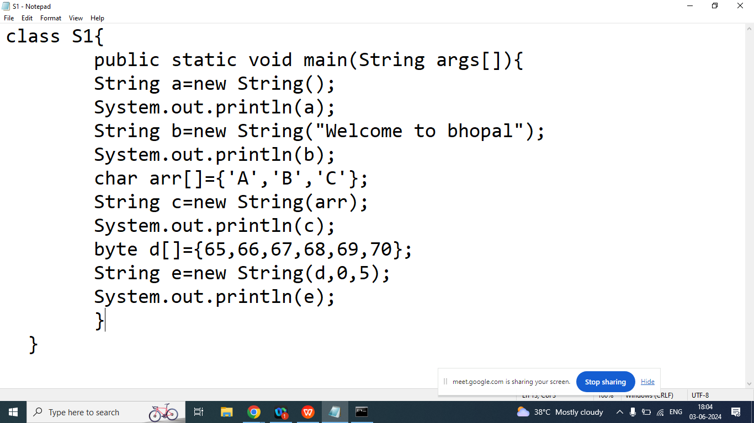

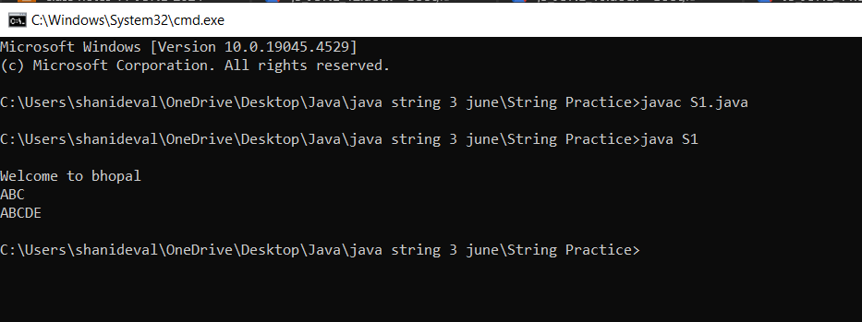

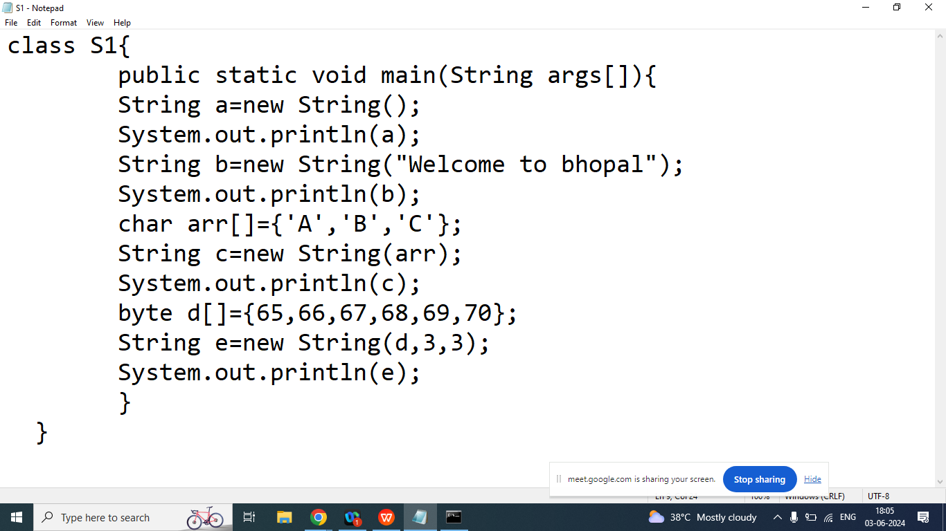

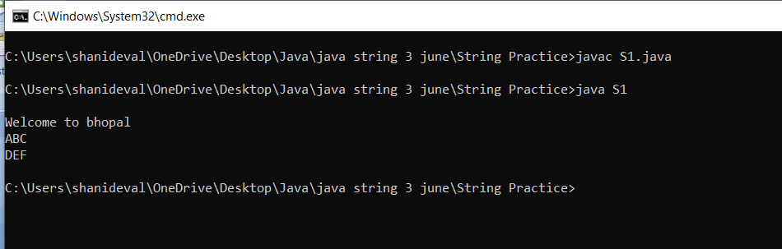

**String class Methods**

1. **charAt()**
2. **compareTo()**
3. **concat()**
4. **contains()**
5. **endsWith()**
6. **equals()**
7. **equalsIgnoreCase()**
8. **isEmpty()**
9. **indexOf()**
10. **lastIndexOf()**
11. **length()**
12. **split()**
13. **startsWith()**
14. **substring()**
15. **toCharArray()**
16. **trim()**
17. **valueOf()**

Q1. Explain String class **charAt()**method?

Ans: Return the character at the specified position

Syntax:

char charAt(int index);

Example:

String str=”Welcome”;

|  |  |  |  |  |  |  |
| --- | --- | --- | --- | --- | --- | --- |
| W | e | l | c | o | m | e |
| 0 | 1 | 2 | 3 | 4 | 5 | 6 |

char x=str.charAt(3);

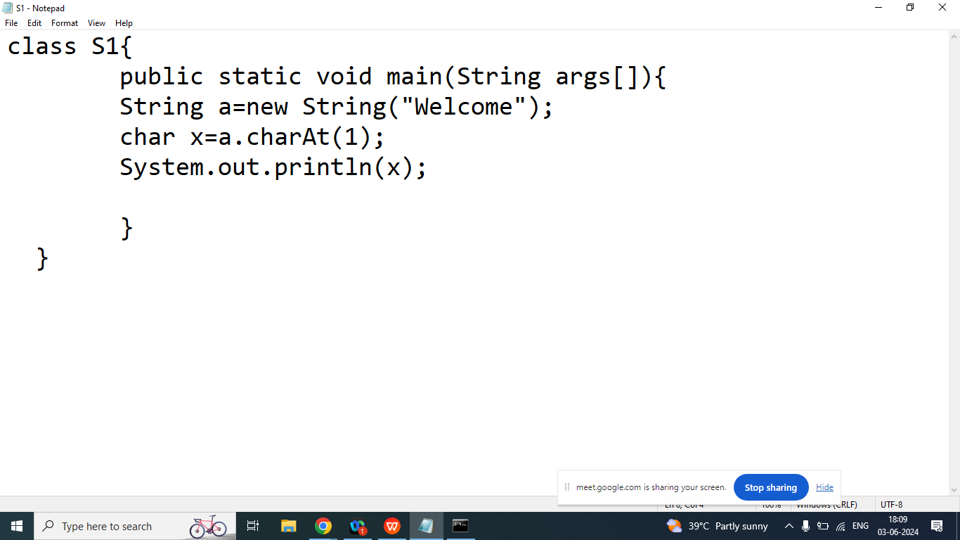

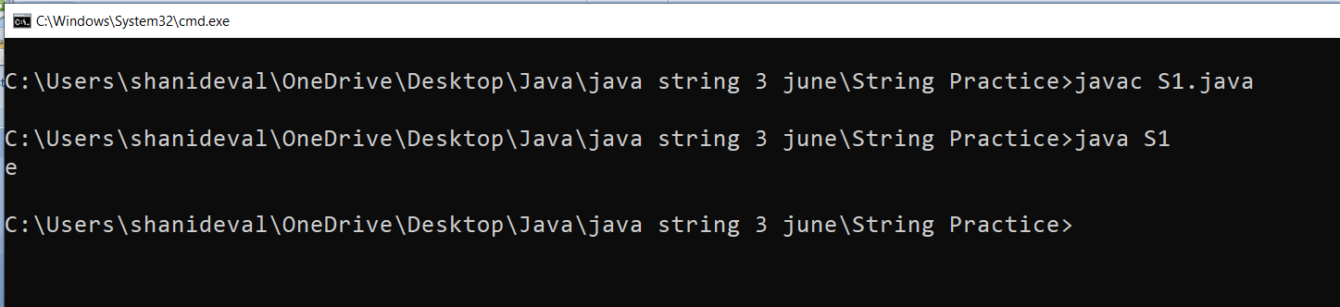

Q2. Explain String class **compareTo()** Method in java programming?

Ans:

It is used to compare two String on the basis of alphabetically order

Syntax:

int compareTo(String)

Example:

String s1=”a”;//97

String s2=”A”;//65

s1.compareTo(s2);: Return Positive value if s1>s2

s1.compareTo(s2);: Return Negative Value value if s1<s2

s1.compareTo(s2): Return 0 if s1 and s2 are equal

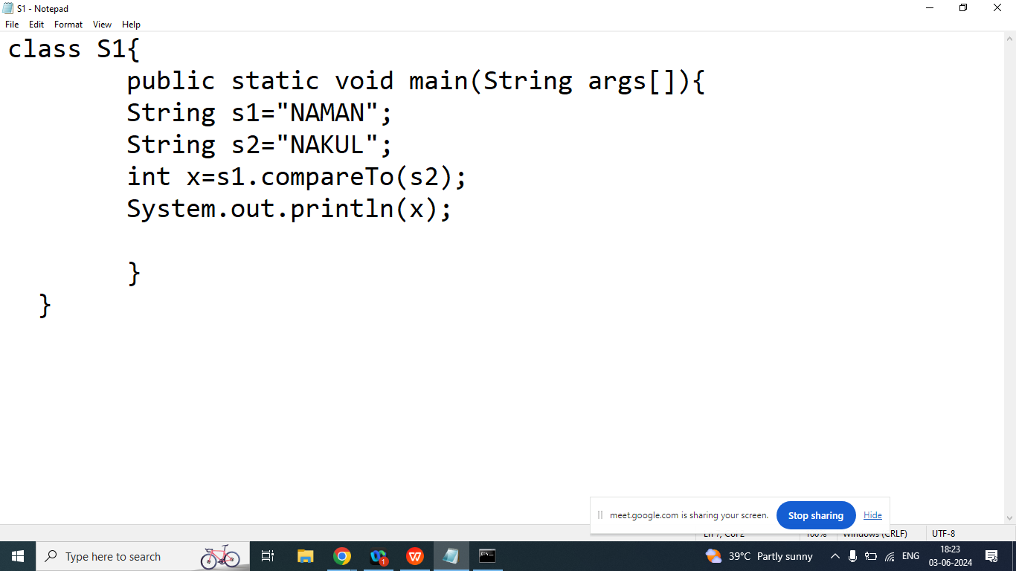

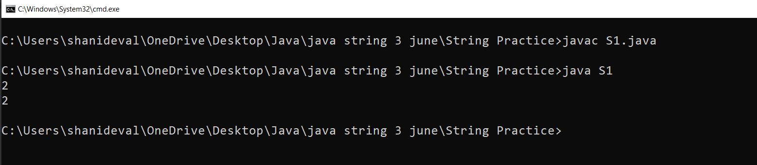

Q3. Explain String class **concat()** Method in java programming?

Ans:

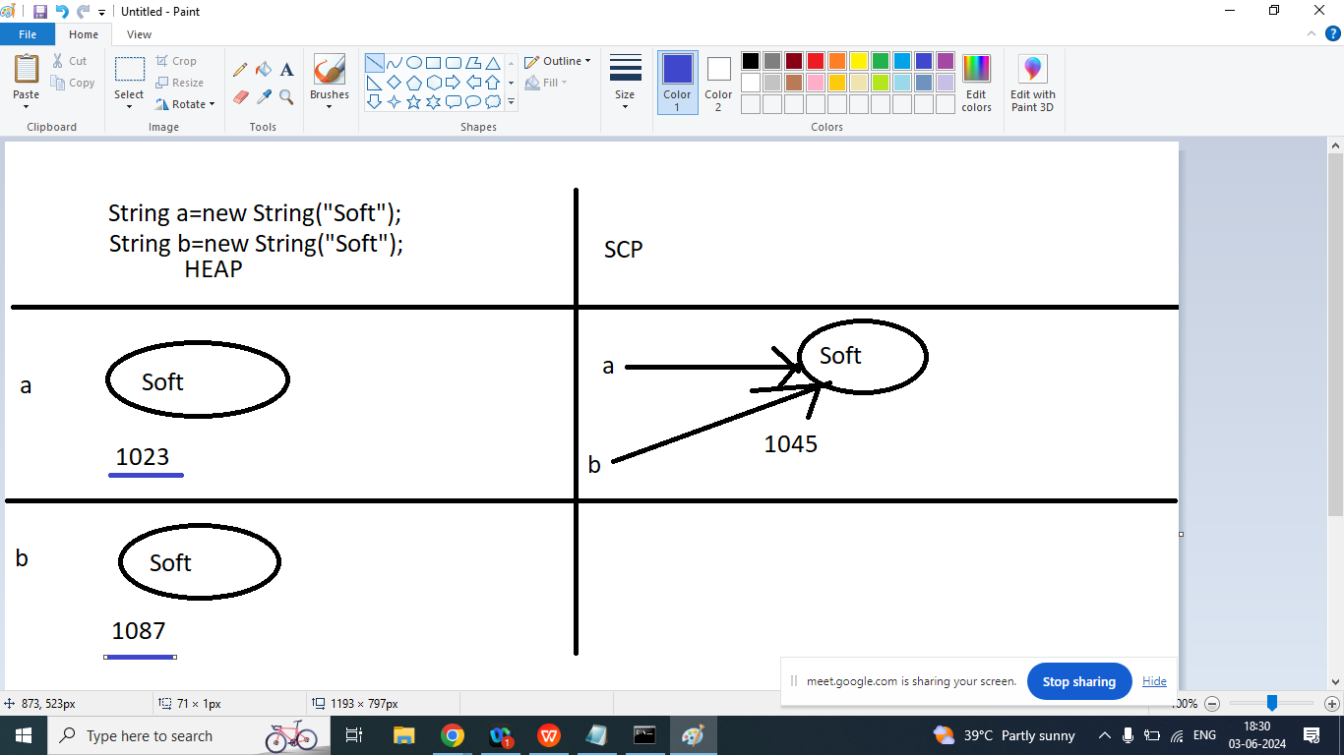

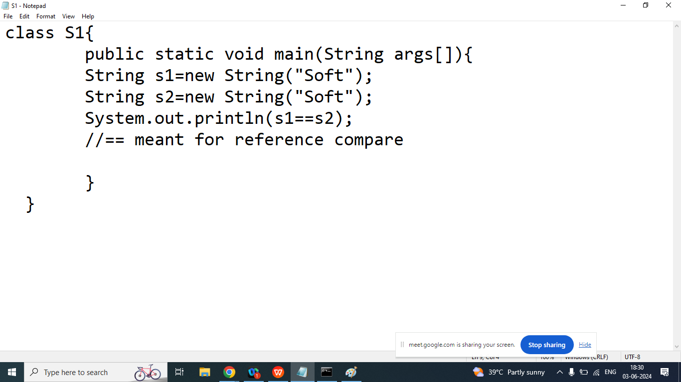

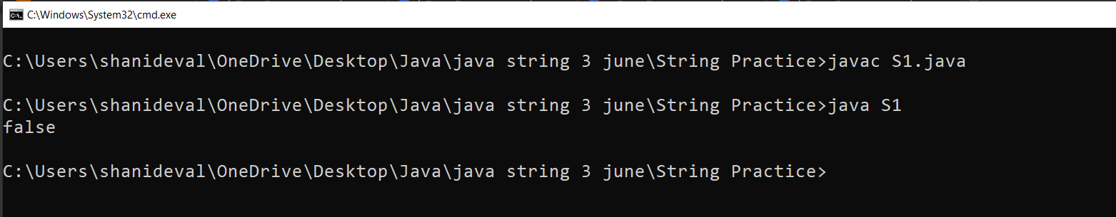

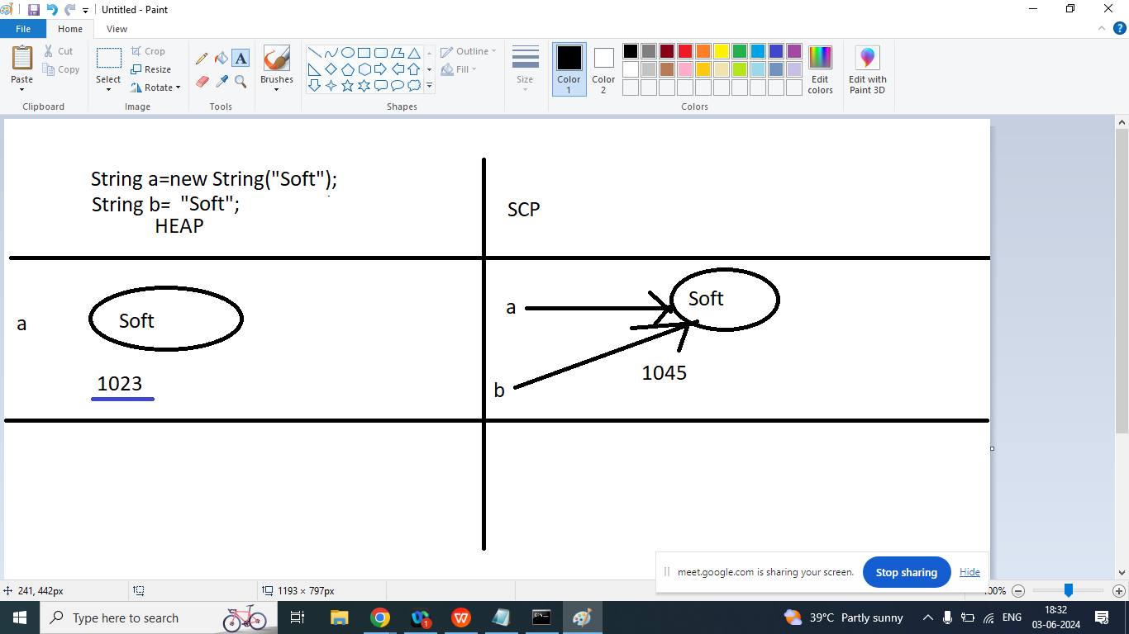

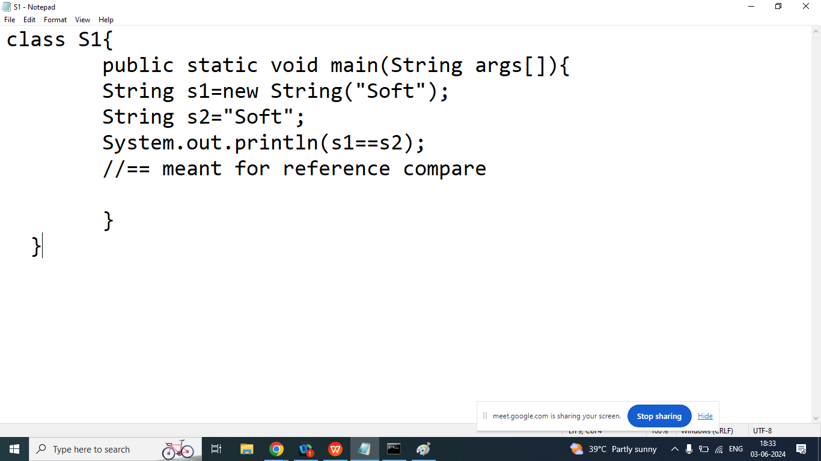



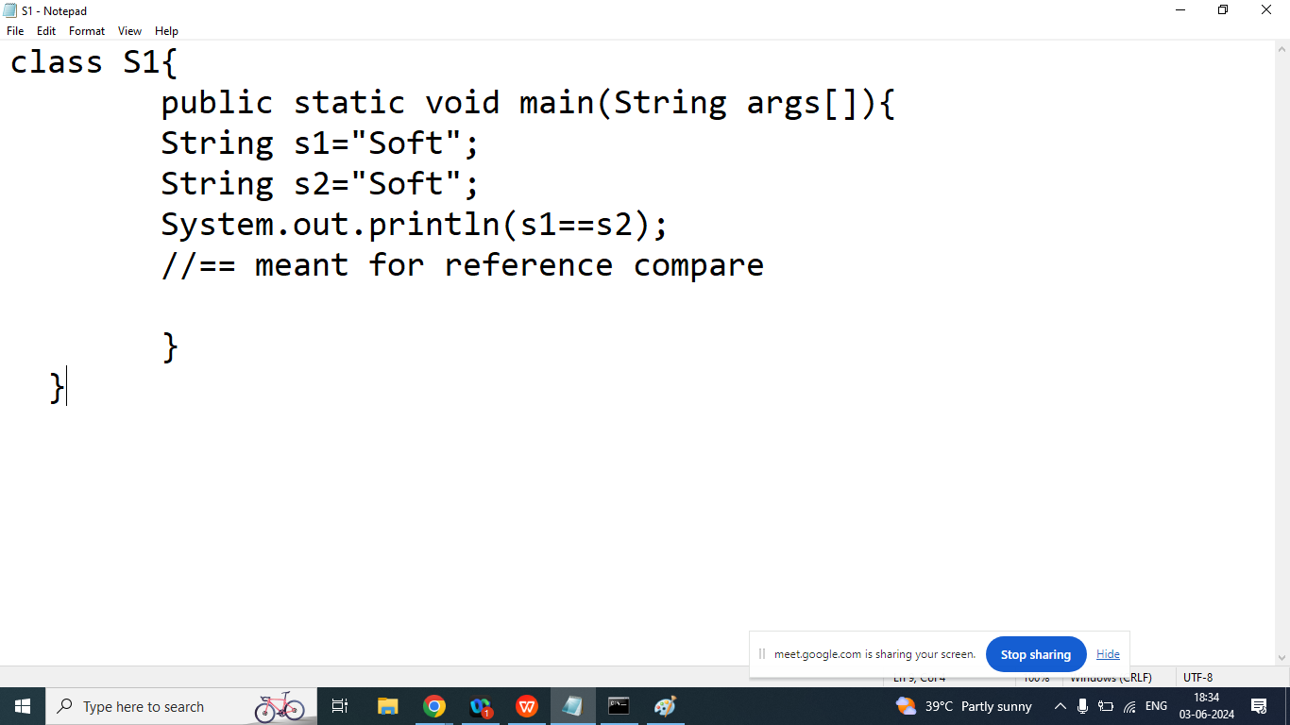

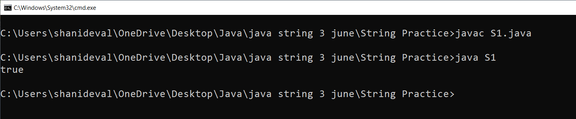

Day 17

Q6. Explain **== operator** and **equals()** method in java programming?

Ans:

== l meant for reference compare. If two object have a same reference then it will return true otherwise it will return false.

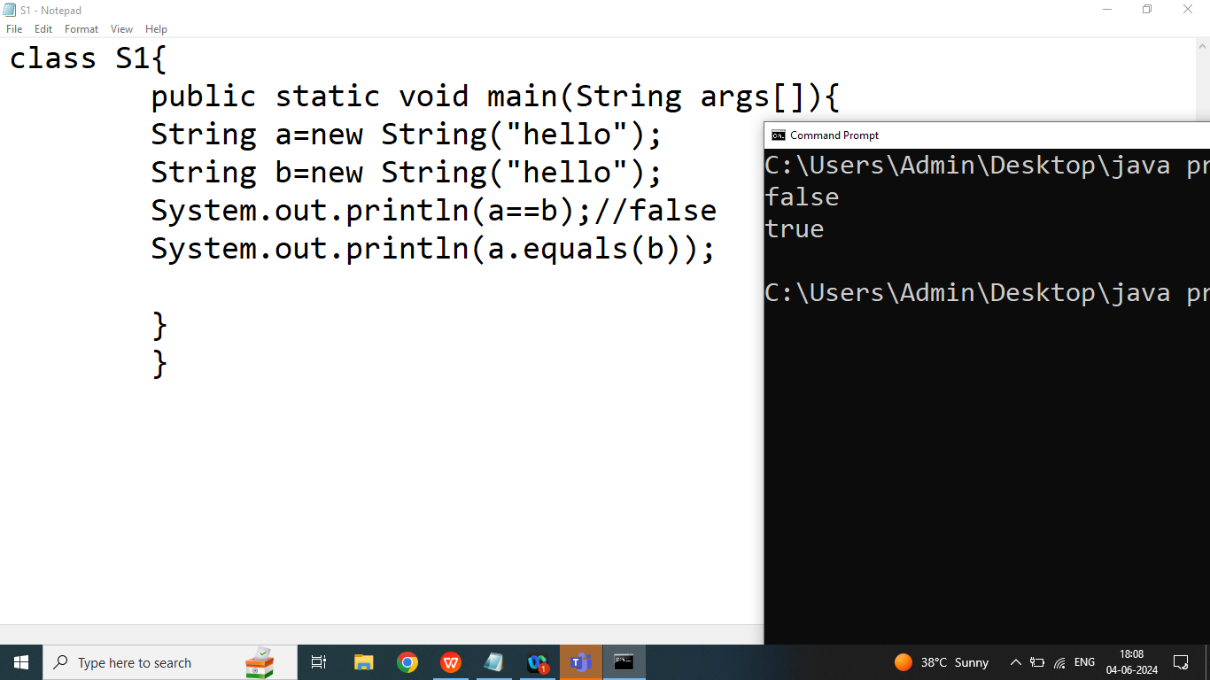

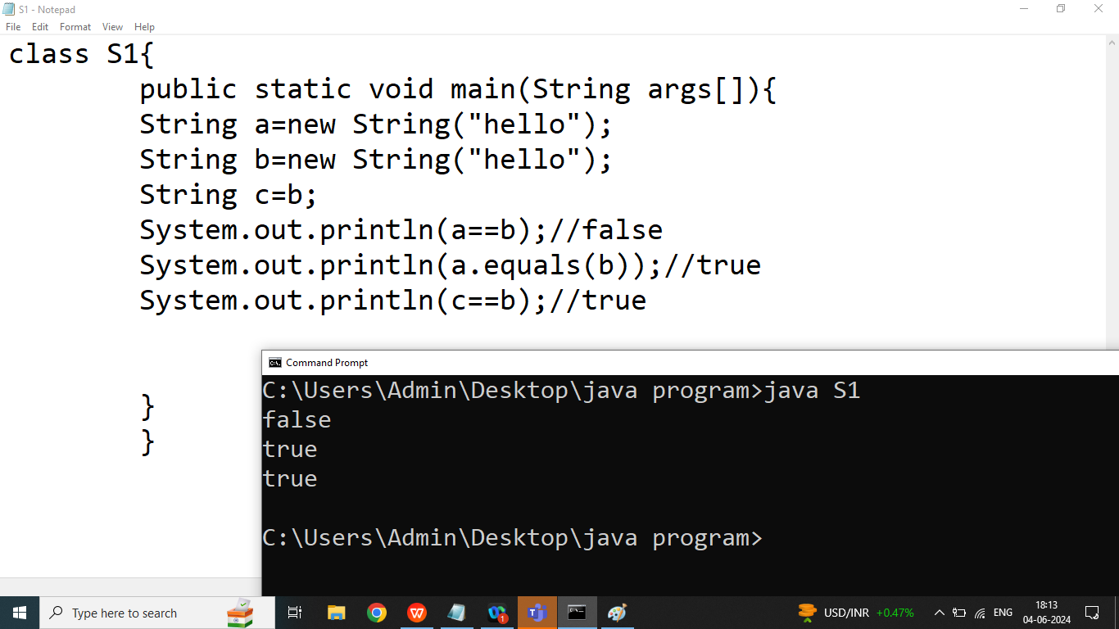

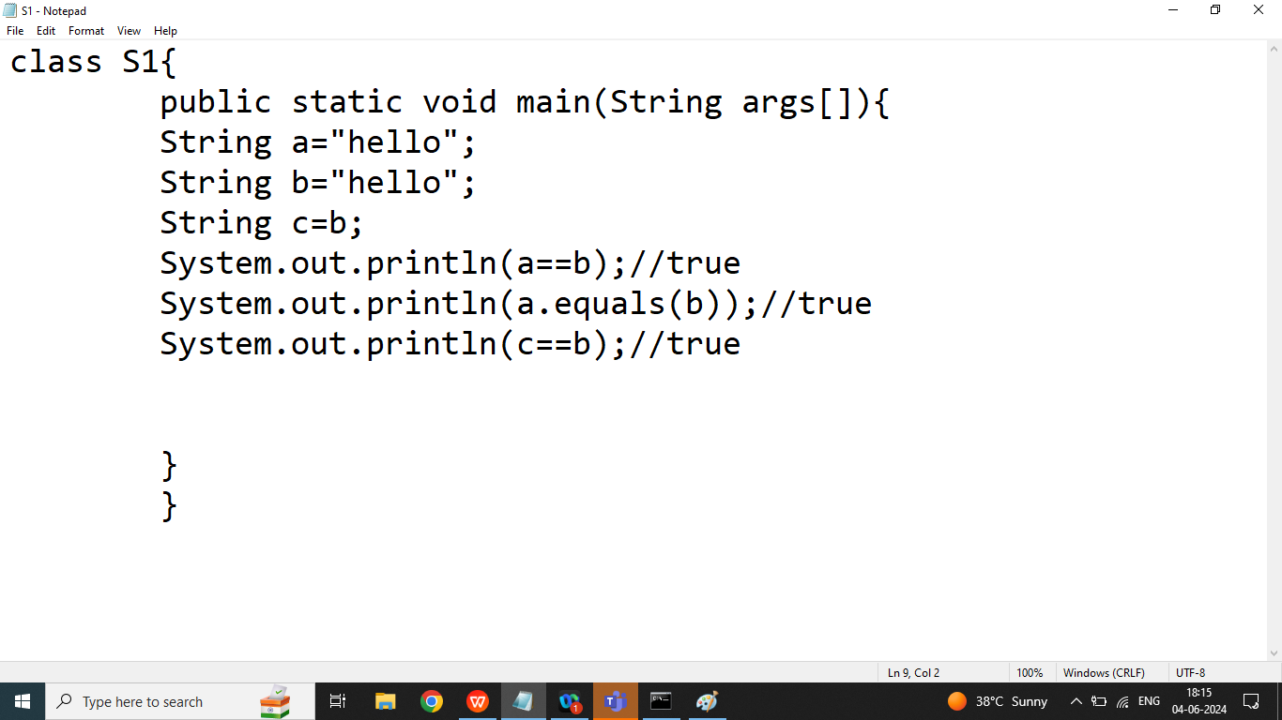

Q6,7. Explain String class equals() method and equalsIgnoreCase() method?

Ans:

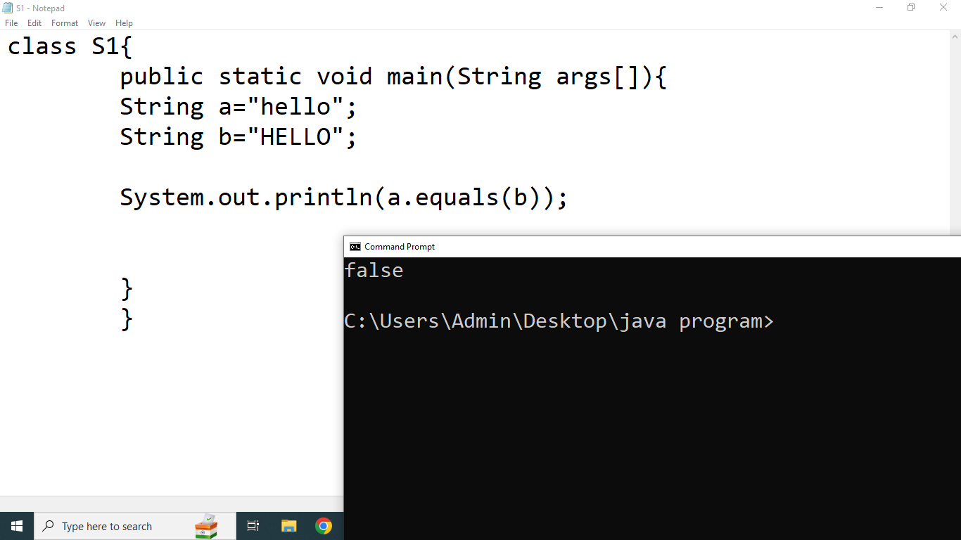

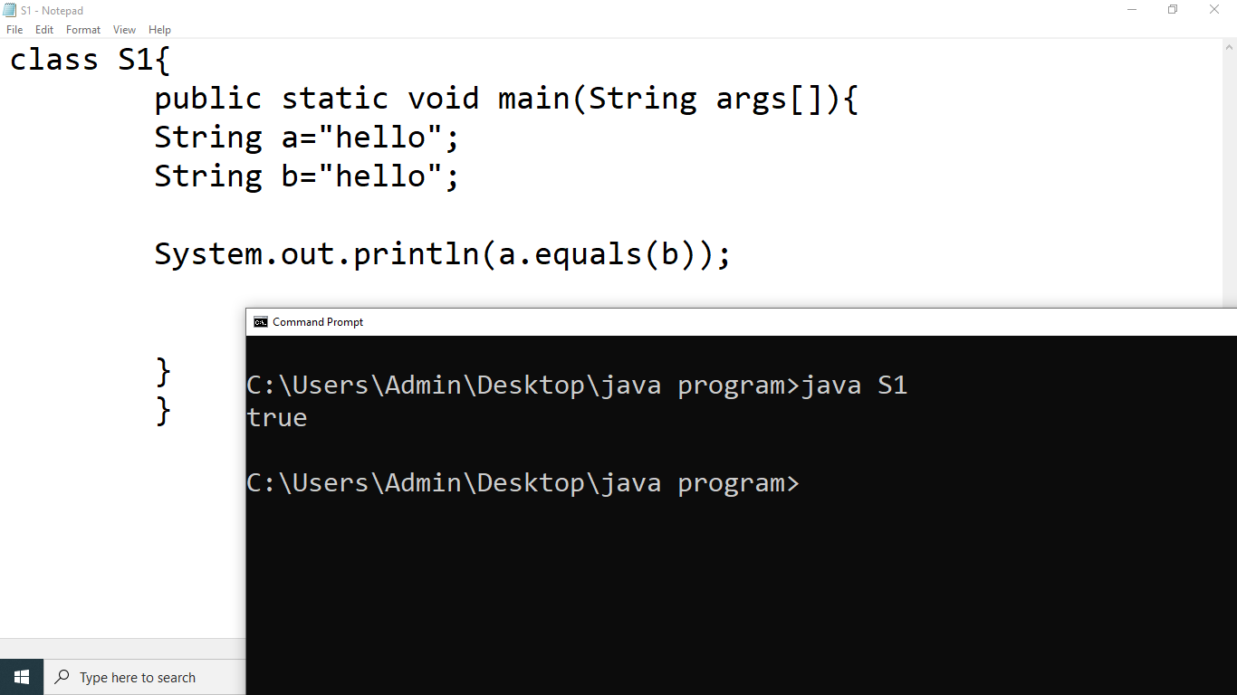

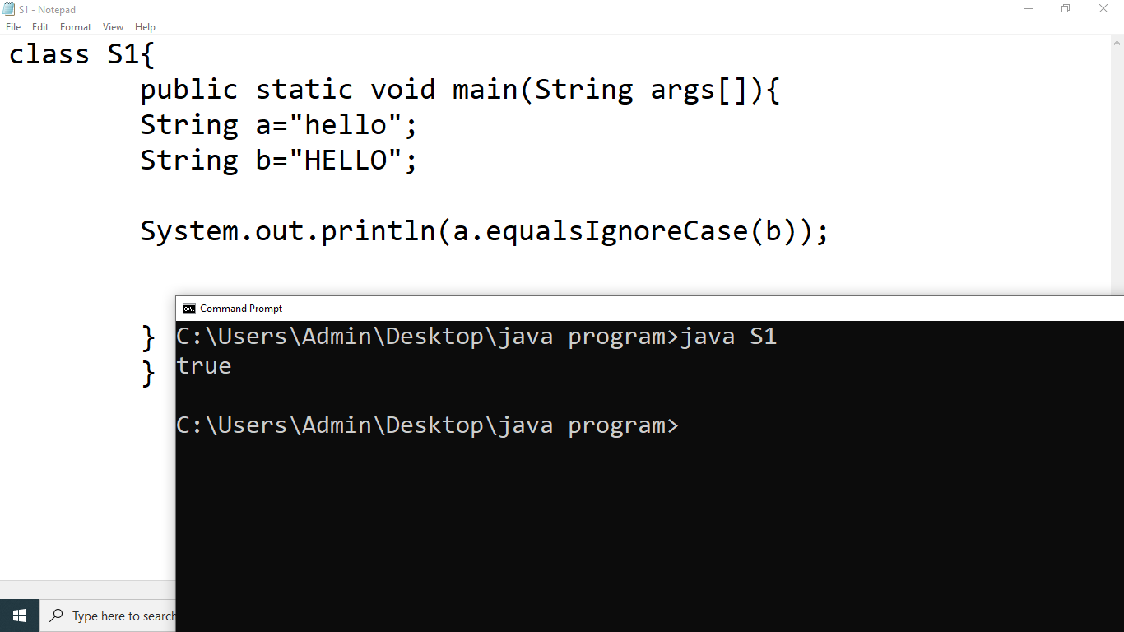

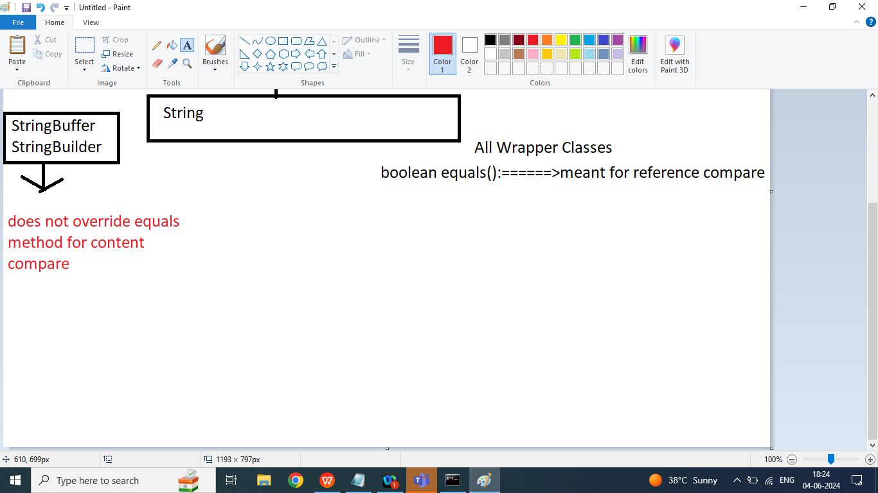

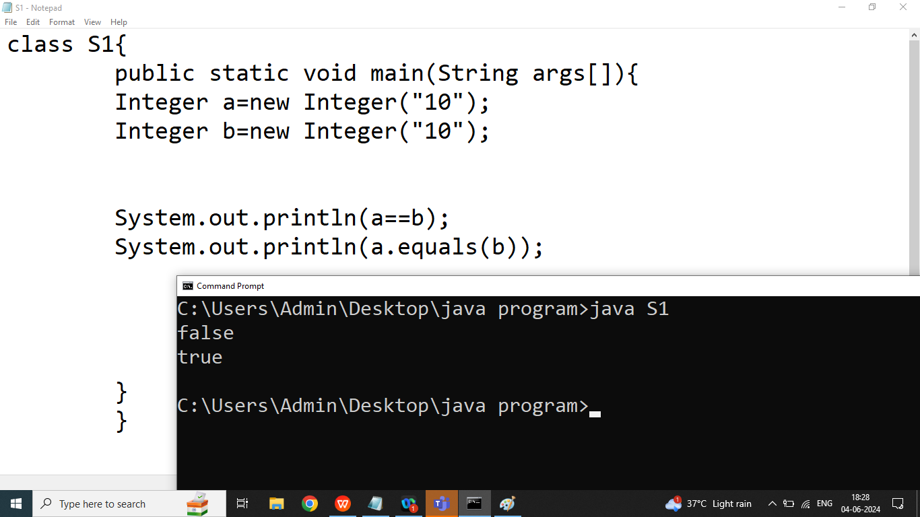

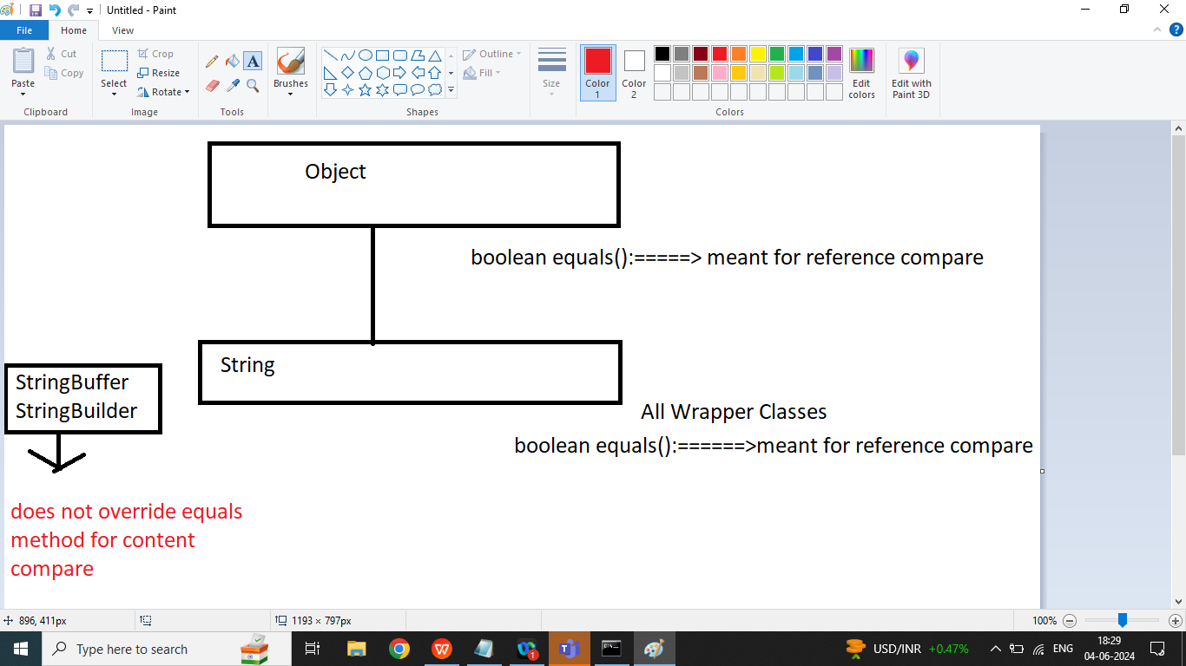

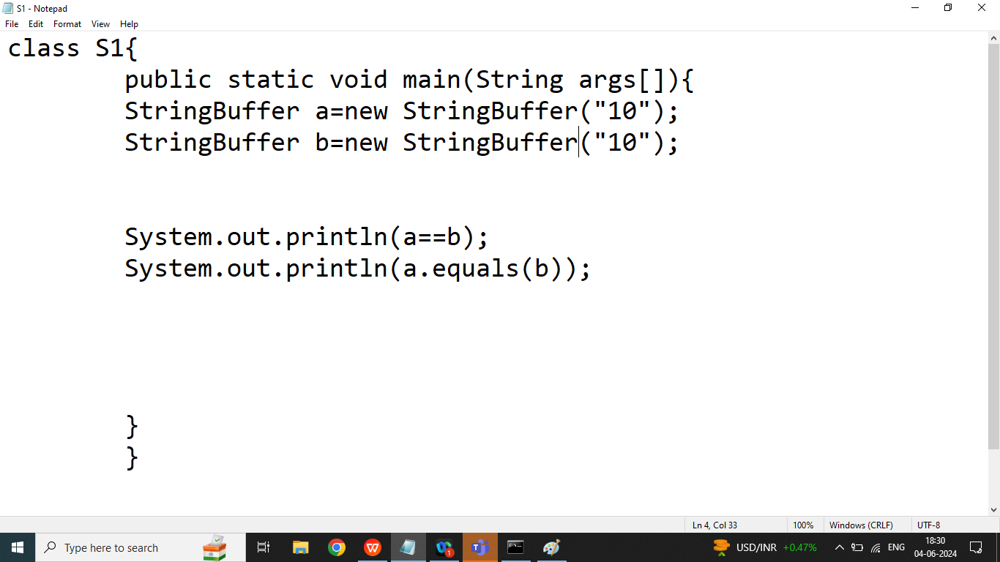

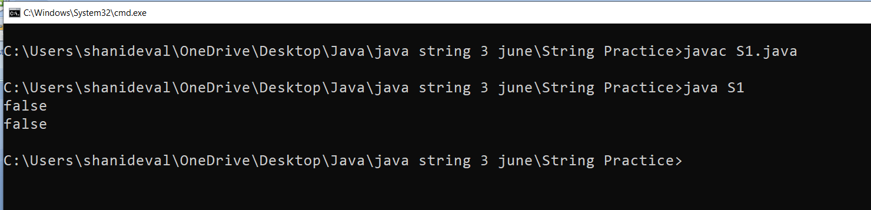

Q8.Explain String class isEmpty() method in java programming?

Ans:

It will return true if given String is empty otherwise it will return false.

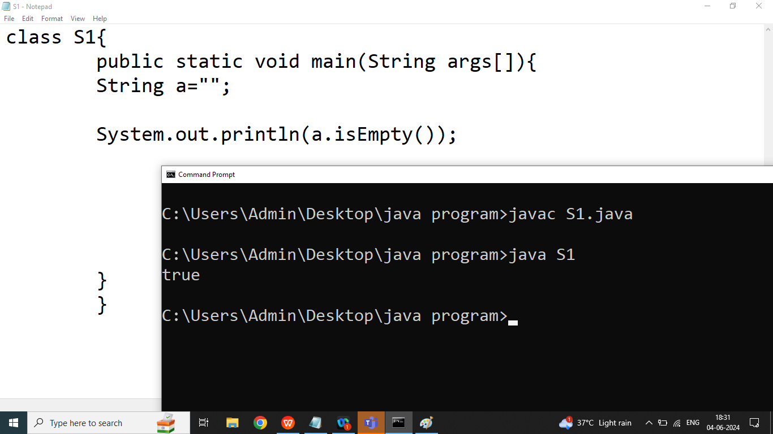

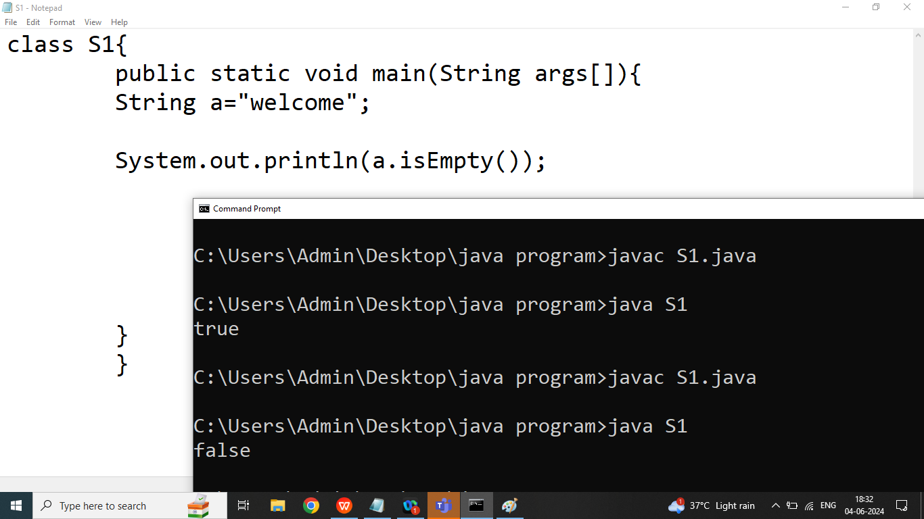

Q4. Explain String class contains()method in java programming?

Ans: Checks whether a String contains a sequence of character.

Syntax:

boolean contains(String);

Example:

String str=” Welcome to bhopal”;

Boolean b=str.contains(“to”);//true

Boolean x=str.contains(“java”);//false

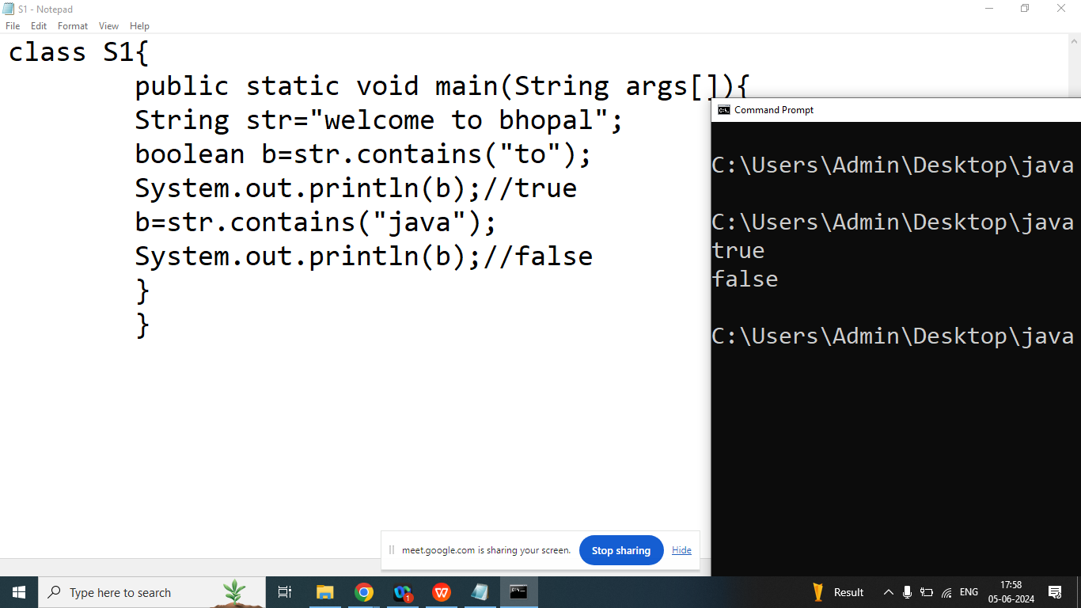

Q5. Explain String class **endsWith()** method in java programming?

Ans: Checks whether a String ends with the specified sequence of character. It is used to check a String ends with a suffix

Syntax:

boolean endsWith();

Example:

String a=”www.cybrom.com”;

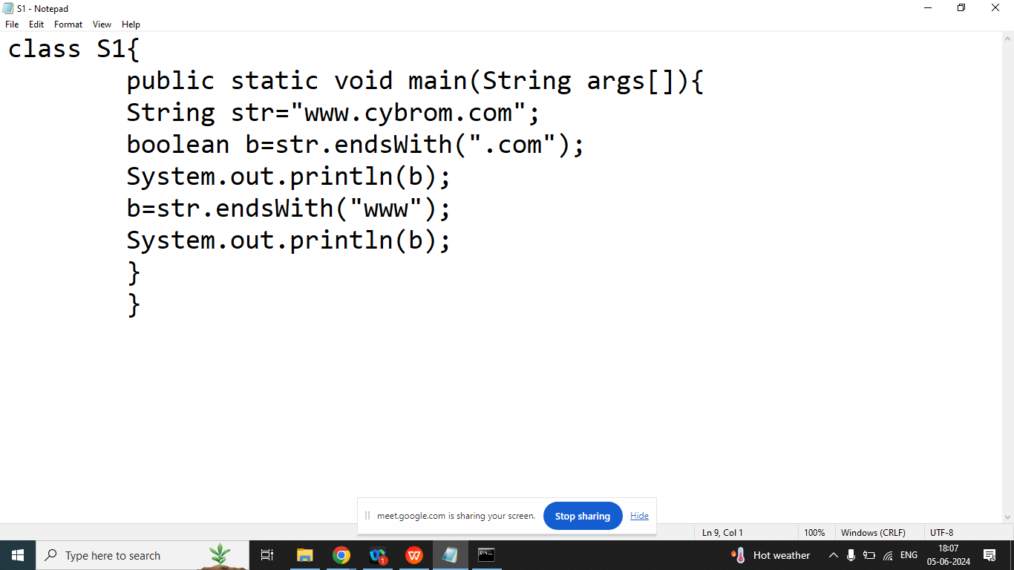

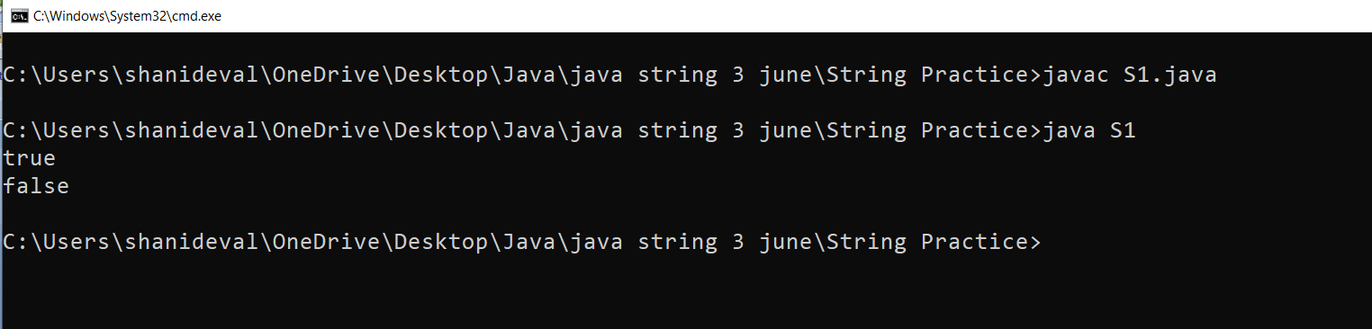

Q13. Explain String class **startsWith()** method in java programming?

Ans: Checks whether a String starts with the specified sequence of character.

It is used to check a String starts with a suffix

Syntax:

boolean startsWith();

Example:

String a=”www.cybrom.com”;

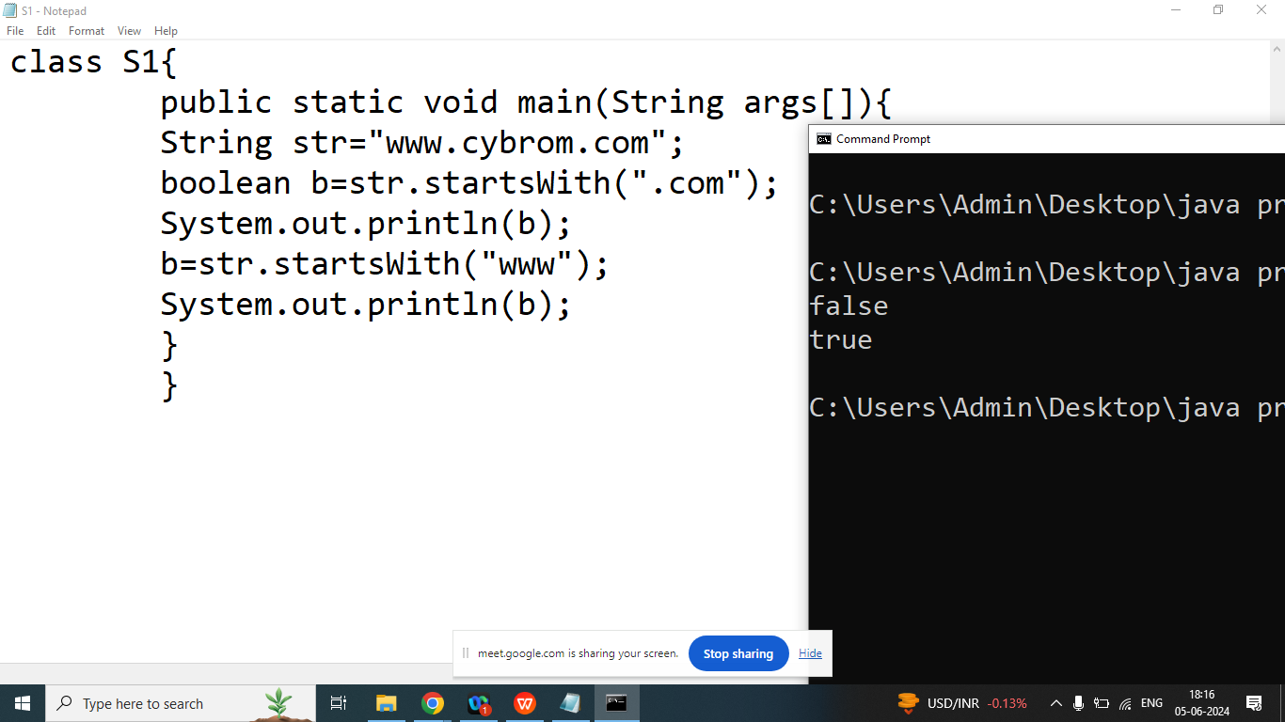

Q9.Explain String class **indexOf()** method in java programming?

Ans: Returns position of the first found occurrence of specified characters in a String.

If characters not found then it will return -1

Syntax:

public int indexOf(String);

public int indexOf(String,int position) ;

Example:

String str=”Welcome”;

|  |  |  |  |  |  |  |
| --- | --- | --- | --- | --- | --- | --- |
| W | e | l | c | o | m | e |
| 0 | 1 | 2 | 3 | 4 | 5 | 6 |

===================================>

int x=str.indexOf(“e”);//1

int y=str.indexOf(“e”,2);//6

int z=str.indexOf(“me”);//5

int k=str.indexOf(“Zee”);//-1

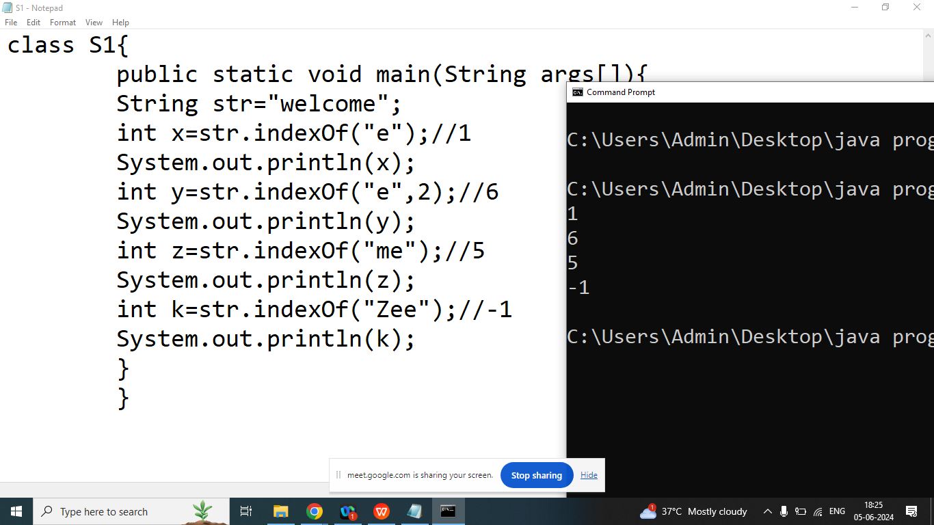

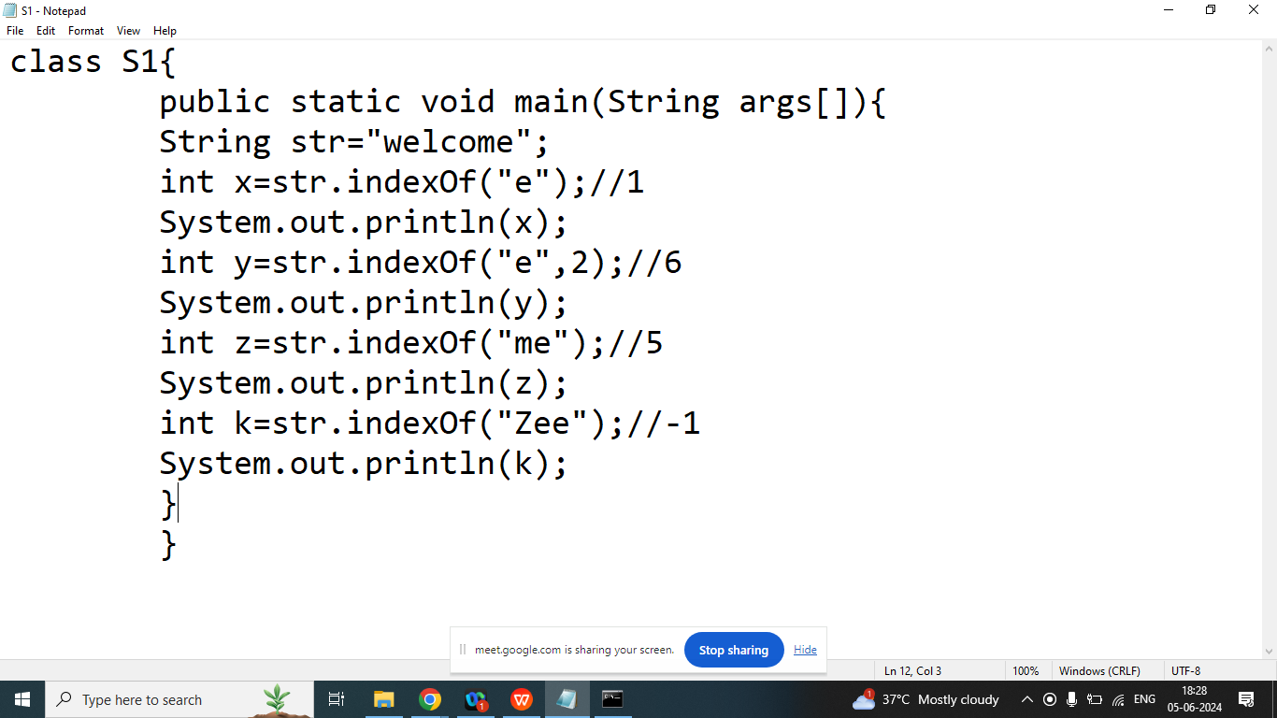

Q10.Explain String class **lastIndexOf()** method in java programming?

Ans: Returns position of the last found occurrence of specified characters in a String.

If characters not found then it will return -1

Syntax:

public int lastIndexOf(String);

public int lastIndexOf(String,int position) ;

Example:

String str=”Welcome”;

|  |  |  |  |  |  |  |
| --- | --- | --- | --- | --- | --- | --- |
| W | e | l | c | o | m | e |
| 0 | 1 | 2 | 3 | 4 | 5 | 6 |

<==============

int x=str.lastIndexOf(“e”);//6

int y=str.lastIndexOf(“e”,5);//1

int z=str.lastIndexOf(“me”);//5

int k=str.lastIndexOf(“Zee”);//-1

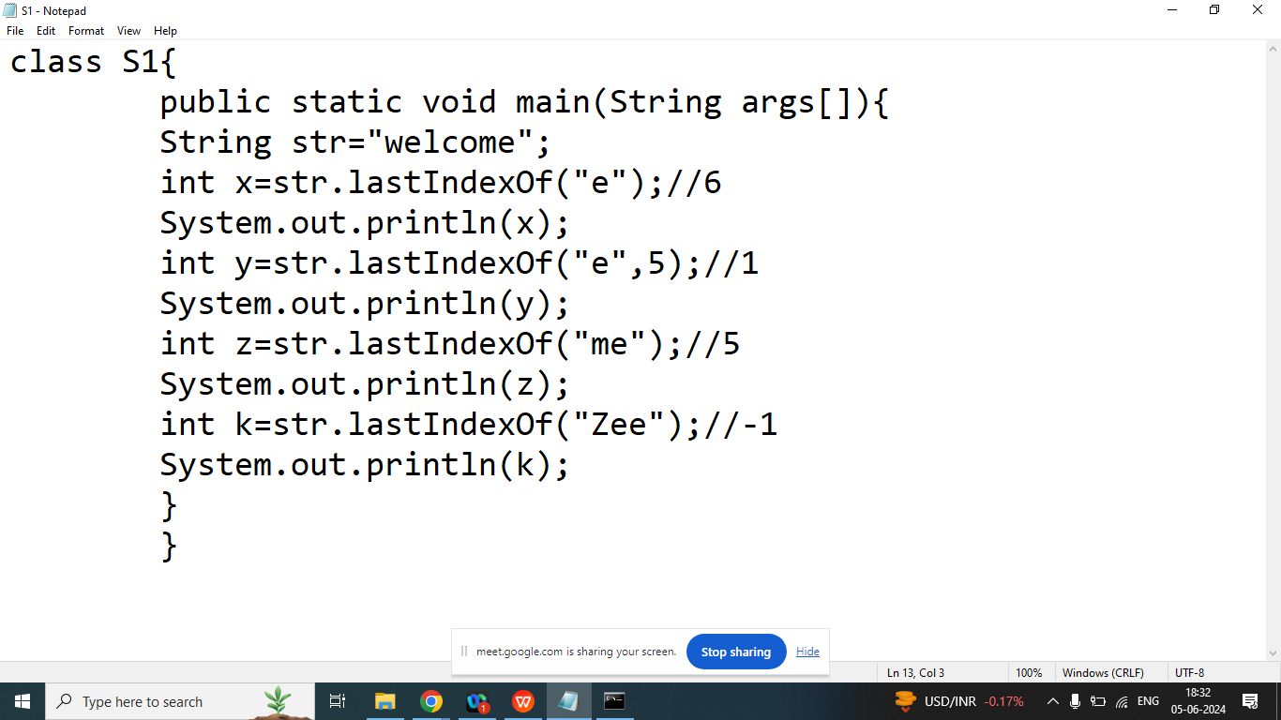

Day 18

Q11. Explain String class **length()** method in java programming?

Ans: Returns the number of characters in the String including space

Syntax:

public int length();

Example:

String x=”Wel come”;

int b=x.length();

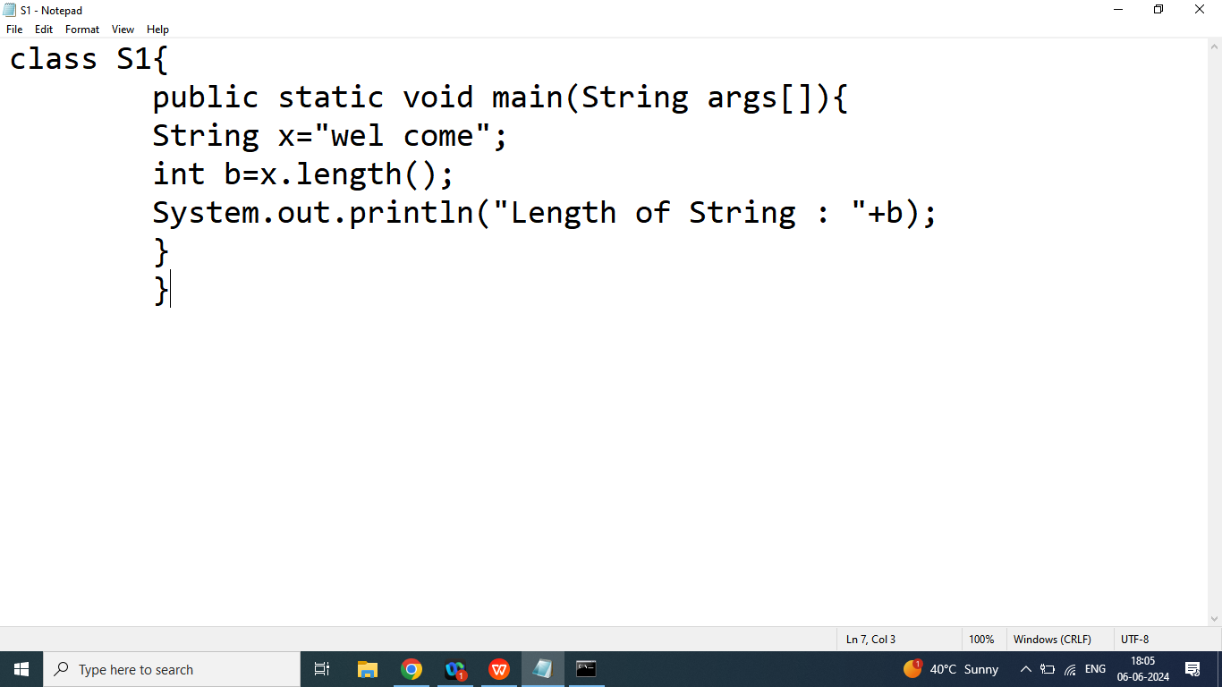

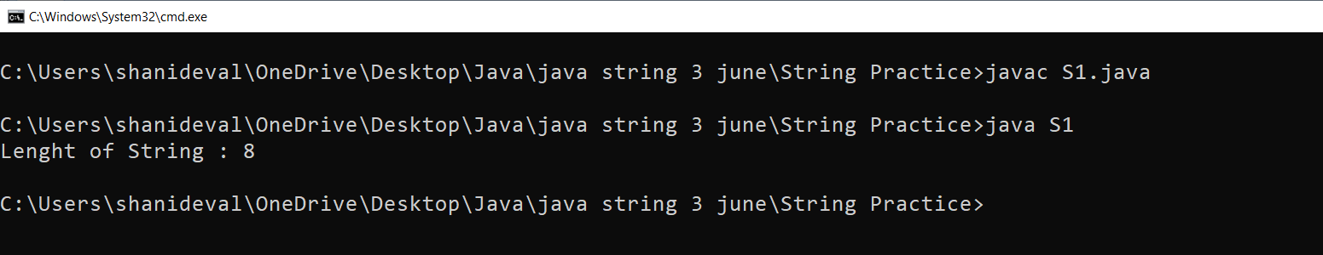

Q12. Explain String class **split()** method in java programming?

Ans: Split a String into an Array of substring

Syntax:

String[] split(separator)

Example:

String sentence=”welcome to bhopal this is city of lake”;

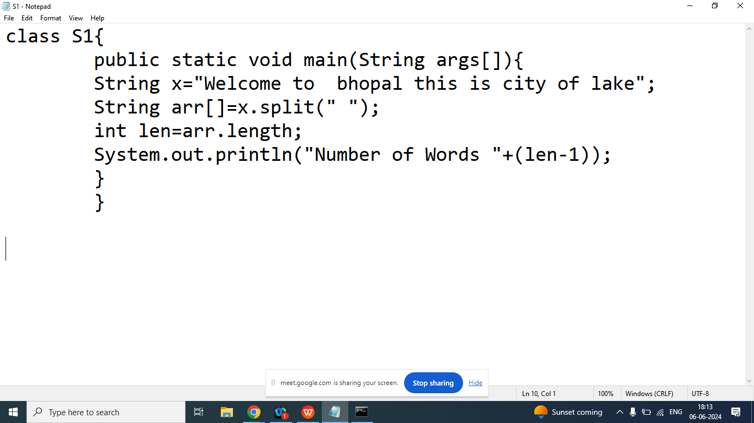

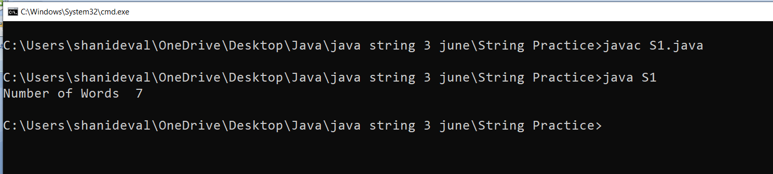

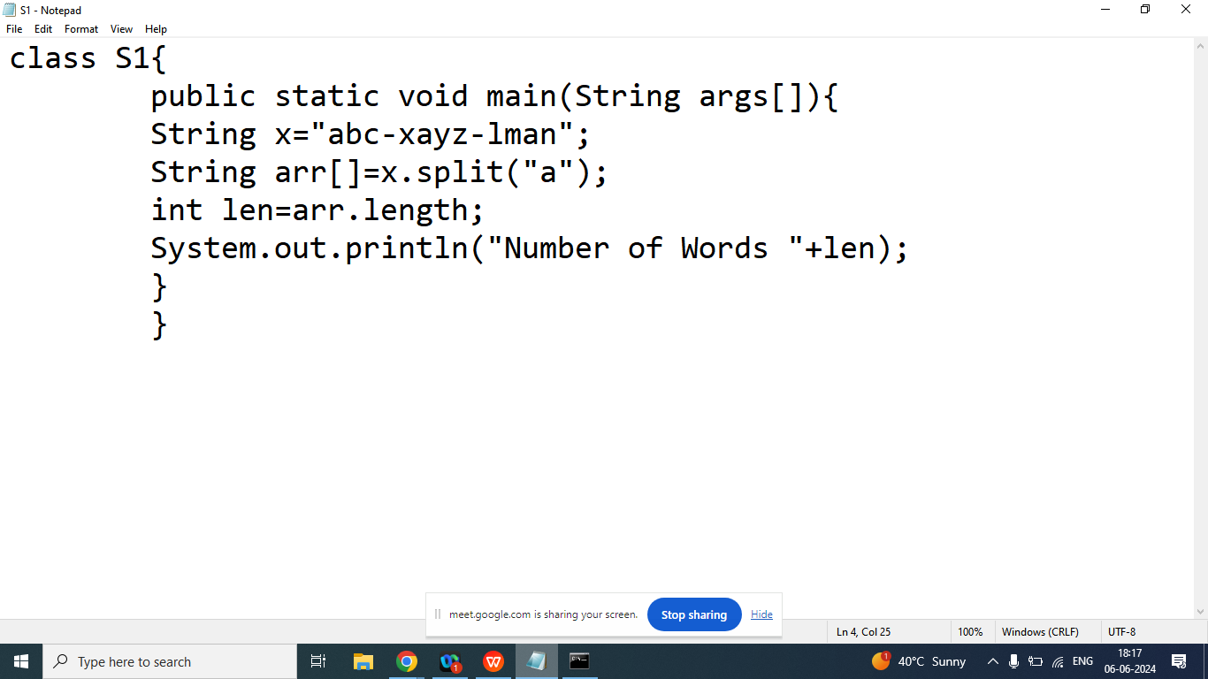

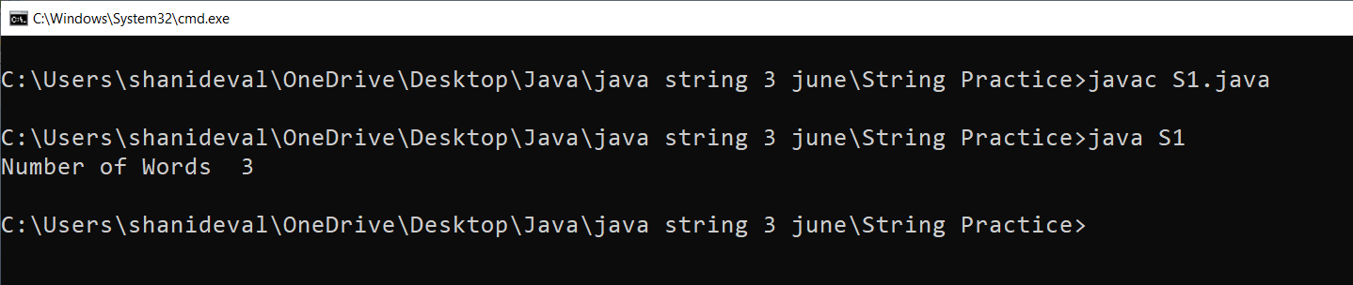

Q14.Explain String class **substring** method in java programming?

Ans: Returns a new String which is substring of a specified String.

Syntax:

public String substring(int start);

public String substring(int start,int end);

Example:

|  |  |  |  |  |  |  |
| --- | --- | --- | --- | --- | --- | --- |
| w | e | l | c | o | m | e |
| 0 | 1 | 2 | 3 | 4 | 5 | 6 |

String x=”welcome”;

String b=x.substring(3); //come

String z=x.substring(0,4);//welc

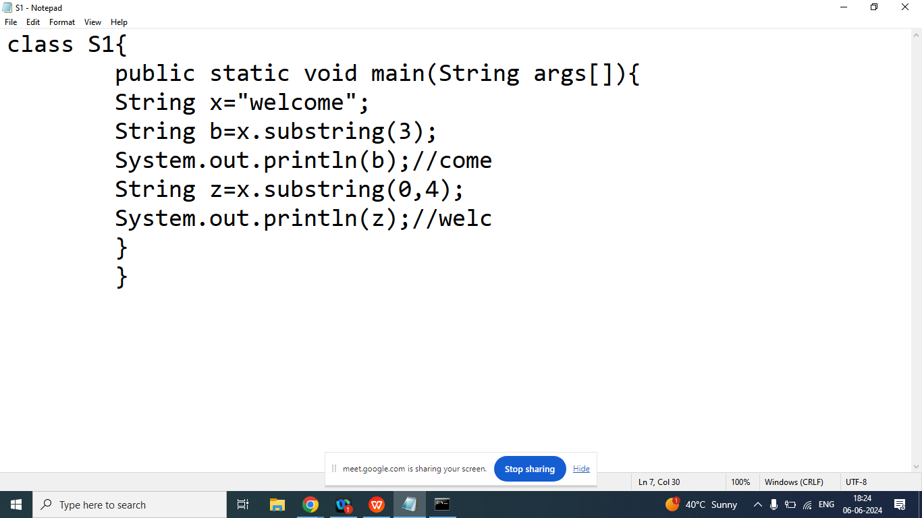

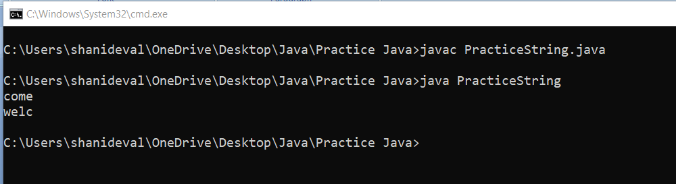

Q6. Explain String **class toCharArrray(**) method in java programming?

Ans: It is used to convert given String into char array

Syntax:

public char[] toCharArray()

Example:

String x=”welcome”;

char arr[]=x.toCharArray();

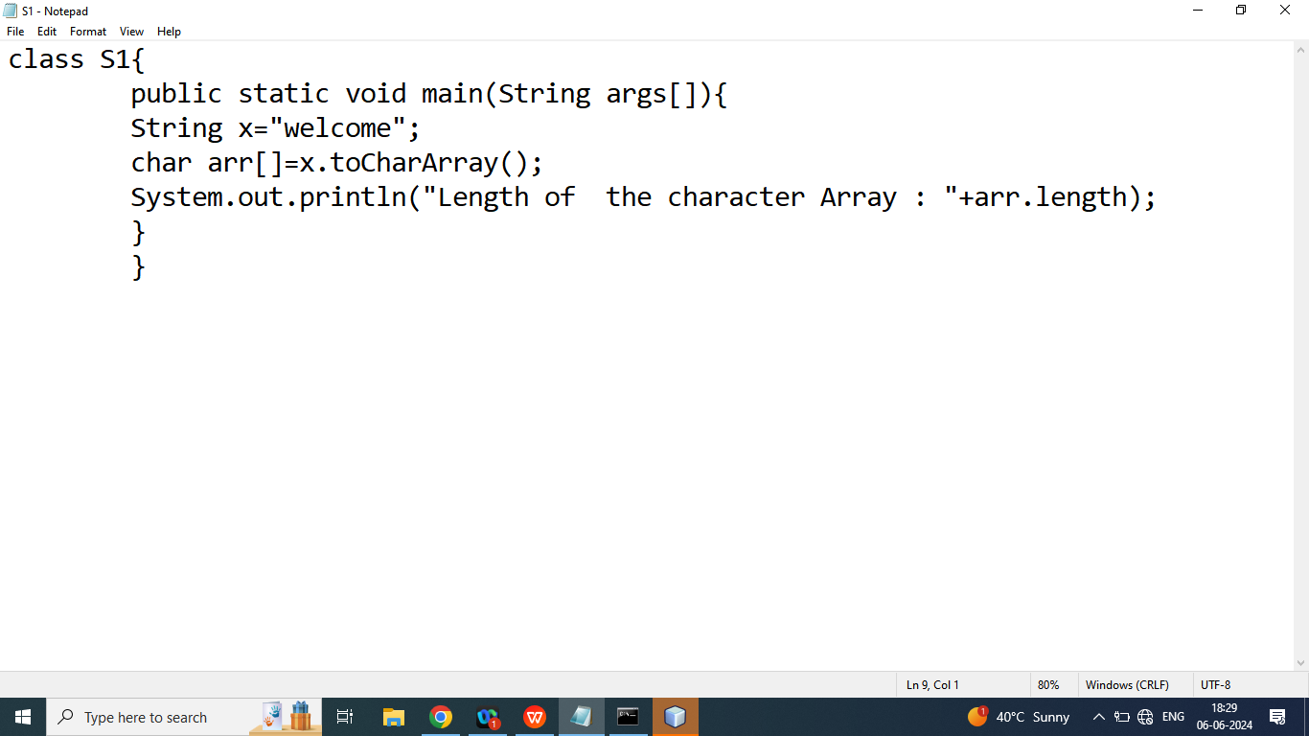

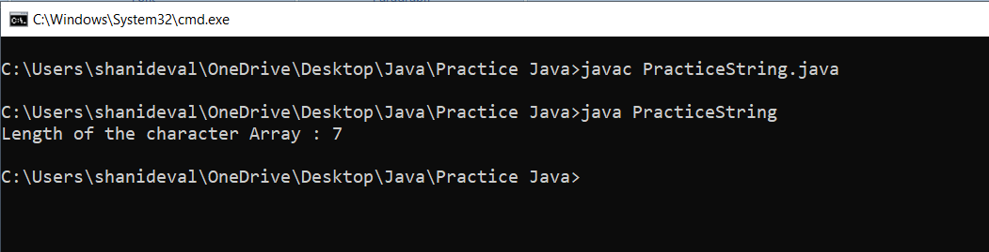

Q7. Explain String class **toUpperCase** and **toLowerCase()** method in java programming?

Ans:

toUpperCase(): It is used to convert upperCase String

toLowerCase(): It is used to convert upperCase String

Syntax:

String x=”welcome”;

String a=x.toUpperCase();

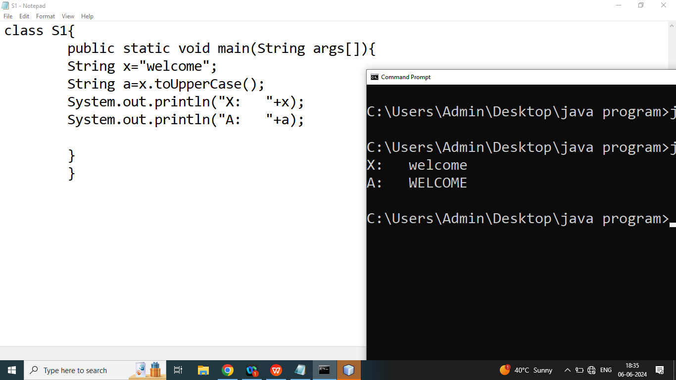

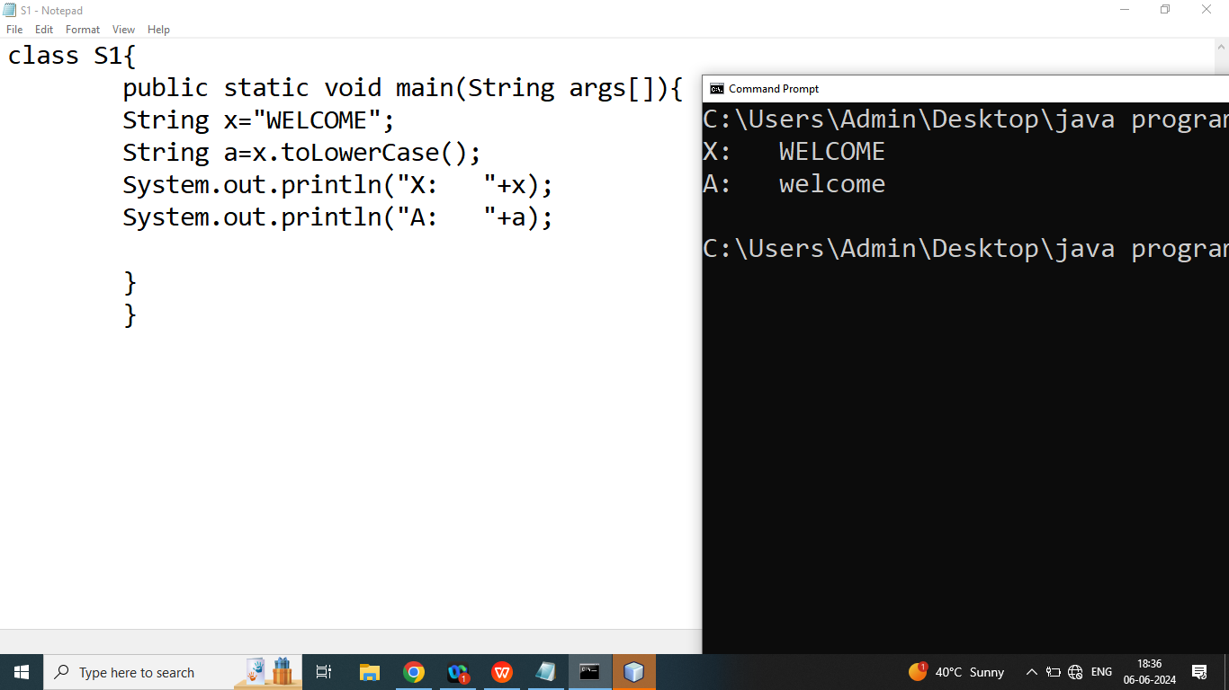

Q1. Explain String class **trim()** mthod in java programming?

Ans: Removes white spaces from both ends(starting and ending)

Syntax:

String trim();

Example:

String str=” Hello World ”;

String a=str.trim();//Hello World

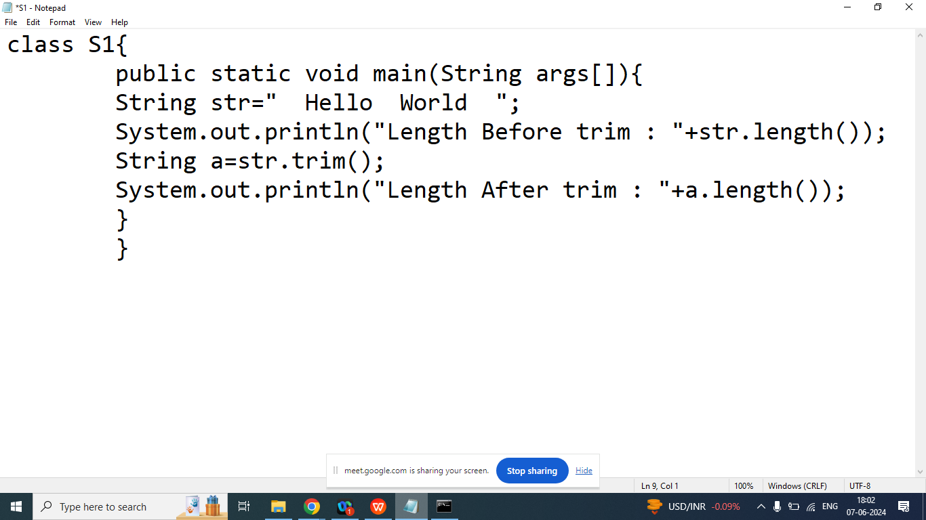

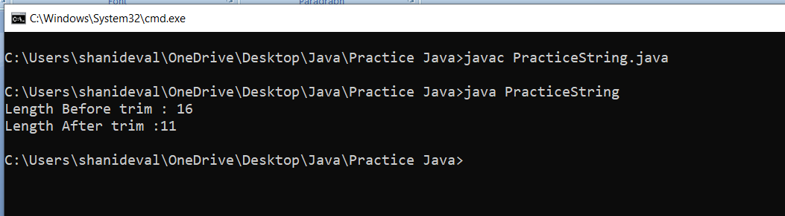

Q2. Explain String class **valueOf()** method in java programming?

Ans: Returns the String representation of the specified value

Syntax:

String valueOf(Integer)

String valueOf(Float)

String valueOf(double)

String valueOf(Char)

String valueOf(boolean)

Example:

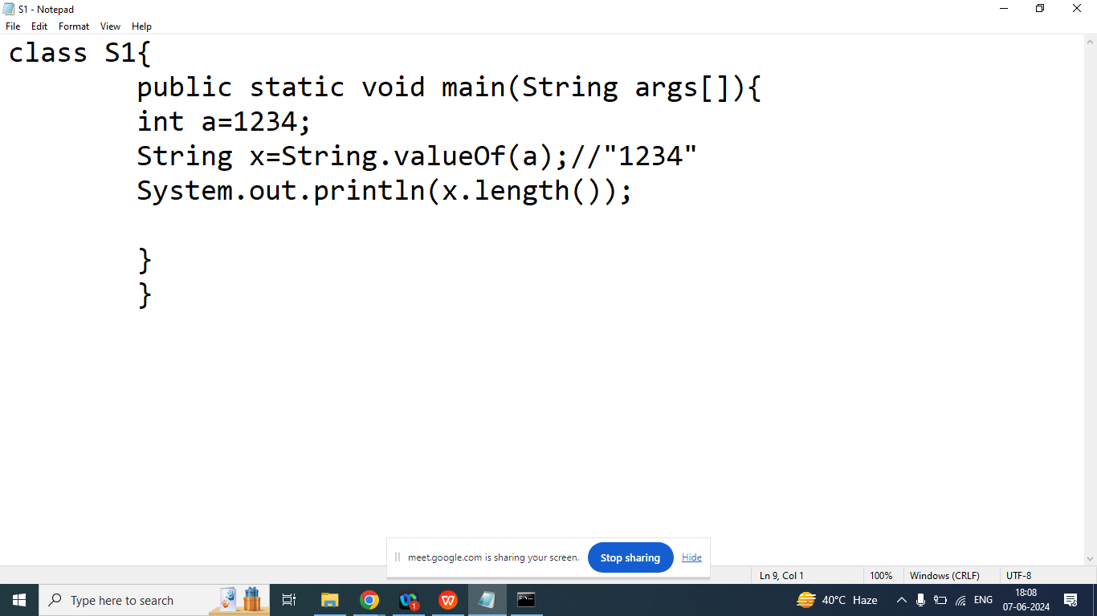

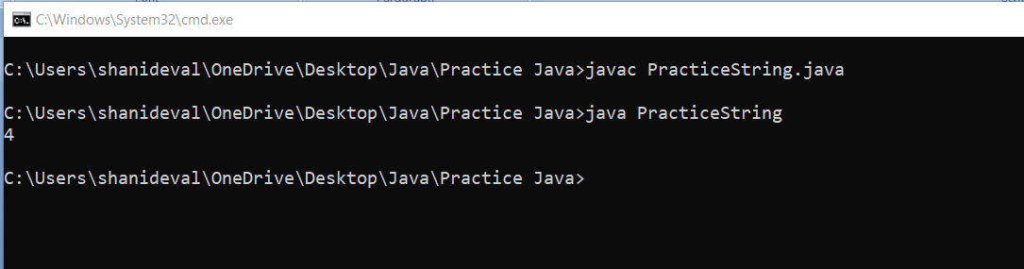

Q1. How many Object created in below program

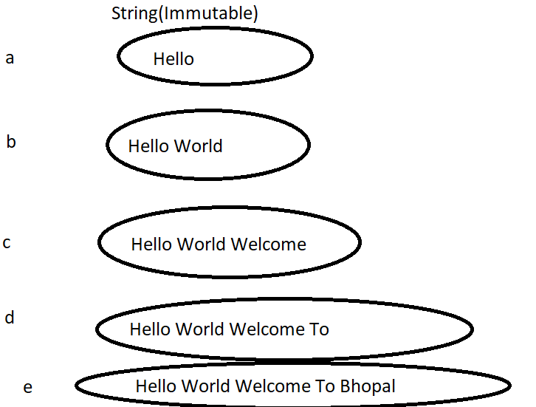

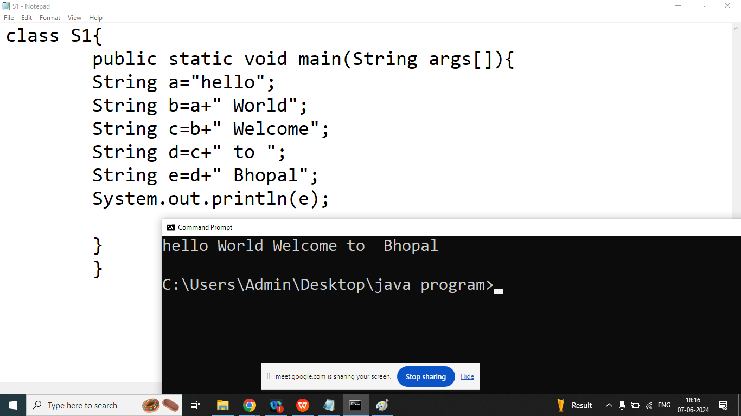

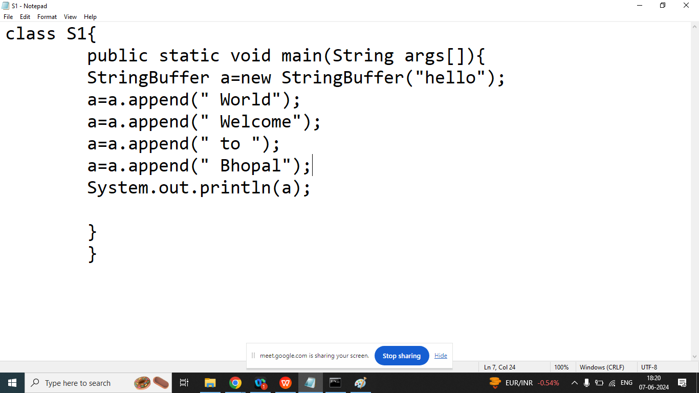

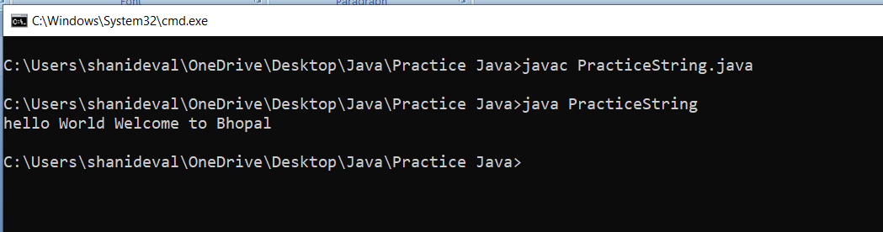

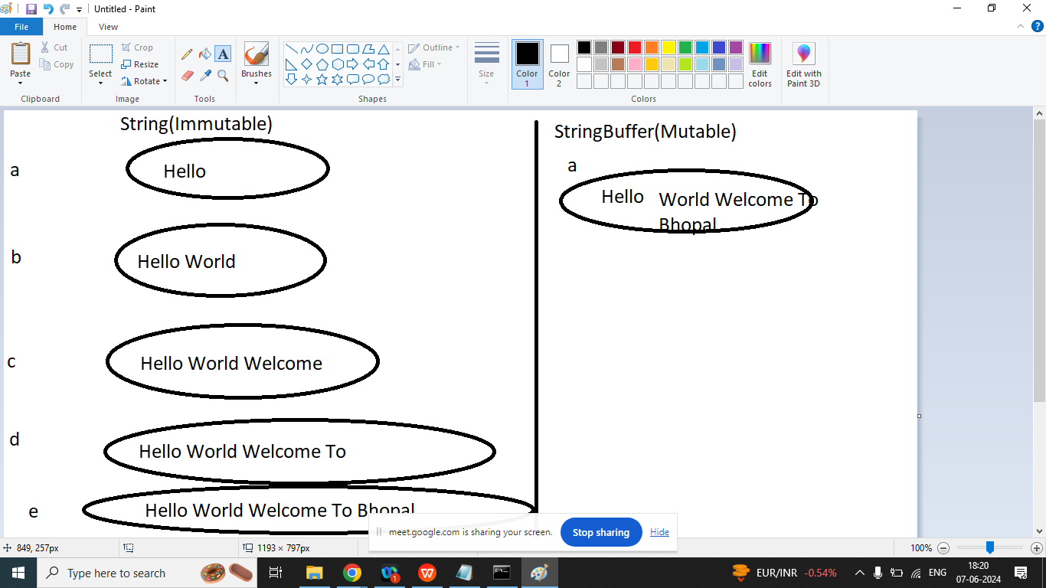

Q1.Explain StringBuffer class in java Programming?

Ans:

If our content are not fixed and we want to perform some modification but thread safety is required then we should go for StringBuffer class.

String Buffer class is a Mutable class present in java.lang package

Constructor of StringBuffer class

1. StringBuffer(): It creates an Empty String Buffer class object and reserves space for 16 character(Default capacity of StringBuffer is 16)
2. StringBuffer(int capacity): It creates an empty StringBuffer object with the specified capacity
3. StringBuffer(String): It creates a StringBuffer object from the specified String. And its capacity=default capacity+ length of the String.

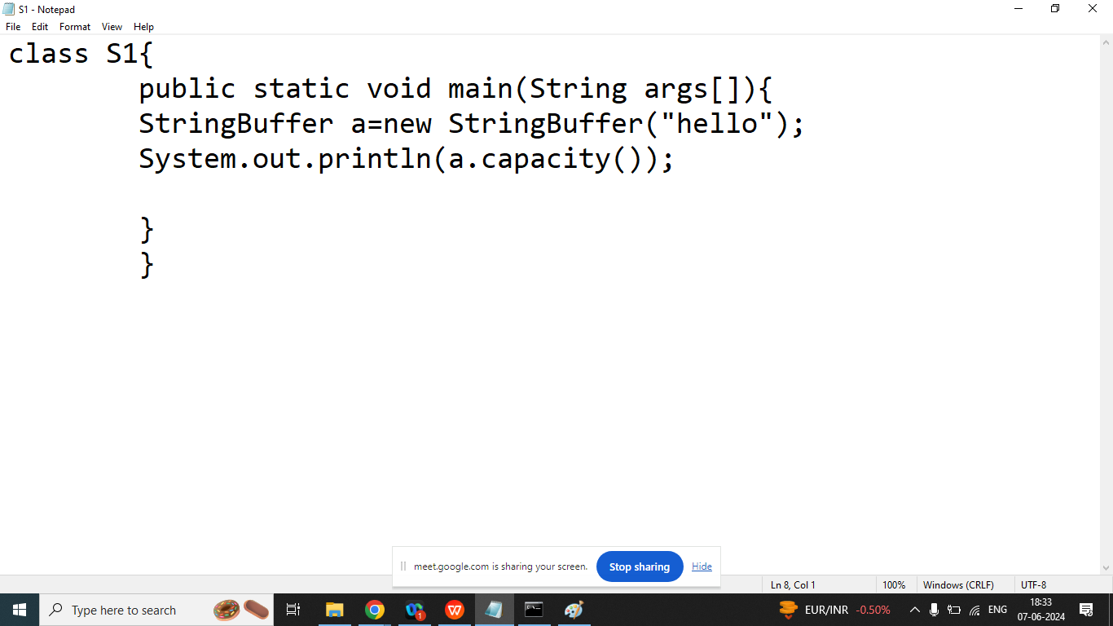

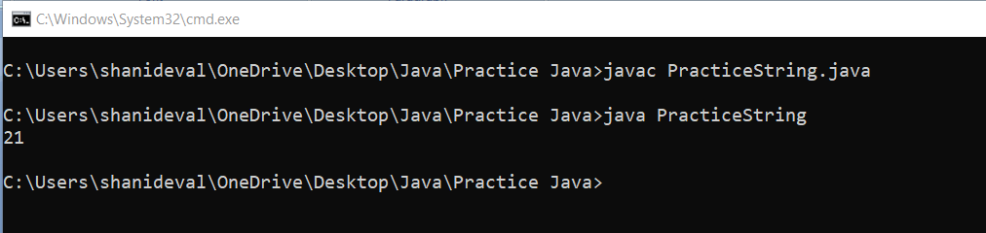

Day 19

Q2. Explain StringBuffer **class insert method** in java programming?

Ans:

The Insert method inserts the given String with the specified position,

Syntax:

StringBuffer insert(int position,String object);

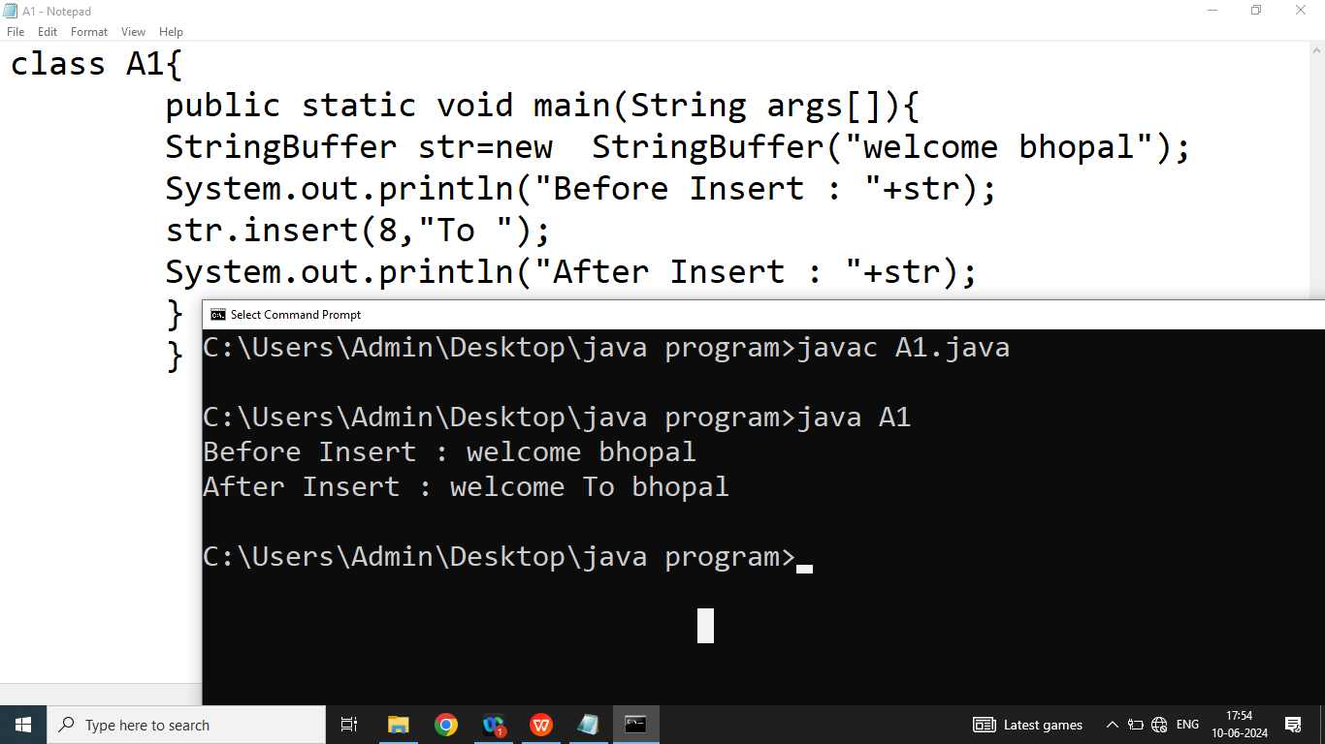

Q2. Explain StringBuffer class **replace()** method in java programming?

Ans:

The replace method replaces the given String from the specified String(from index to endIndex).

Syntax:

StringBuffer replace(int startindex, int endindex, String);

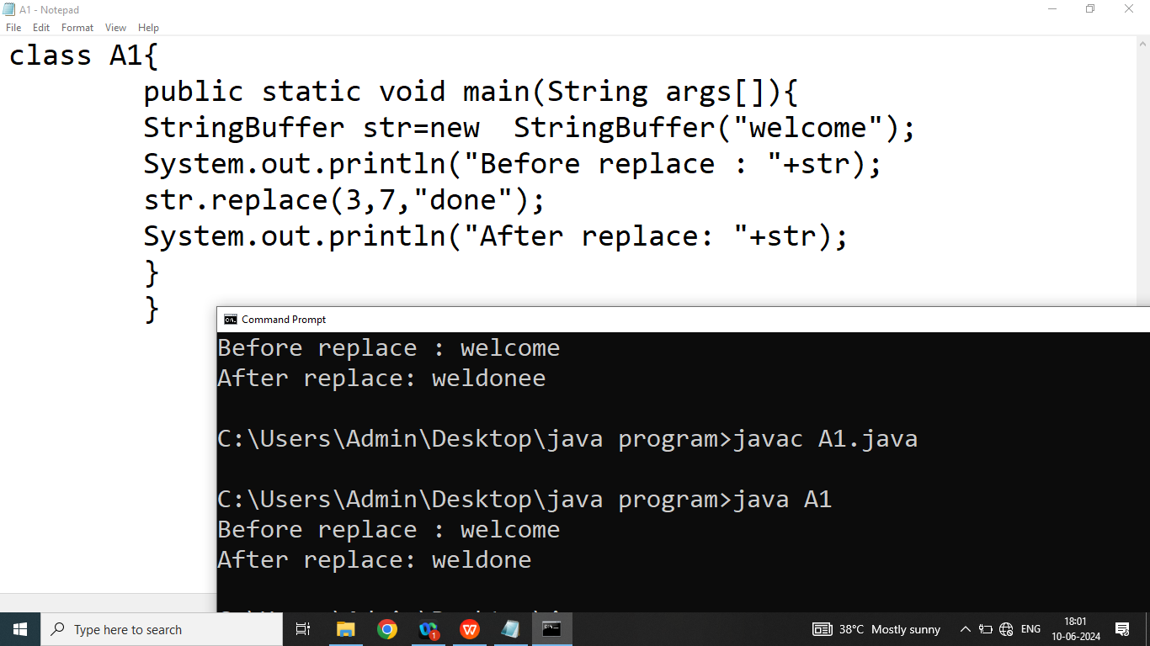

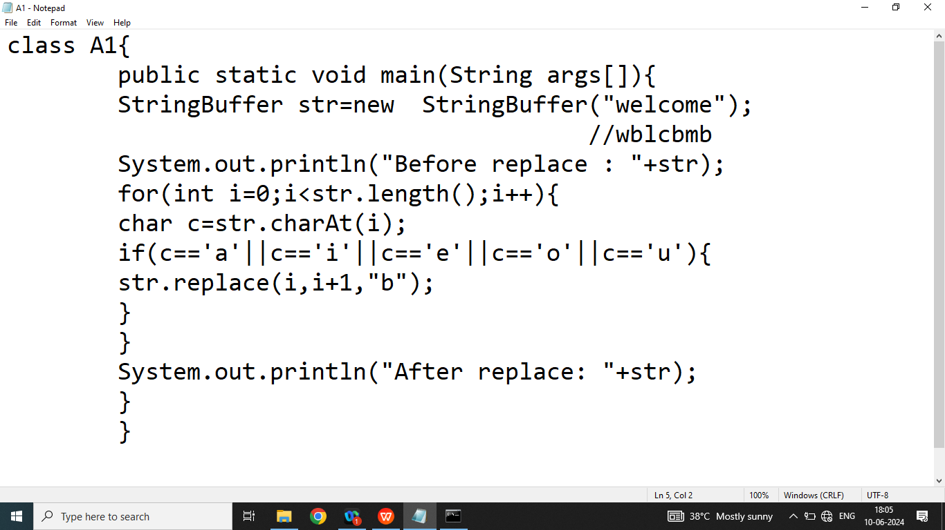

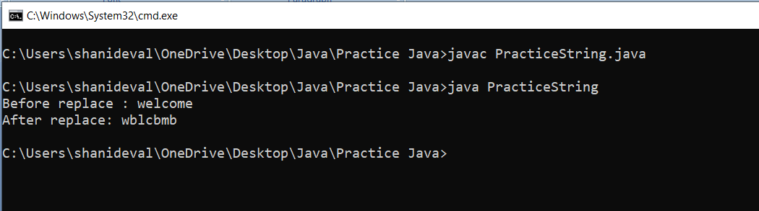

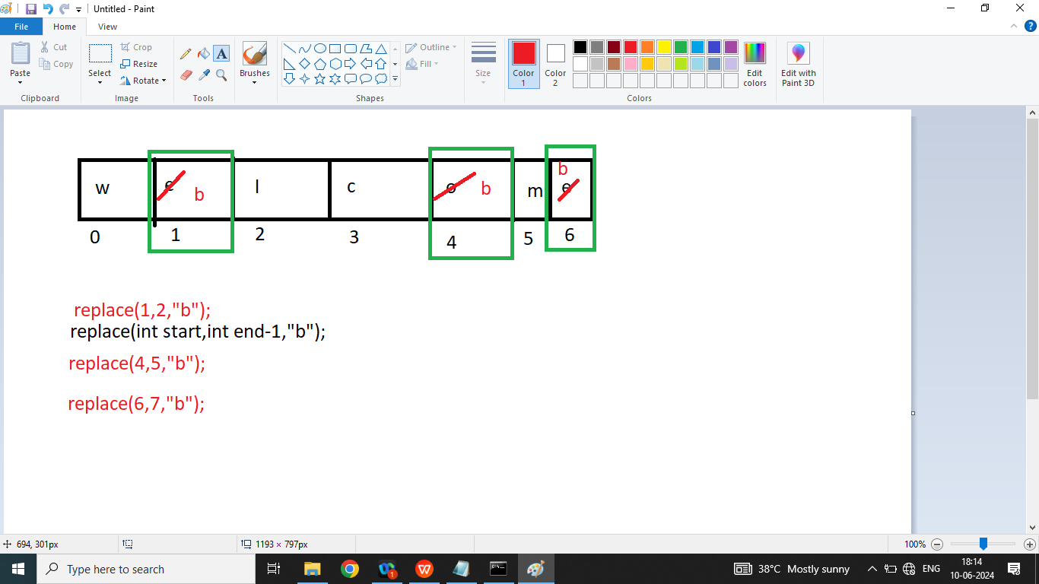

Q4.Explain StringBuffer class **delete method** in java programming?

Ans: The delete() method of StringBuffer class deletes the String from fromINdex to EndIndex.

Syntax:

StringBuffer delete(int start,int end);

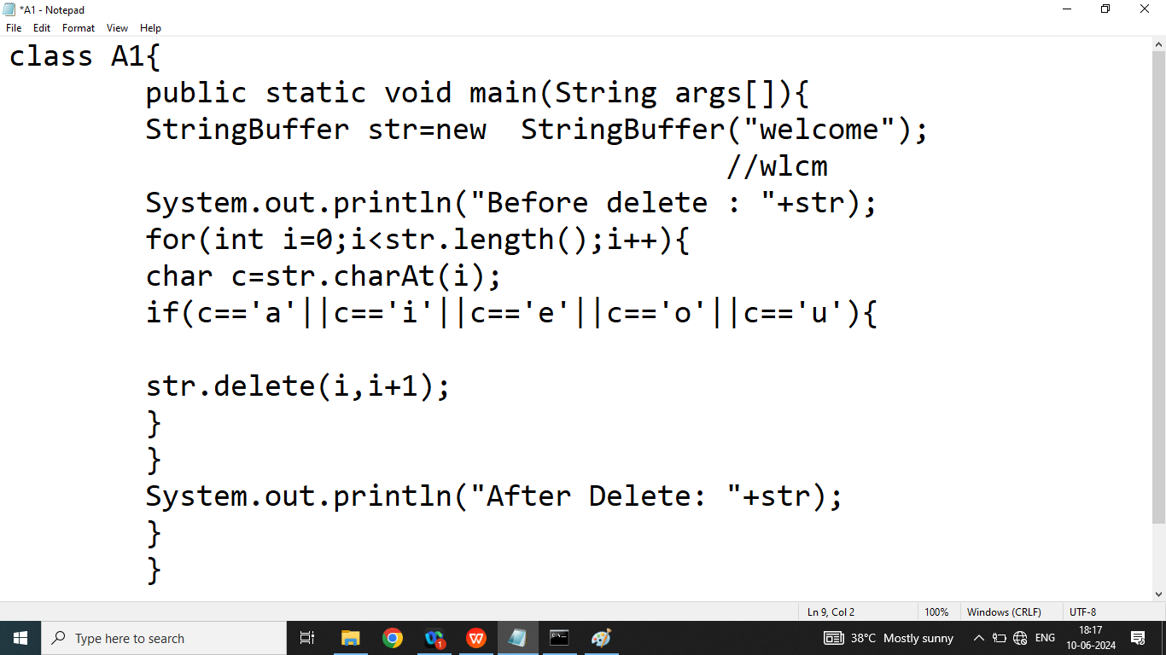

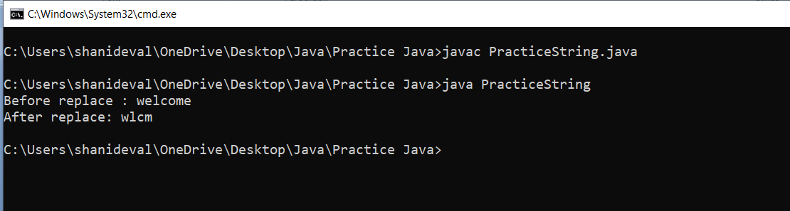

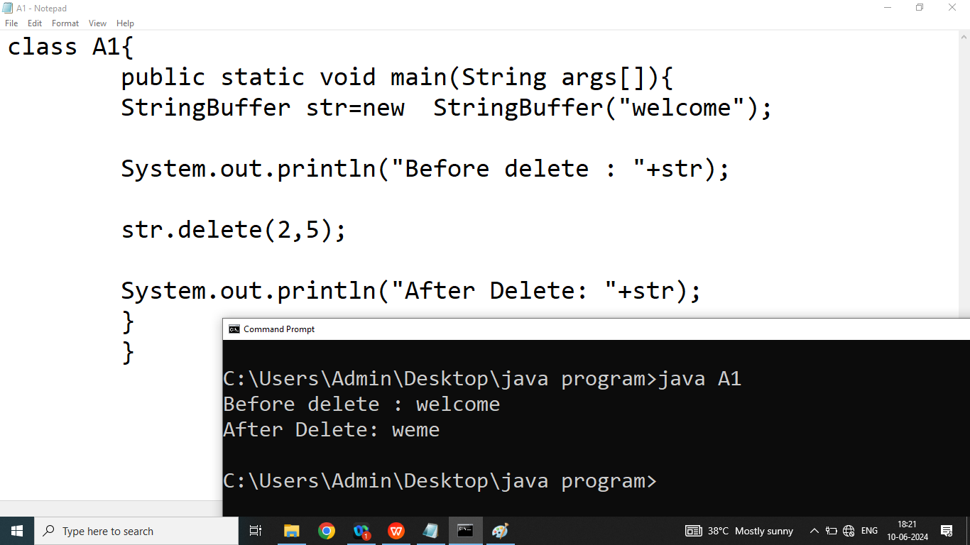

Q5. Explain StringBuffer class **deleteCharAt()** method in java programming?

Ans: It is used to delete single character at a time from the give String.

Syntax:

StringBuffer deleteCharAt(int index);

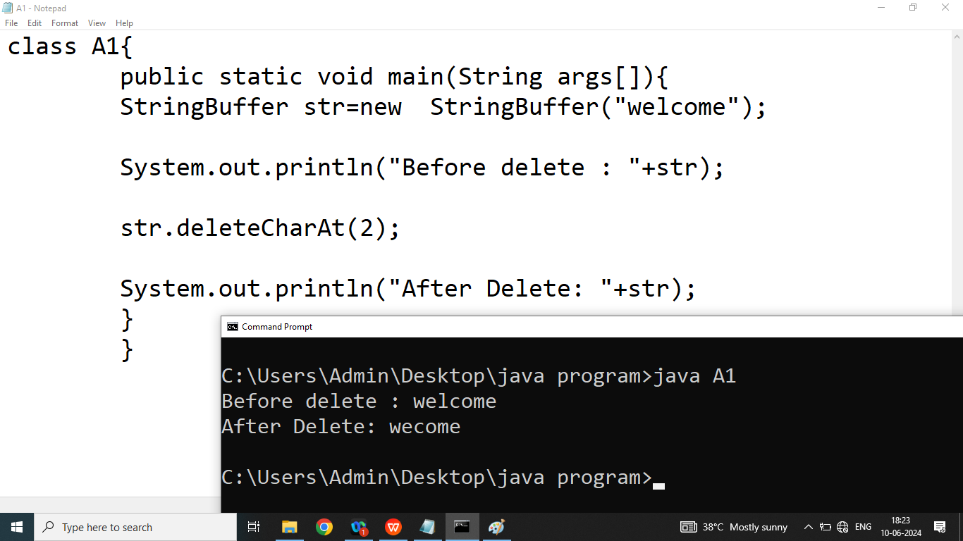

Q6. Explain StringBuffer class **reverse()** method in java programming?

Ans: It is used to reverse the specified String.

Syntax:

StringBuffer reverse()

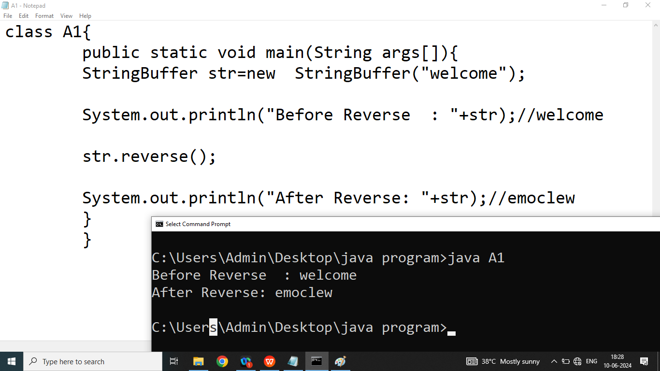

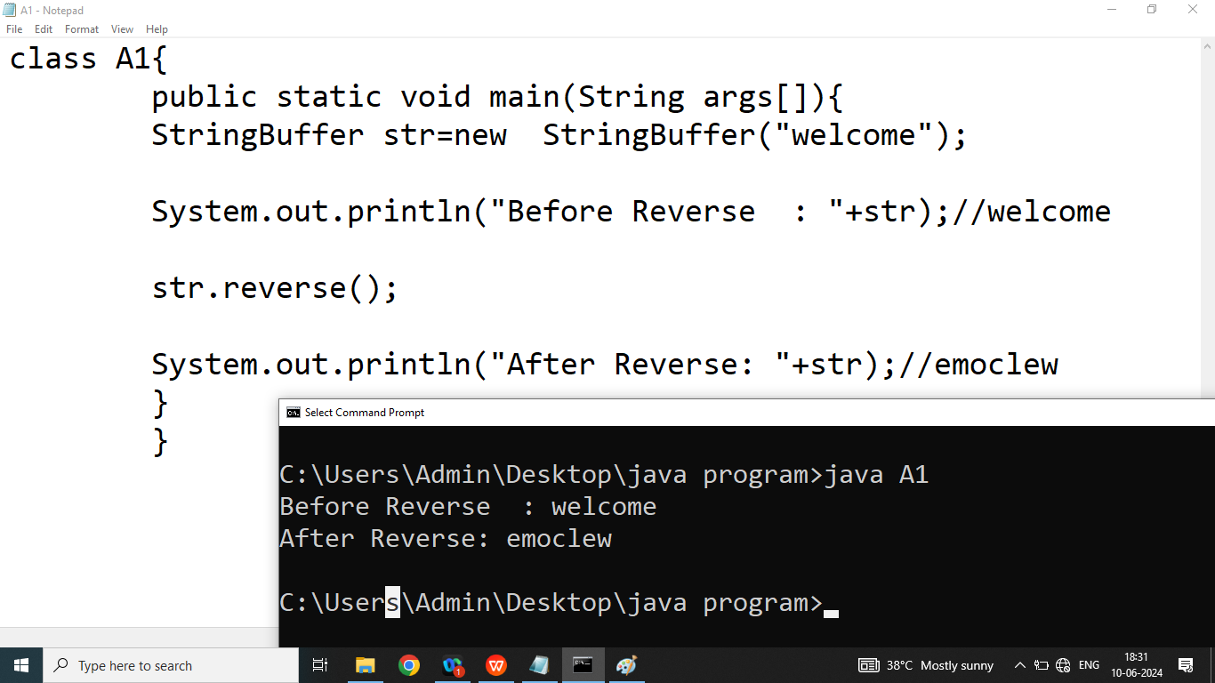

Day 20

Q1. Explain StringBuilder class in java programming?

Ans:

The StringBuilder class is exactly same as StringBuffer class except the following difference

1. All methods of StringBuffer class are synchronized. Hence StringBuffer class are thread Safe.(one- one trnsation )
2. NO Methods of StringBuilder class are synchronized. Hence StringBuilder are not thread safe.(all transation do be with one)

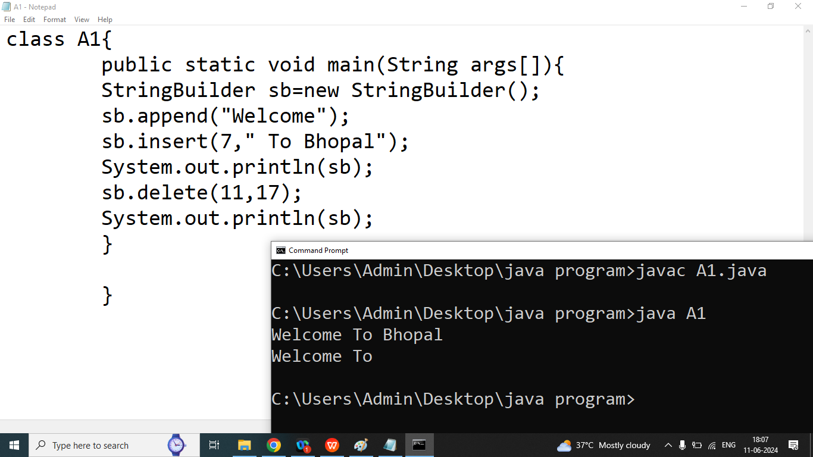

**String:** if our content are fixed and we won’t perform some modification then we should go for String class.String class is Immutable class

**StringBuffer:** if our content are not fixed and we want to perform some modification and thread safety is required then we should go for StringBuffer class.

StringBuffer class is a mutable.

**StringBuilder:**if our content are not fixed and we want to perform some modification and thread safety is not required then we should go for StringBuilder class.StringBuilder class is a mutable

Day 21

Q1. Explain Array in java programming?

Ans:

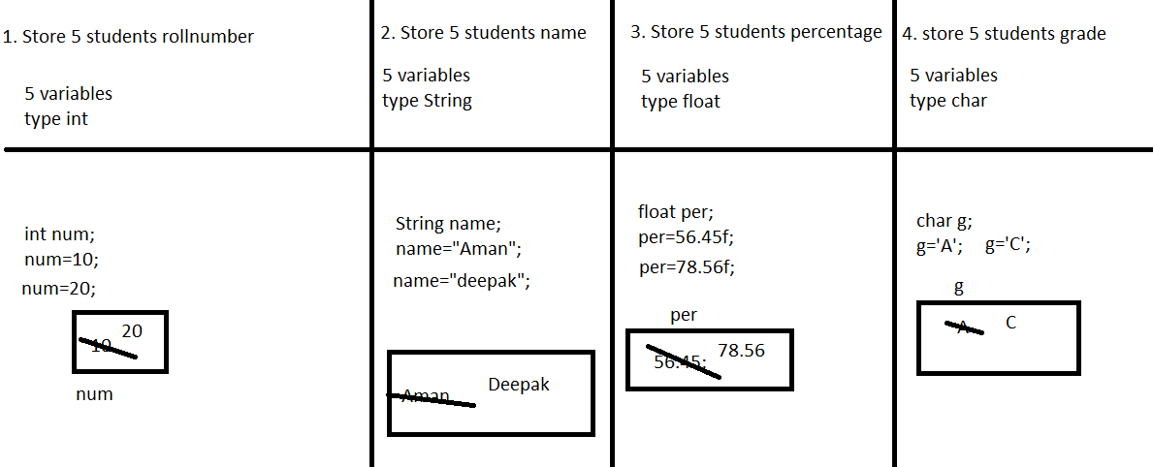

If we want to store multiple values under single variable name then we should go for Array

* Arrays are collection of same types of data
* In case of Array memory allocation is continuous
* Values stored in array are known as Elements
* Elements of the array accessed by index
* Java Does not support negative index
* In java index always starts with 0.
* In java array are dynamic
* We allocate memory dynamically using new keyword
* We can accesses array elements randomly and sequentially

1. **Declaration of the Array**

**Syntax:**

Datatype arrayName[]=new Datatype[size];

Size must not be Negative,float,double,String

Examples:

int nums[]=new int[5];//valid

int x[5];//invallid

int x[];

x=new int[5];

float per[]=new float[5];

String names[]=new String[5];

char g[]=new char[5];

1. **Initialization of the Array: Assign some vales to the array**

**Syntax:**

**Type1:**

**Example:**

int nums[]=new int[5];

Initialization

Syntax:

ArrayName[INDEX]=value;

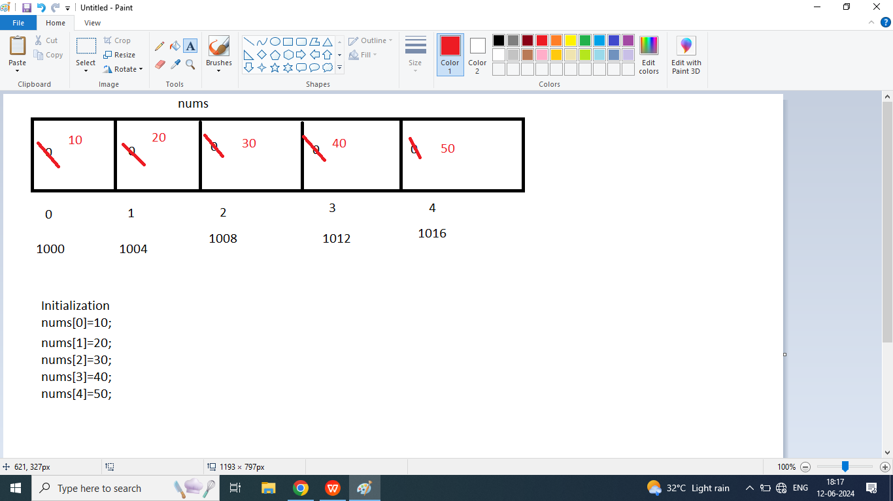

1. **Print elements of the Array**

System.out.println(arrayName[index]);

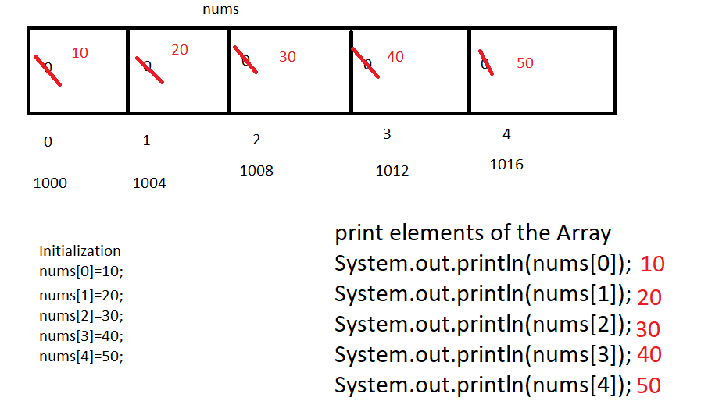

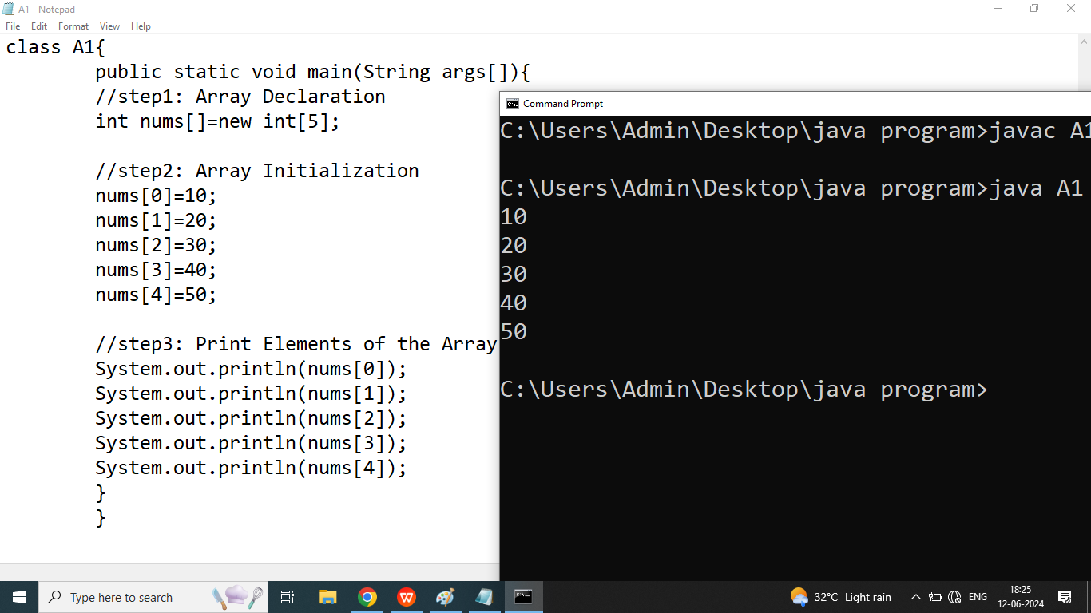

Day 22

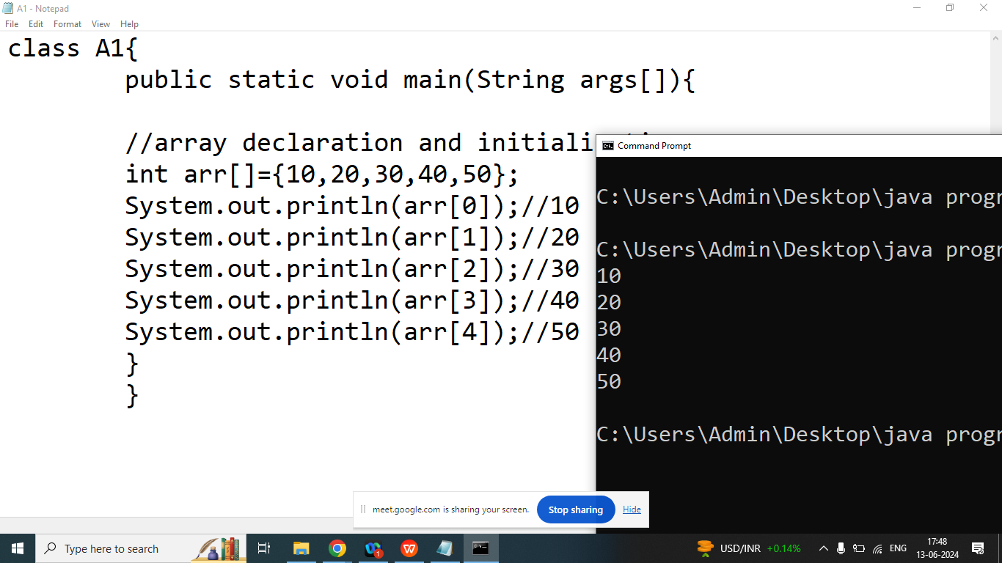

import java.util.Scanner;

class A1{

public static void main(String args[]){

//array declaration and initialization

int arr[]=new int[5];

Scanner sk=new Scanner(System.in);

System.out.println("Enter ELements of Index 0 : ");

arr[0]=sk.nextInt();

System.out.println("Enter ELements of Index 1 : ");

arr[1]=sk.nextInt();

System.out.println("Enter ELements of Index 2 : ");

arr[2]=sk.nextInt();

System.out.println("Enter ELements of Index 3 : ");

arr[3]=sk.nextInt();

System.out.println("Enter ELements of Index 4 : ");

arr[4]=sk.nextInt();

System.out.println(arr[0]);//10

System.out.println(arr[1]);//20

System.out.println(arr[2]);//30

System.out.println(arr[3]);//40

System.out.println(arr[4]);//50

}

}

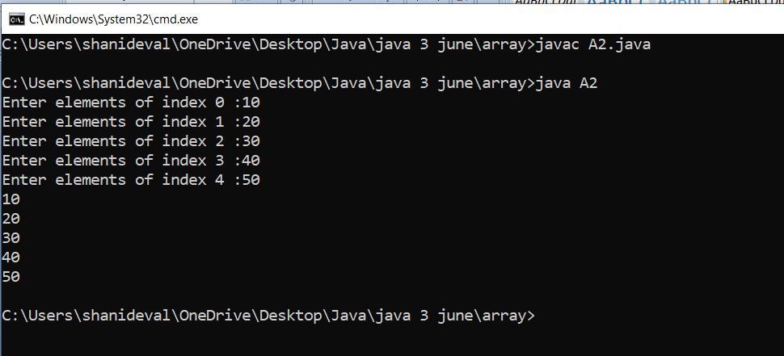

Q2. Explain length properties of the array

Ans: It will return size of the array or number of elements in the array

Syntax:

arrayName.length;

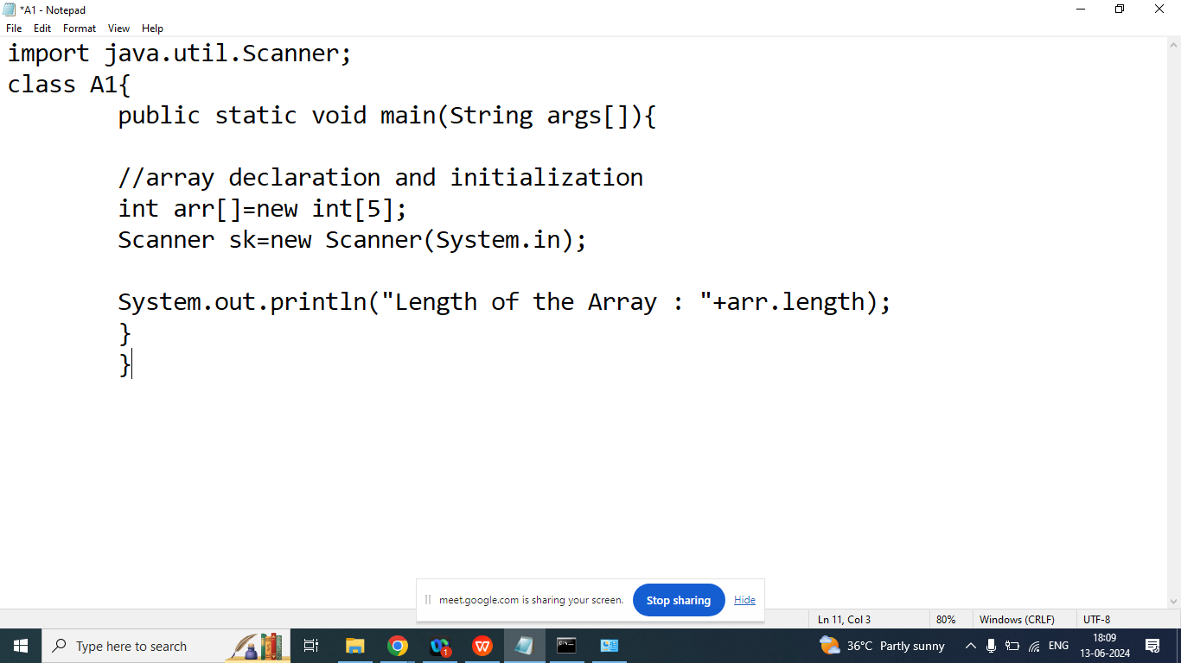

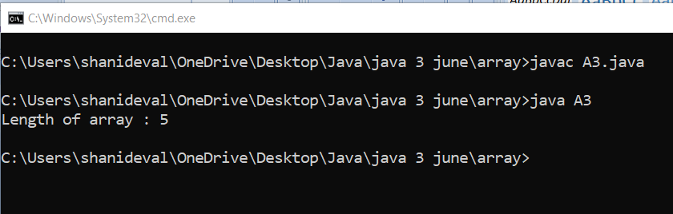

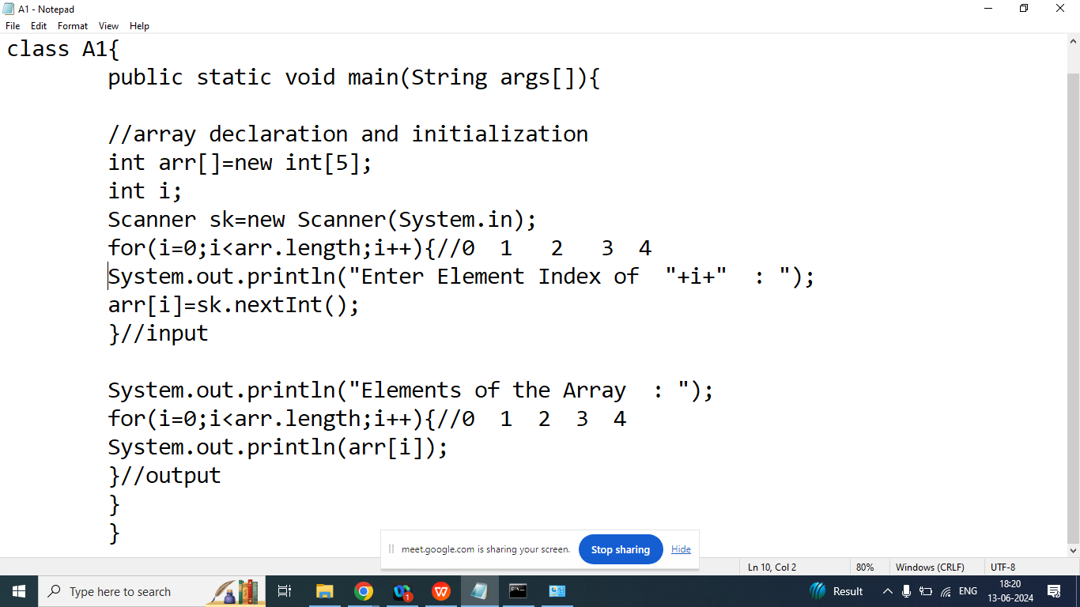

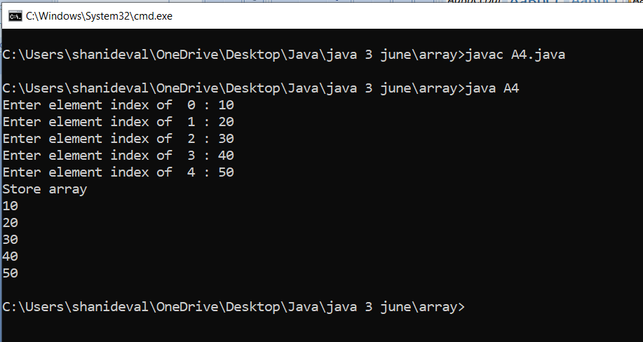

Q4. Write a java program to take 5 students name from the user and print its on the screen.

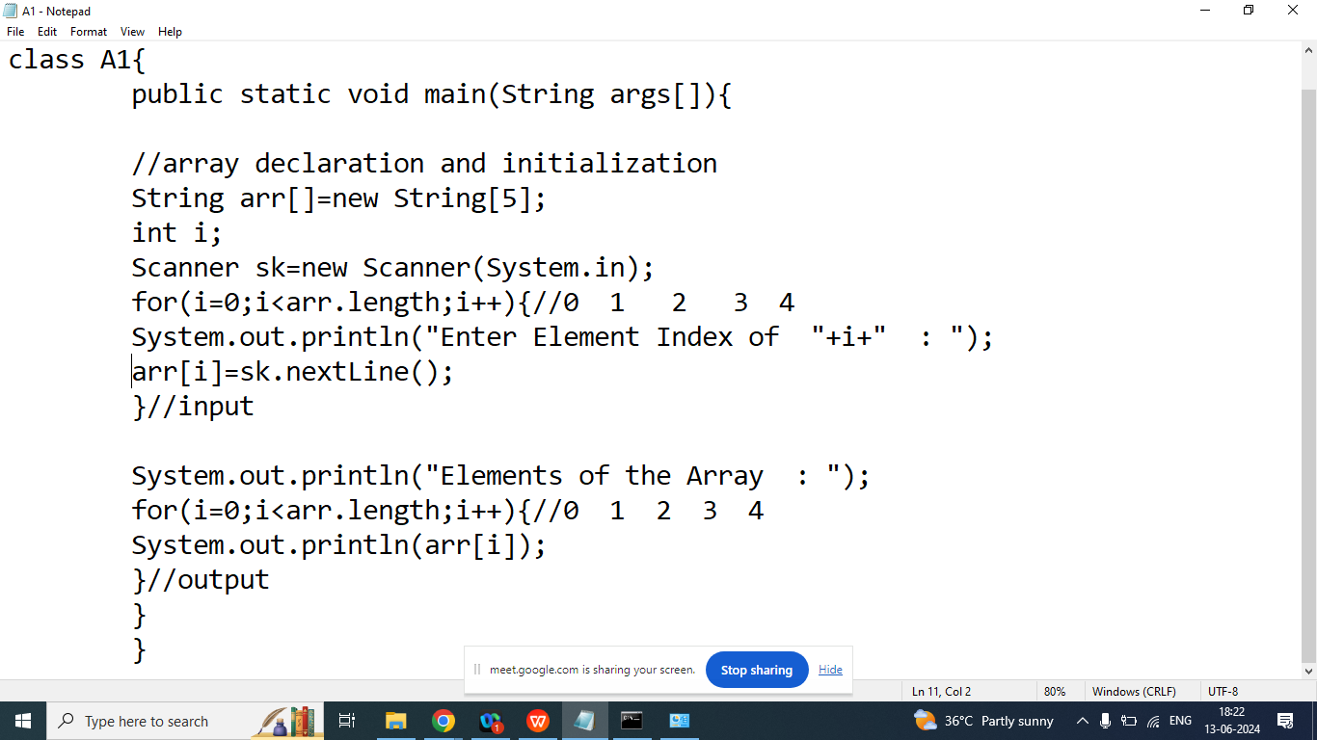

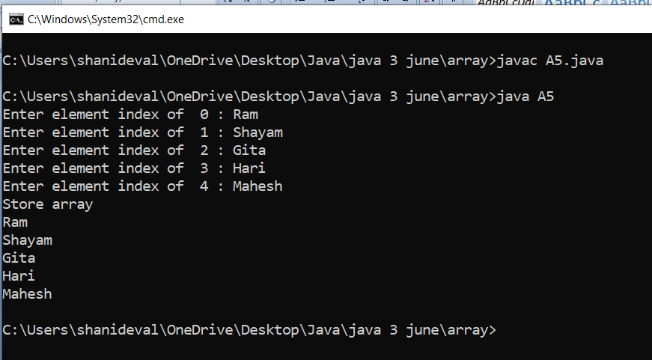

Day 23

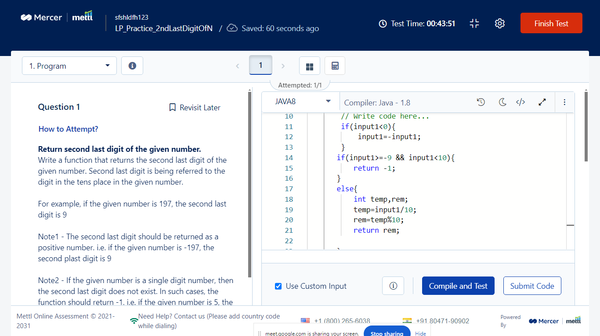

Q2. Write a java program to print sum and average of all array elements?

Array Elements: 10 20 30 40 50

Sum: 150

Average: 30

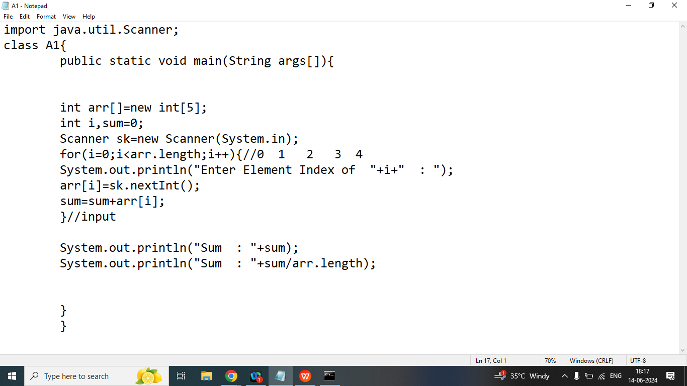

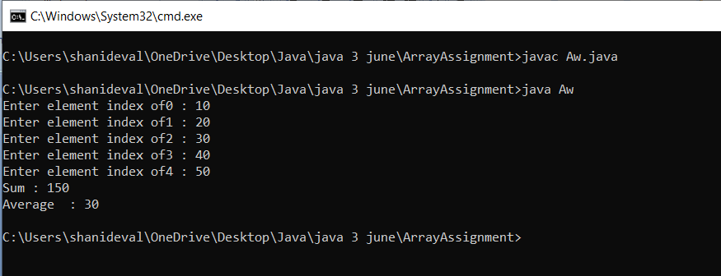

Q2. Write a java program to print sum of all even elements of the array

Array Elements: 10 21 32 41 51

Sum of All Even Elements : 42

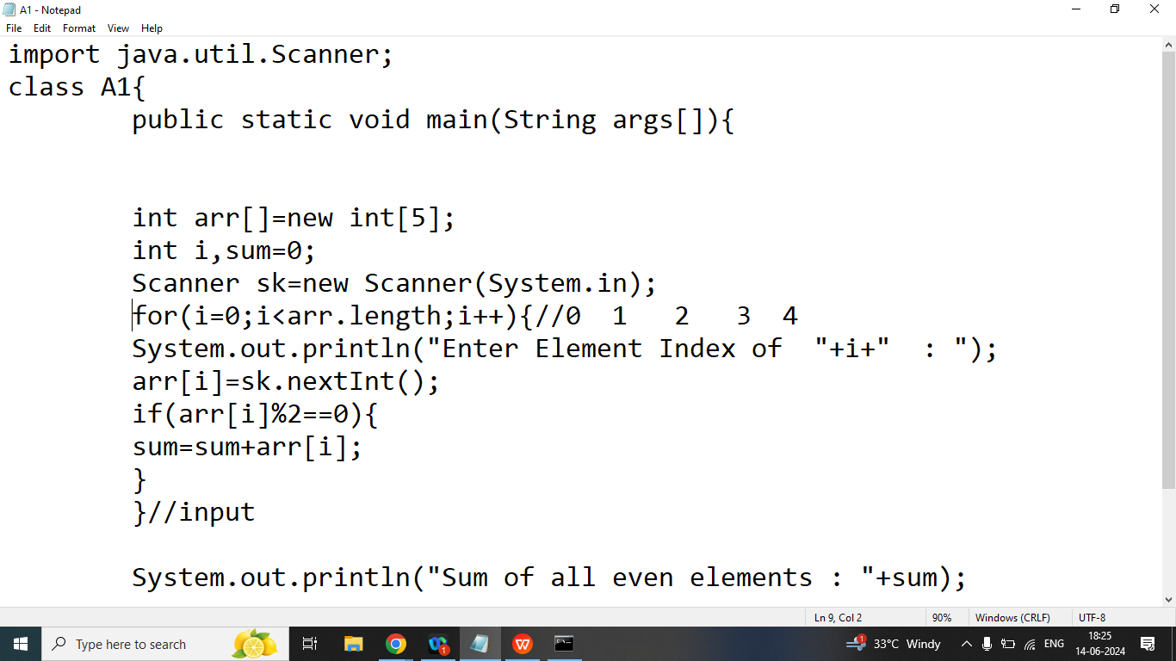

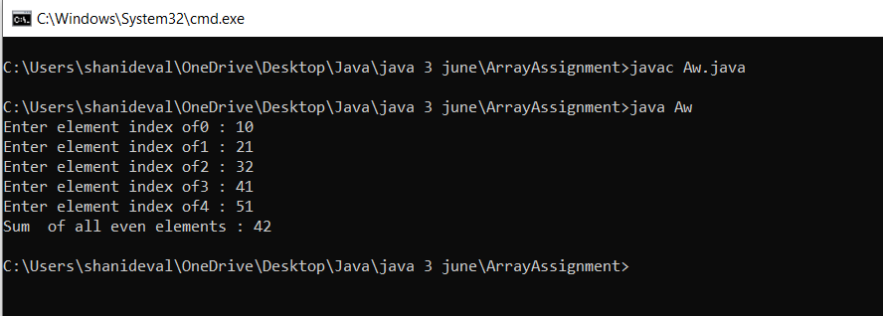

Q2. Write a java program to print sum of all odd elements of the array

Array Elements: 10 21 32 41 51

Sum of All odd Elements : 113

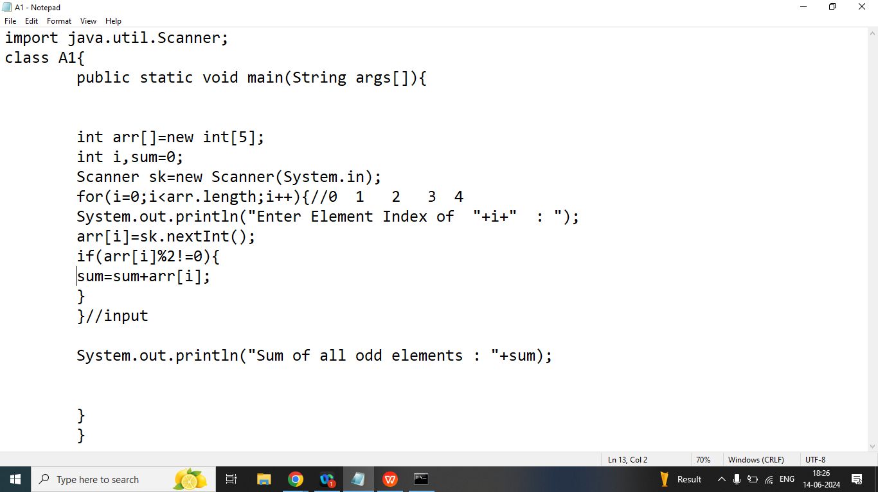

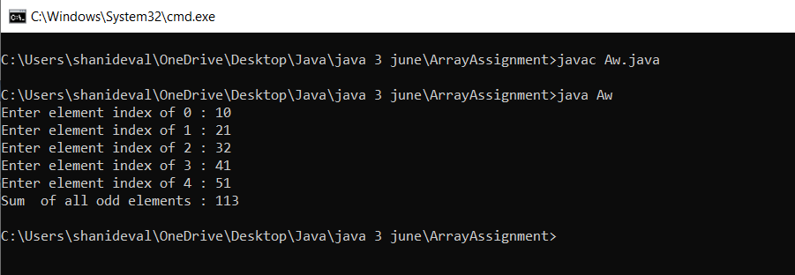

Q3. Write a java program to print all array elements in reverse order

Array Elements: 10 20 30 40 50

Reverse Oder: 50 40 30 20 10

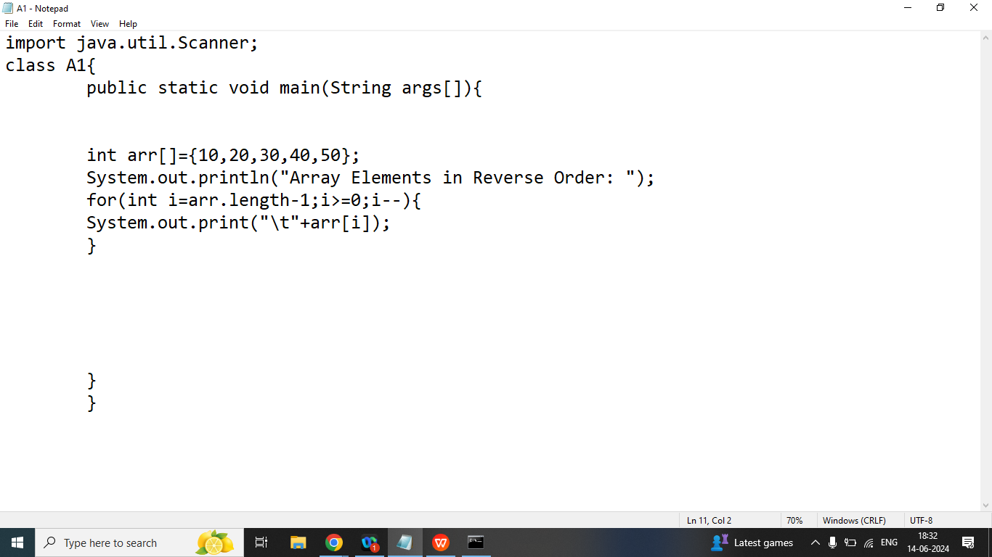

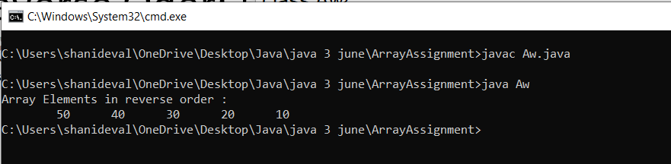

Day 24

Q1. Write a java program to find largest element from the Array.

Array Elements: 100 20 200 30 500

Largest Element: 500

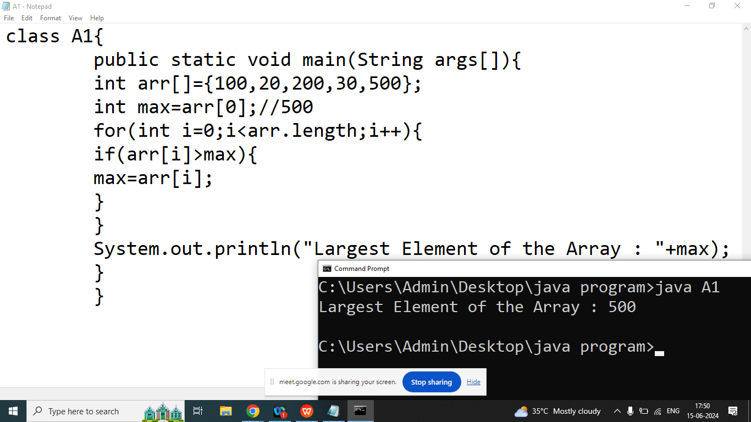

Q1. Write a java program to find smallest element from the Array

Array Elements: 100 20 200 30 500

Largest Element: 20

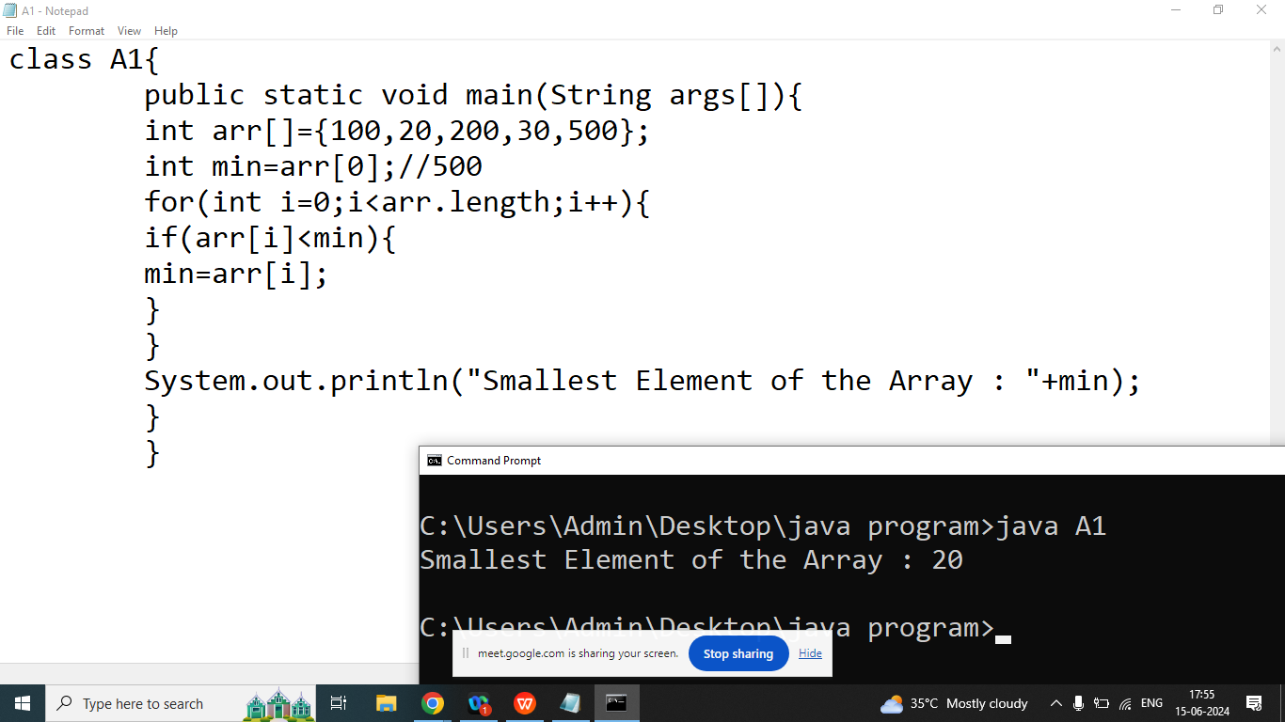

Homework

Q1. Write a java program to find second smallest element from the Array

Array Elements: 100 20 200 30 500

Largest Element: 30

Q2. Write a java program to find second largest element from the Array

Array Elements: 100 20 200 30 500

Largest Element: 200

Q3. Write a java program to convert given decimal number to binary Number.

Enter Any Number: 6

Binary Number: 110

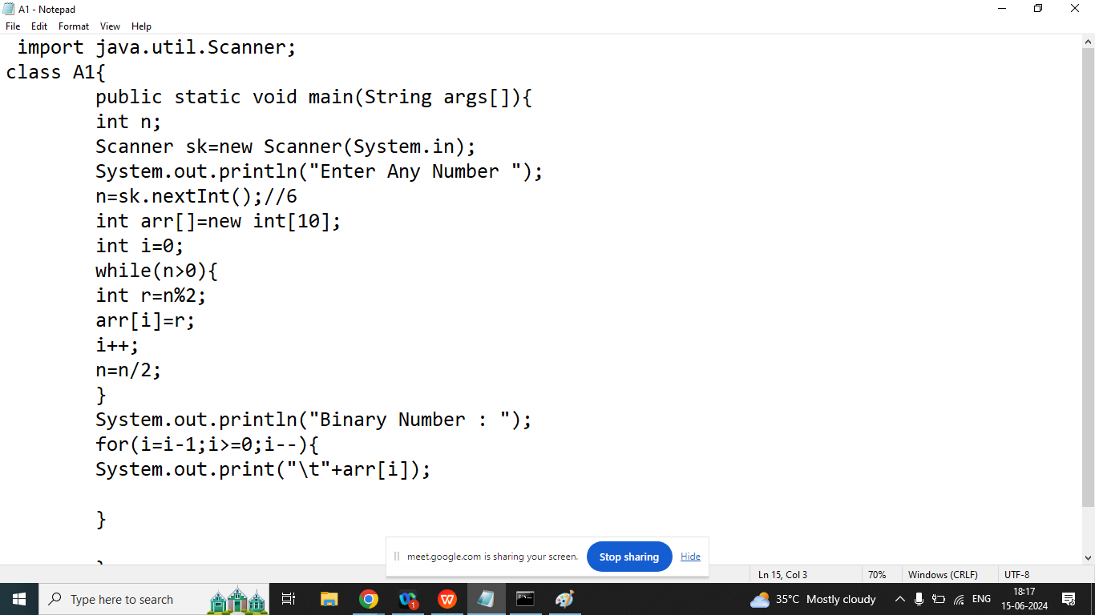

Q3. Write a java program to sort array elements in ascending order

Array Elements: 30 10 20

Before Sorting: 30 10 20

After Sorting : 10 20 30

int a,b,c;

c=arr[i];

arr[i]=arr[j];

arr[j]=c;

class A1{

public static void main(String args[]){

int arr[]={30,10,20,100,40,90,80,50,70,60};

System.out.println("Before Sorting : ");

for(int i=0;i<arr.length;i++){

System.out.print("\t"+arr[i]);

}

//sorting

for(int i=0;i<arr.length;i++){

for(int j=i+1;j<arr.length;j++){

if(arr[i]>arr[j]){

int c;

c=arr[i];

arr[i]=arr[j];

arr[j]=c;

}

}

}

System.out.println("\nAfter Sorting : ");

for(int i=0;i<arr.length;i++){

System.out.print("\t"+arr[i]);

}

}

}

Day 25

**Q1. Find Second Largest Element from the Array?**

class A1{

public static void main(String args[]){

int arr[]={100,20,300,40,500};

int max=arr[0];

for(int i=0;i<arr.length;i++){

if(arr[i]>max){

max=arr[i];

}

}

System.out.println("First MAX ELEMENT : "+max);

int max1=arr[0];

for(int i=0;i<arr.length;i++){

if(arr[i]>max1&&arr[i]<max){

max1=arr[i];

}

}

System.out.println("Second MAX ELEMENT : "+max1);

}

}

Q2. Explain Multidimensional Array / 2D Array in java programming?

Ans:

A Multidimensional Array is an Array of Arrays

A Multidimensional Array is useful when we want to store data in Tabular form or Matrix form

Syntax:

Data type[][]=new data type[ROW SIZE][COLUMN SIZE];

Example:

int A[][]=new int[3][3];

A

|  |  |  |  |
| --- | --- | --- | --- |
|  | COLUMN 0 | COLUMN 1 | COLUMN 2 |
| ROW 0 | 00(10) | 01(20) | 02(30) |
| ROW 1 | 10(40) | 11(50) | 12(60) |
| ROW 2 | 20(70) | 21(80) | 22(90) |

How to initialize 2D Array

ArrayName[ROW INDEX][COLUMN INDEX]=value;

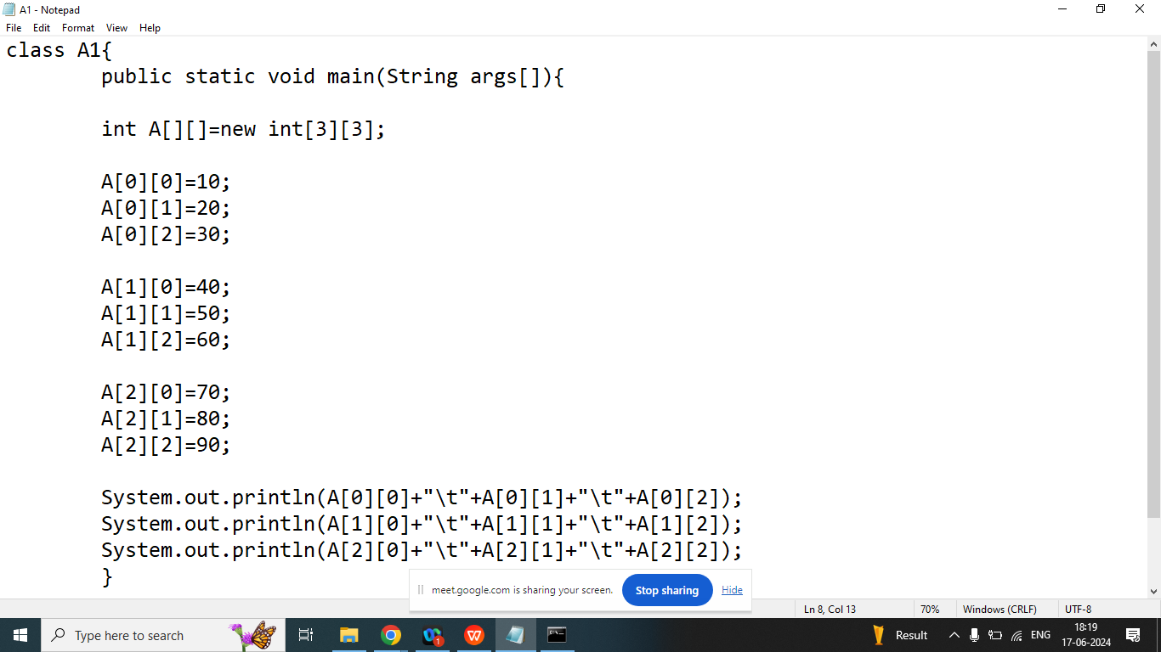

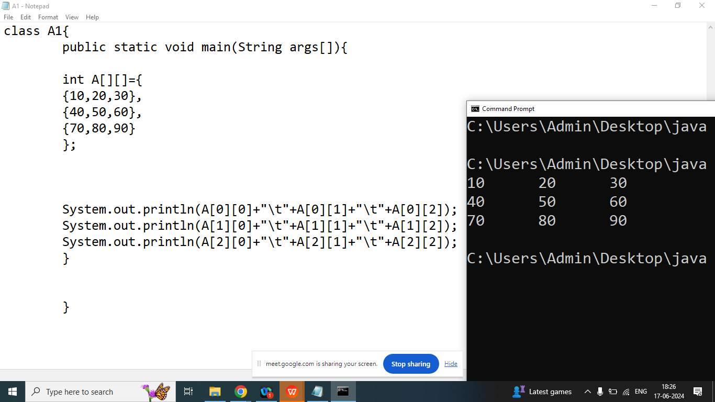

import java.util.Scanner;

class A1{

public static void main(String args[]){

int A[][]=new int[3][3];

Scanner obj=new Scanner(System.in);

System.out.println("Enter Element Index of 00 : ");

A[0][0]=obj.nextInt();

System.out.println("Enter Element Index of 01 : ");

A[0][1]=obj.nextInt();

System.out.println("Enter Element Index of 02 : ");

A[0][2]=obj.nextInt();

System.out.println("Enter Element Index of 10 : ");

A[1][0]=obj.nextInt();

System.out.println("Enter Element Index of 11 : ");

A[1][1]=obj.nextInt();

System.out.println("Enter Element Index of 12 : ");

A[1][2]=obj.nextInt();

System.out.println("Enter Element Index of 20 : ");

A[2][0]=obj.nextInt();

System.out.println("Enter Element Index of 21 : ");

A[2][1]=obj.nextInt();

System.out.println("Enter Element Index of 22 : ");

A[2][2]=obj.nextInt();

System.out.println(A[0][0]+"\t"+A[0][1]+"\t"+A[0][2]);

System.out.println(A[1][0]+"\t"+A[1][1]+"\t"+A[1][2]);

System.out.println(A[2][0]+"\t"+A[2][1]+"\t"+A[2][2]);

}

}

Day 26

Q2. Print array in 2d

import java.util.Scanner;

class A2{

public static void main(String args[]){

int A[][]=new int[3][3];

Scanner kb=new Scanner(System.in);

int r,c;

for(r=0;r<3;r++){//0 1 2

for(c=0;c<3;c++){// 0 1 2

System.out.println("Enter Element Index "+r+c+" : ");

A[r][c]=kb.nextInt();

}

}//input

System.out.println("Array Elements Are : ");

for(r=0;r<3;r++){

for(c=0;c<3;c++){

System.out.print("\t"+A[r][c]);

}

System.out.println("");

}//output

}

}

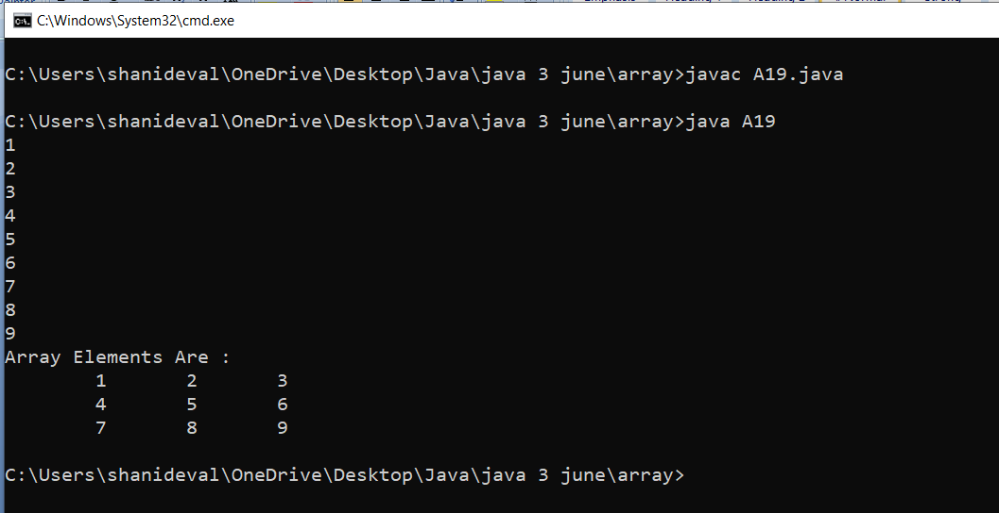

Q2.Write a java program to print sum of two matrix A

|  |  |  |
| --- | --- | --- |
| 10 | 20 | 30 |
| 40 | 40 | 60 |
| 70 | 80 | 90 |

B

|  |  |  |
| --- | --- | --- |
| 1 | 2 | 3 |
| 4 | 4 | 6 |
| 7 | 8 | 9 |

C

|  |  |  |
| --- | --- | --- |
| 11 | 22 | 33 |
| 44 | 55 | 66 |
| 77 | 88 | 99 |
|  |  |  |

import java.util.Scanner;

class A2{

public static void main(String args[]){

int A[][]=new int[3][3];

int B[][]=new int[3][3];

int C[][]=new int[3][3];

Scanner kb=new Scanner(System.in);

int r,c;

System.out.println("Enter Matrix A : ");

for(r=0;r<3;r++){//0 1 2

for(c=0;c<3;c++){// 0 1 2

System.out.println("Enter Element Index "+r+c+" : ");

A[r][c]=kb.nextInt();

}

}//input

System.out.println("Enter Matrix B : ");

for(r=0;r<3;r++){//0 1 2

for(c=0;c<3;c++){// 0 1 2

System.out.println("Enter Element Index "+r+c+" : ");

B[r][c]=kb.nextInt();

}

}//input

//matrix Addition

for(r=0;r<3;r++){

for(c=0;c<3;c++){

C[r][c]=A[r][c]+B[r][c];

}

}

System.out.println("output of MATRIX A : ");

for(r=0;r<3;r++){

for(c=0;c<3;c++){

System.out.print("\t"+A[r][c]);

}

System.out.println("");

}//output

System.out.println("output of MATRIX B : ");

for(r=0;r<3;r++){

for(c=0;c<3;c++){

System.out.print("\t"+B[r][c]);

}

System.out.println("");

}//output

System.out.println("output of MATRIX C Addition : ");

for(r=0;r<3;r++){

for(c=0;c<3;c++){

System.out.print("\t"+C[r][c]);

}

System.out.println("");

}//output

}

}

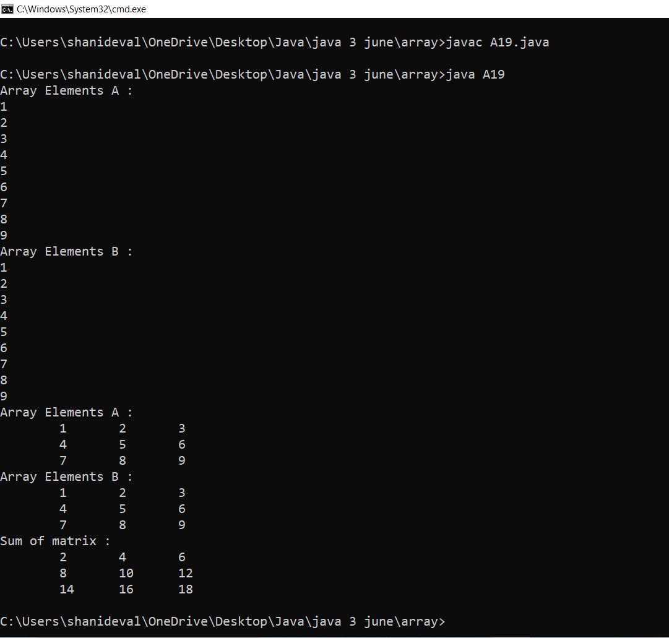

Home Work:

1. Write a java program to print multiplication of two matrix
2. Write a java program to print row wise sum and column wise of a particular matrix

A

|  |  |  |  |
| --- | --- | --- | --- |
| 10 | 20 | 30 | 60 |
| 40 | 50 | 60 | 150 |
| 70 | 80 | 90 | 240 |
| 120 | 150 | 180 |  |

Day 27

Q1. Explain Function/ Method in java programming?

Ans:

* If a group of statements is repeatedly required then it is not recommended to write these statements every time separately. We have to define these statements as a single unit and we can call that unit any number of times based on our requirement without rewriting. This unit is nothing but function/method.
* The main advantage of functions is code Re-usability.
* Note: In other languages functions are known a methods,procedures,subroutines etc.
* Time saving
* Call many times

Methods States

1. Method Definition (working of methods)

public static void main(){

//definition of the method

}

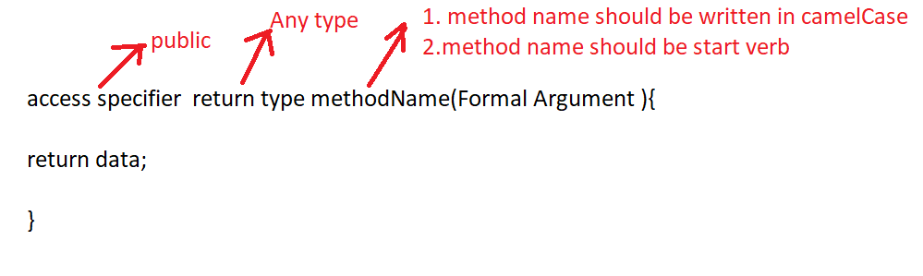

Methods Types on the Basis of Return Type and Argument

1. Taking nothing returning nothing

Example:

public void add(){

//definition of the method

Input

Operation

output

}

Calling the method

methodName();

1. Taking something returning nothing

Example:

public void add(int a,int b){

//1. no need to take input inside the method definition

//2. perform operation

//3. print result

}

//Taking nothing returning nothing

import java.util.Scanner;

class A1{

public static void add(){

Scanner kb=new Scanner(System.in);

System.out.println("Enter Number 1 : ");

int n1=kb.nextInt();

System.out.println("Enter Number 2 : ");

int n2=kb.nextInt();

int n3=n1+n2;

System.out.println("Addition : "+n3);

}

public static void main(String args[]){

add();//calling of the Addition function

add();

}

}

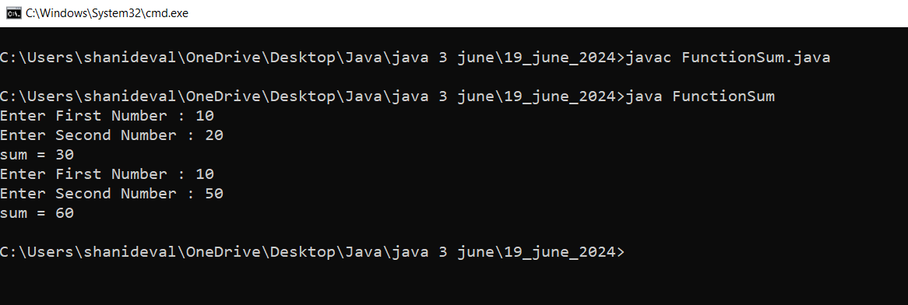

Q2. Write a java program to check given number is even or odd using method(Taking nothing returning nothing)

//Taking nothing returning nothing

import java.util.Scanner;

class A1{

public static void evenodd(){

Scanner kb=new Scanner(System.in);

System.out.println("Enter Any Number : ");

int n=kb.nextInt();

if(n%2==0){

System.out.println("This is Even Number");

}

else{

System.out.println("This is Odd Number");

}

}

public static void main(String args[]){

evenodd();//calling of the evenodd function

evenodd();

}

}

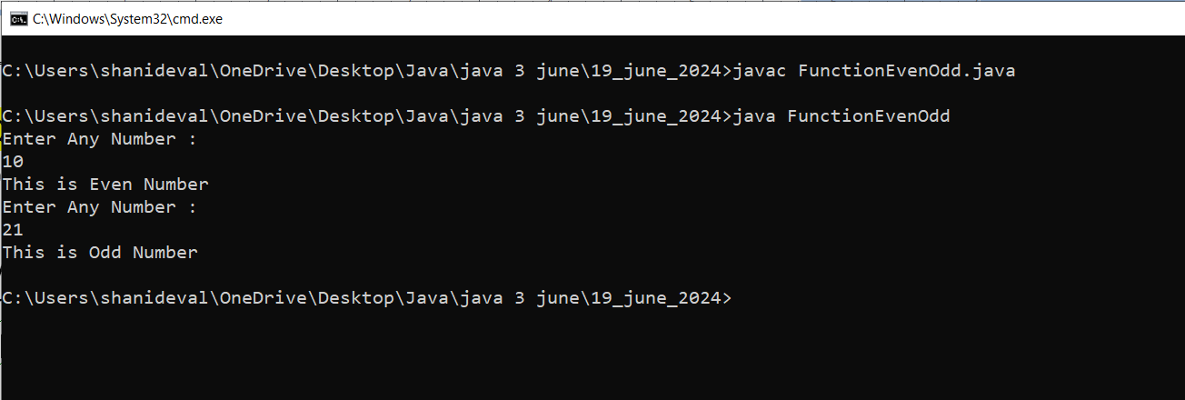

//Taking something returning nothing

import java.util.Scanner;

class A1{

public static void add(int n1,int n2){//formal Argument

int n3=n1+n2;

System.out.println("Addition : "+n3);

}

public static void main(String args[]){

Scanner kb=new Scanner(System.in);

System.out.println("Enter Number 1 : ");

int a=kb.nextInt();

System.out.println("Enter Number 2 : ");

int b=kb.nextInt();

add(100,200);//calling of the Addition function

// Actual Argument

add(a,b);

}

}

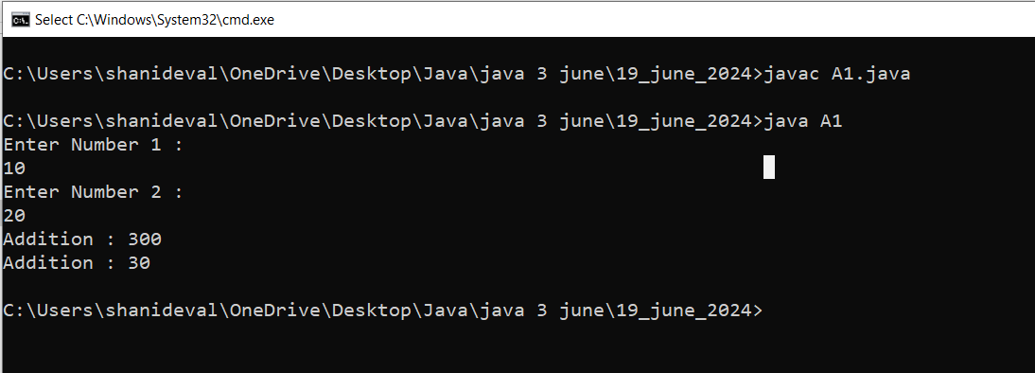

Day 28

Q1. Write a java program to print table of given number using method(Taking something returning nothing)

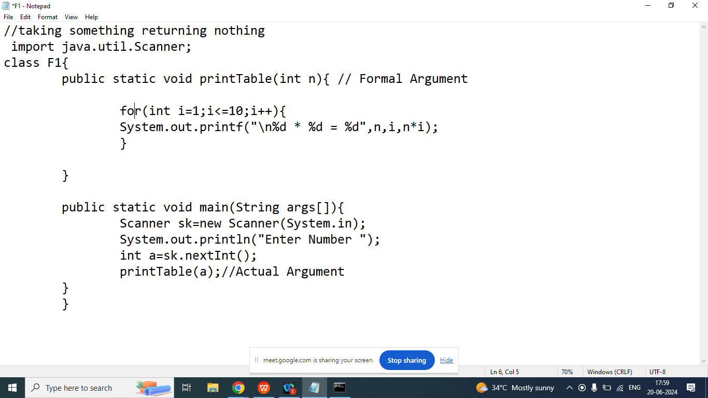

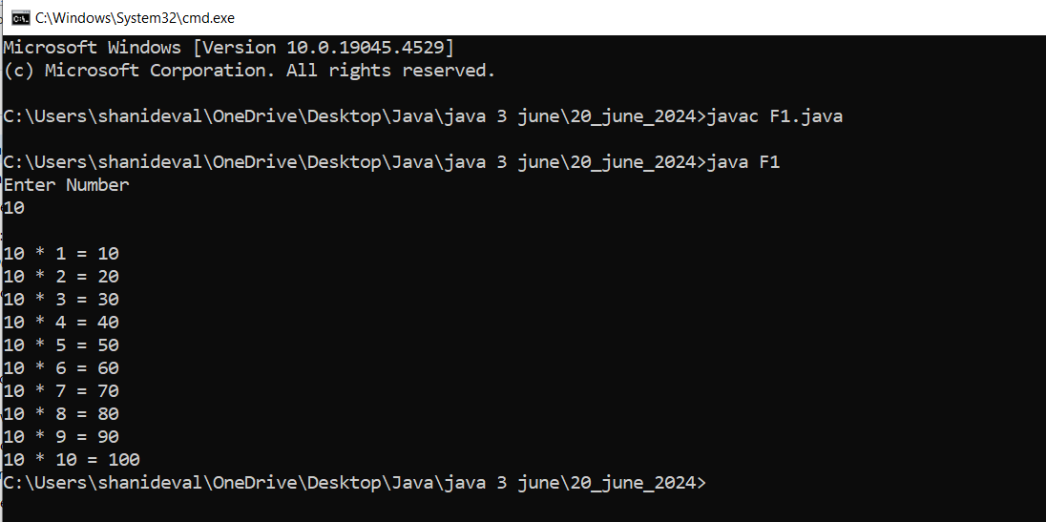

1. Taking Nothing Returning Something

Note:

1. In java method can return one value at a time

Example:

public int add(){

1. Write Input Logic
2. Perform operation
3. Return the result

}

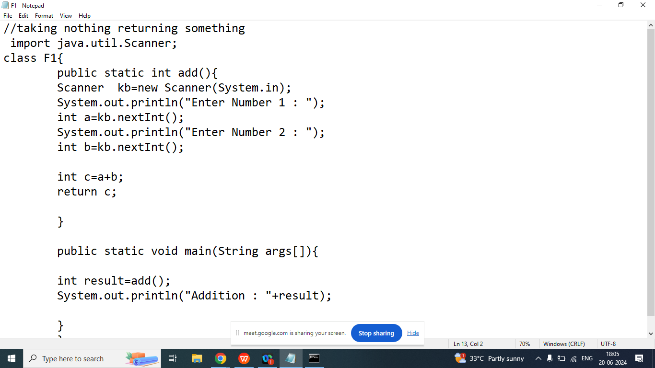

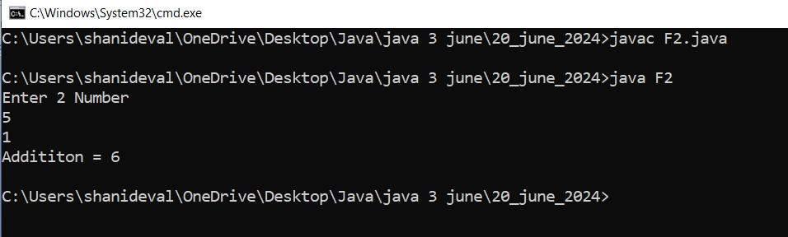

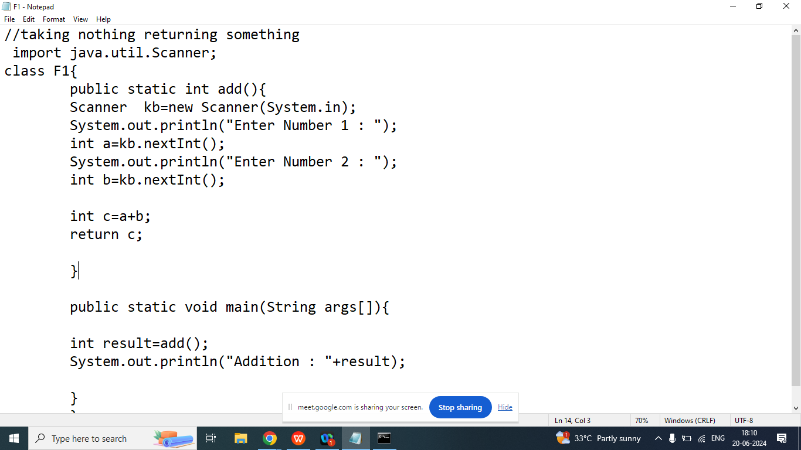

1. Taking Something and Returning Something

Example:

public int add(int,int){

//perform operation

//return result

}

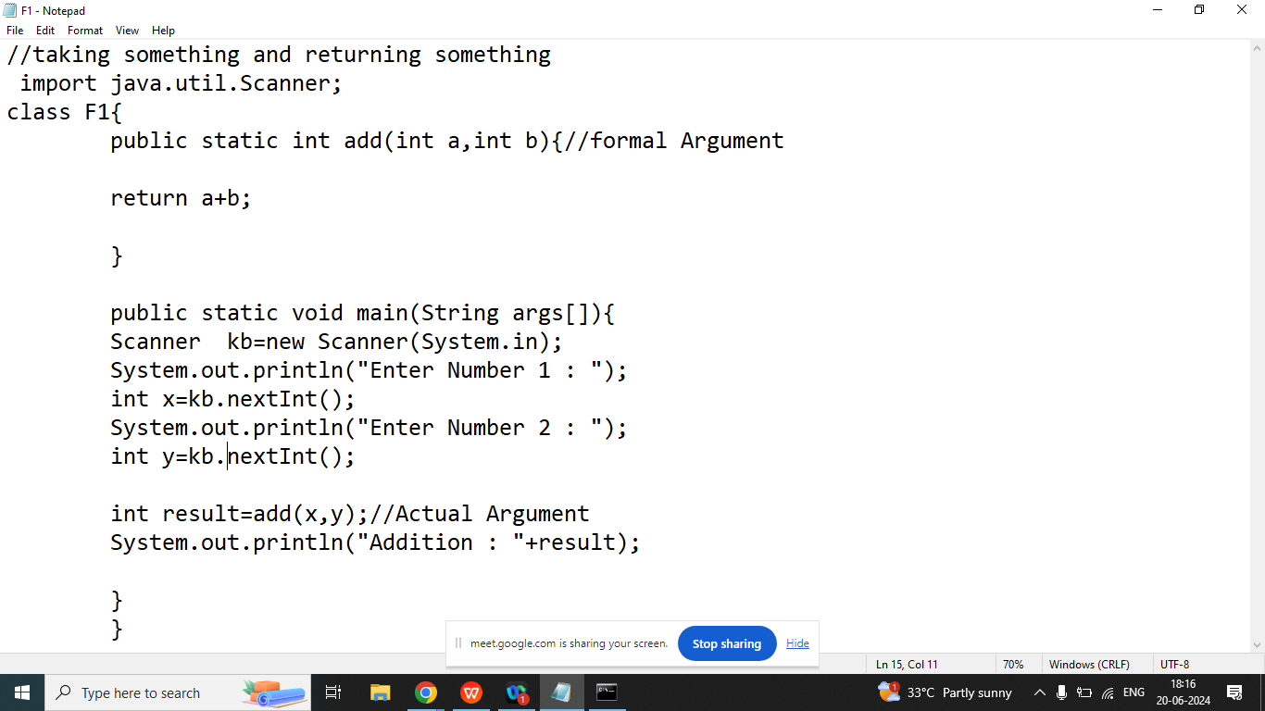

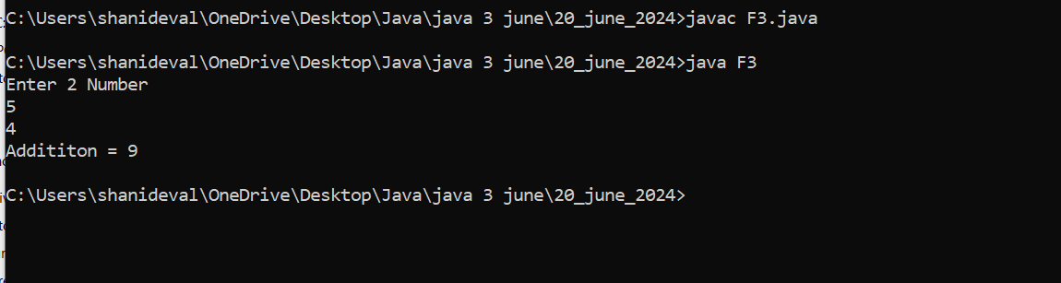

Q1. Explain Recursion in java programming?

Ans: A method called itself is known as recursion

Example : Without Recursion

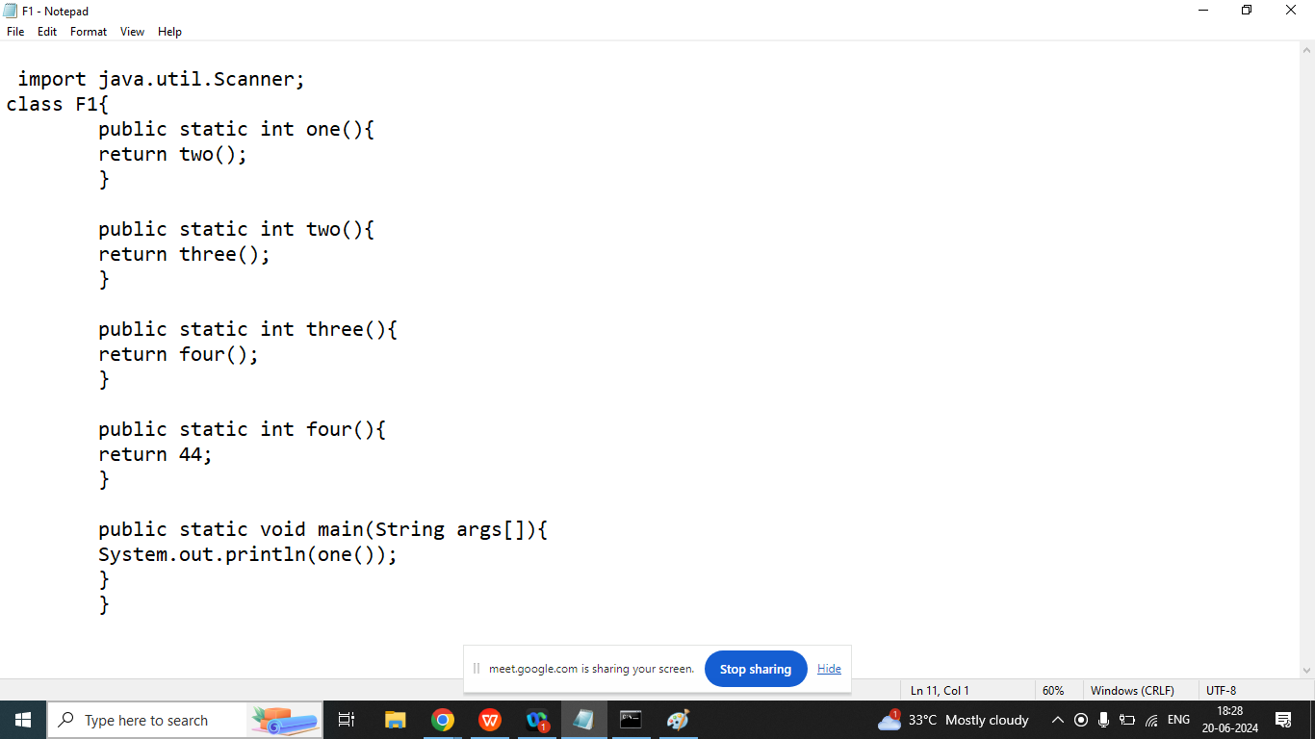

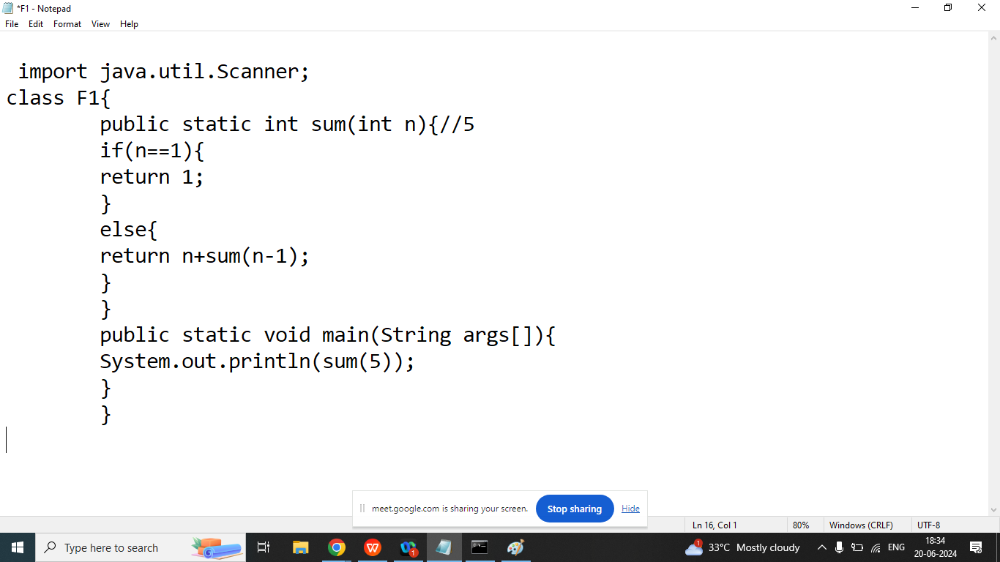

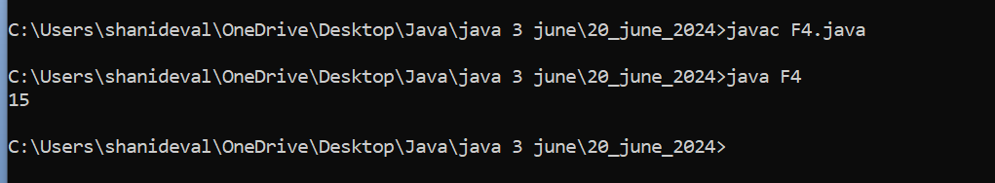

Day 29

Q1. Write a java program to calculate factorial of given number using recursion.

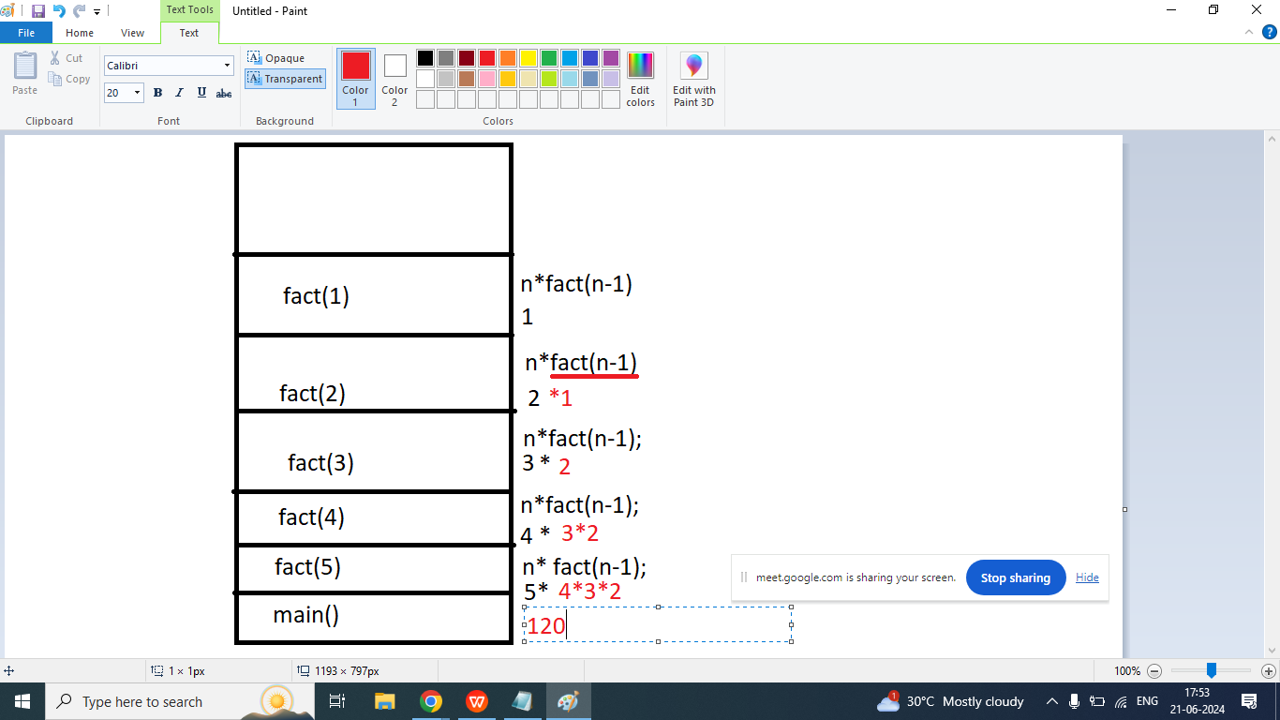

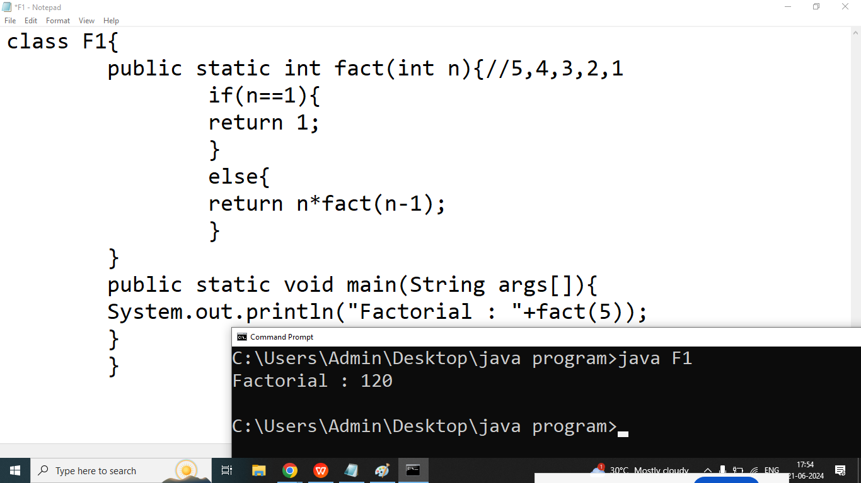

Q2. Write a java program to print nth Fibonacci Number.

Enter Any Number : 3

class F1{

public static void fibo(int n){//5

int a=0,b=1;

System.out.print("\t"+a+"\t"+b);//0 1

for(int i=2;i<=n;i++){

int c=a+b;

System.out.print("\t"+c);//3

a=b;

b=c;

}

}

public static void main(String args[]){

fibo(8);

}

}

Day 30